Bloody childhoods
Dawn Editorial
Tuesday, 07 Jul, 2009 | 07:59 AM PST |
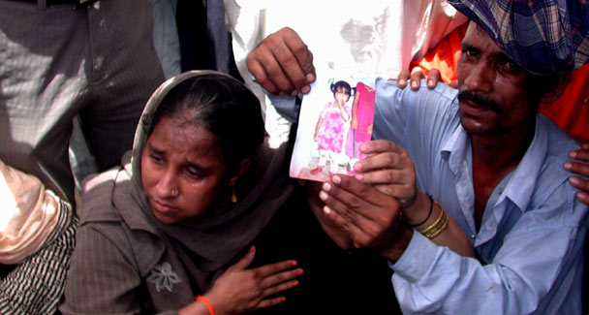
Three year victims girl Sana’s father show pic at during demonstration out side the kpc. — White Star

Metropolitan
How to curb child marriages in Pakistan

The easiest, and now customary, escape from tackling felonies as heinous as child rape is to pour scorn on depraved elements, offer compensation to their prey and move on, burying both the crime and punishment. In some incidents, these last rites involve a real burial such as that of three-year-old Sana who was allegedly raped and murdered by two police constables after she went missing last week. However, a true confrontation involves a battle with the state as it is a virtual accomplice in terminating countless childhoods — civil society’s long and seemingly endless struggle to have the Child Protection Bill endorsed by parliament continues.
The ‘law’ will shield innocent lives by preserving child rights and protection; a subject almost alien to the lower classes. The great contradiction remains the fact that Pakistan enjoys the status of being one of the first 20 countries that sanctioned the United Nations Convention on the Rights of the Child (UNCRC) in 1990. It can be asked then, that, as the authority responsible makes five-year reports on its implementation to the UN committee on child rights mandatory, what the state has to say for its children, and secondly, why the delay in the enactment of the bill into law has not been condemned by international bodies. Also, it is the government’s duty to overhaul the almost non-existent forensic and medico-legal facilities so vital to the dispensation of justice.
Regrettably, there is precious little to not only prevent but to assuage the wounds of despicable offences. Child victims and their hapless families often face a long, arduous road to justice and recovery. The most destructive consequence is that child abuse breeds future offenders as the child and his/her family grapple with the sense of violation without help such as counselling by qualified personnel who visit the home. This can prevent aftermaths including depression, anxiety, low self-esteem and fractured adult relationships. Lamentably, little Sana’s case threatens to be yet another police crime; and if the perpetrators go scot-free, it may once again see the public taking the law into its own hands as it did this time.
The journey to justice becomes all the more onerous and perilous when it involves its own ‘custodians’. After all, how long can an impoverished family hold out against criminals who may be members of the police and what mechanism ensures that the police department will not do all it can to wash its hands of Sana’s blood? It is this helplessness that spawns mob justice — it would do the authorities some good to bear previous gory incidents of mob fury in mind.

