Rethinking jirgas
By Huma Yusuf
Sunday, 11 Apr, 2010
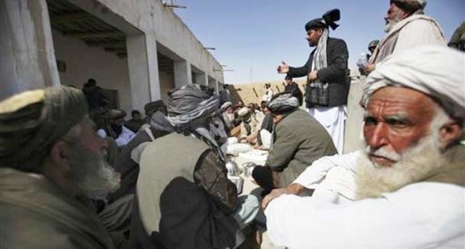
Afghan men listen to Abdul Sattar Mirzakawal, Deputy Provincial Governor, standing in black coat, during a local jirga in the village Qari Sahib, Nad Ali district, Helmend province, southern Afghanistan, Sunday, Feb. 14, 2010. - Photo by AP.
It has been a good week for Pakistani democracy. The National Assembly unanimously adopted the 18th Amendment Bill, the parliament reigned supreme again, and politicians congratulated, rather than lambasted, each other.
But two news items this week indicate how much work is still needed to strengthen the country’s democratic set-up. Ambitious constitutional reforms may have bolstered democratic norms at the highest levels of governance but at the highly local, village-by-village level, democracy continues to be threatened by the persistence of an ancient institution: the jirga.
On Wednesday, PPP Senator Islamuddin Sheikh along with a former provincial minister convened a jirga at his residence in Sukkur to settle a dispute between the Lakhan and Mirani communities. Both groups were guilty of killing and injuring members of each other’s community, and after long deliberations, the jirga imposed significant fines on each side to amicably settle the matter.
Last week, the president of the Sindh chapter of the PML-Q, Ghaus Bakhsh Khan Mahar, also convened a jirga to settle a dispute that arose when an FIR was lodged against two individuals for kidnapping a former naib nazim. Both politicians were in violation of the law, since an April 2004 Sindh High Court ruling declared jirgas to be unconstitutional and illegal. But for his troubles, only Mahar was reprimanded by the state, and an FIR has been registered against him on the charge of holding a jirga.
The contradictory outcomes of these two incidents reveal Pakistan’s conflicting perspectives on the jirga (or panchayat in the Punjab). On the one hand, the jirga has been embraced by the government in recent times as a way to forge consensus against militancy among Pakhtun tribes based along the Pakistan-Afghanistan border. Since jirgas serve a legislative function in Fata under the Frontier Crimes Regulation, the government has also recently approached Mehsud jirgas in South Waziristan with requests to form lashkars against the Taliban.
Last month, political parties and civil society groups in Peshawar also took up the mantle of the jirga in their fight against terrorism. The Qaumi Amn Jirga, comprising 700 delegates, issued a ‘Peshawar Declaration’ which called on the government to take urgent measures to stem terrorism, and supported forming a 5,000-strong ‘peace jirga’ to implement the document.
Since 2007, in diplomatic dealings with Afghanistan too, Pakistan has participated in grand jirgas to develop a strategy to implement Kabul’s ‘reintegration and reconciliation’ plan. During Afghan President Hamid Karzai’s recent visit to Pakistan, it was decided that a jirgagai would be held in Kabul later this month, followed by a grand jirga in Islamabad. In these contexts, jirgas are posited as inclusive, democratic institutions that facilitate consensus-building while expressing regard for and engaging with ancient tribal customs.
But for democratically minded individuals, jirgas are far more demonic institutions. They are the entities that ordered and implemented (most famously) the gang-rape of Mukhtar Mai as well as thousands of other cases of rape, swara, karo-kari, vani, and other so-called tribal practices that devastate the lives of women. Like other all-male institutions that regularly trounce the fundamental rights of Pakistani women, jirgas have long been the target of human rights groups who advocate that on this basis alone the councils should be deemed undemocratic and abolished nationwide.
No doubt, the track record of jirgas on the issue of women’s rights demonstrates that they are incompatible with democracy. Beyond the women’s angle too, it is clear that jirgas have no place in a functioning democracy because they erode the writ of the state. In his 2004 SHC ruling outlawing jirgas, Justice Rehmat Hussain Jaffery pointed out that since jirgas exercise legislative, judicial and executive authority, they usurp and undermine the power of the state, and are therefore unconstitutional. Moreover, the fact that politicians such as Sheikh and Mahar — whose very power stems from the parliamentary system — are convening jirgas totally undercuts our system of governance.
The fact is that no institution can be considered democratic if it grants certain Pakistani citizens power over other Pakistani citizens; offers no opportunities to appeal its decisions; disregards international conventions on human rights and law that Pakistan is a signatory to; and appropriates the government’s accountability to its citizens in matters of law and order.
There is also no masking the fact that jirgas preserve the privileges of waderas, sardars and other land-holding or politically influential ‘gentry’. In reinforcing feudal dynamics, jirgas become the very antithesis of democracy, which is premised on equality and social mobility.
As this government presents itself as the greatest defender of democracy, it should consider extending the ban on jirgas from Sindh to the rest of the country — and ensure that, unlike the SHC ruling, it is stringently enforced. Plans for political reform in Fata should also stipulate that regular courts replace jirgas there. Such legislature would have to be accompanied by a marketing campaign to rebrand the jirga as a negative institution. That means changing the vocabulary that currently defines Pak-Afghan relations and anti-terrorism initiatives.
Defenders of the jirga point to the severe backlog of cases in the country’s judicial system — 1.52 million cases were pending in the superior and lower courts at the end of 2009. They argue that jirgas keep ‘petty’ matters out of the courts, thereby facilitating the system. The government must address this backlog so that otherwise intelligent people do not use backhanded logic to support an undemocratic and feudal practice.
There is one other option: incorporating hyper-local, jirga-like institutions within the system of governance. In 2004, in a brash attempt to nullify the SHC ruling, the government drafted the Sindh Amicable Settlement of Disputes Ordinance, which preserved jirgas and continued to grant them the power to try, punish, and even execute offenders. Such legislature makes a mockery of democracy and the judicial system.
But the Local Government Ordinance 2001 allowed for Reconciliation Councils at the union council level, which could settle certain minor disputes in accordance with the law, and had to include women. Enabling such bodies — in complete compliance with the constitution, of course — could be the best way to rid Pakistan of the undemocratic taint of the jirga.

