Stabilising democracy
By Anwar Syed
Sunday, 21 Feb, 2010
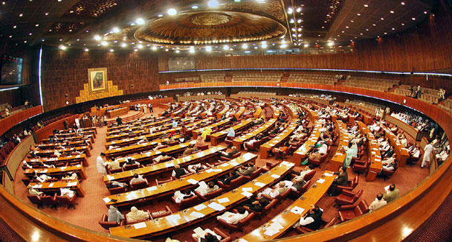
If the National Assembly is still to be regarded as stable, one may wonder what good stability is.

The government of Pakistan has reportedly told American officials that their assistance should be focused on stabilising democracy and economic development in this country. The idea of the stabilisation of democracy is not self-explanatory and we have to figure out what it means and how the US can help in this regard.
An institution may be considered stable if it is not subject to abrupt and frequent changes. Continuity is reassuring to those who do business with it. The requisites of stability do not preclude incremental change to further improve its capabilities.Systems of governance — both democratic and authoritarian — can have considerable longevity and therefore stability. Democracy, with limitations that abated with time and a few brief interruptions (imposed by the Stuart kings and Oliver Cromwell), has been operating in England since the advent of the Magna Carta (1215). It has been functioning in America since the arrival of the Puritans in Massachusetts in the early 17th century.
Groups in America have differed from each other on fundamental issues (slavery) and fought a bloody and protracted civil war, but that did not turn them away from democracy. It may then be said that democracy had become stable in England and America. The same may be said of democracy in several English-speaking countries and parts of Western Europe.
The story of democracy has not been similar in Pakistan. Here, the ‘establishment’ (military and bureaucratic elite and the landed aristocracy) believed that democracy did not suit the ‘genius’ of the people. They suspended, dismissed and abolished democratic institutions repeatedly. For half its life as an independent state the country suffered rule by military dictators.
Democracy returned to Pakistan following reasonably free and fair elections held in February 2008. Elected governments are ruling at the centre and in the provinces. Legislative assemblies are in place and they are meeting regularly. Yet it is being said in several quarters that democracy in Pakistan is fragile, that certain forces in the country are working to disrupt or expel it, and that it needs to be protected. Its alleged fragility needs to be examined.
Army takeovers have pushed democracy out in the past. Many people are apprehensive that since the present government is widely perceived as both incompetent and corrupt, the army may intervene once again. In my view this fear is not well-founded. The army has its hands full fighting militants in the northwest areas. Second, it is presumably satisfied with the fruit of power that is already coming its way. Third, its leaders know that they cannot meet the crises the country faces any better than the civilian government does.
Indifferent performance in this area will lower it in public esteem. Fourth, the US government, which pays a substantial part of its expenses, does not want the present regime in Pakistan to be overthrown, because it does everything that America wants from it. In sum there is no likelihood of an army coup in the foreseeable future.
Looking around, I do not see any specific or imminent threat to democracy. If there is any, it is latent. The foremost threat comes from the feudal ethos, which has spread to virtually all relationships in both rural and urban settings. It recognises only the superior-subordinate, command-and-obey pattern of interaction. It does not recognise equality and it does not know how equals may work together in pursuing a common interest.
Democracy and equality go together; not in terms of incomes but with regard to civil rights. The vote of one citizen has the same value as that of any other. Likewise, the votes of all members of the National Assembly carry the same weight. That may be the reason why the assembly does not get much work done. It is dominated by feudal lords who are sceptical of democracy, and while they will not abolish democratic institutions, they do all they can to emasculate them and obstruct their proper functioning.
Are the criteria of stability met if an institution holds the number of meetings its charter requires but does not do any work? The present National Assembly has been meeting regularly since its inauguration after the elections of February 2008. The question hour during its sessions is good and lively, but the National Assembly has few bills, some of them amendments to existing laws, in an entire year. Far too many of its members sign in but do not sit in the house and participate in its proceedings. If the National Assembly is still to be regarded as stable, one may wonder what good stability is.
In a working democracy elected representatives of the people are accountable to them for their performance. In Pakistan it has not been customary for many legislators to maintain regular contact with their constituents during the period between elections to remain informed of their problems and do something to alleviate them. As the people become politically more aware and active, their representatives will become more attentive and responsive to them. Democracy will then be more fully functional and stabilised. This process will be aided if both the government and parliament learn to truly value democracy.
What can the US do to stabilise democracy in Pakistan? American media, intellectuals, politicians and even officials have traditionally held India in high esteem because it is a democracy and Pakistan in lower regard because its governments have been authoritarian for the most part. The government of the United States has not been much concerned with the character of Pakistan’s political system. Note also that its transactions with Pakistan were more satisfactory when it dealt with military dictators than they were with a democratic regime, such as that of Zulfikar Ali Bhutto.
Things change with time. My own feeling is that President Obama’s administration welcomes the return of democracy in Pakistan and would like to see it stay and flourish. If American assistance does help Pakistan’s economic development and stability it may indirectly serve to improve the environment in which democracy has to operate. This is a secondary, peripheral role.
The nurturing and stabilising of democracy is primarily the responsibility of Pakistan’s own politicians, media and organs of civil society.

