The axis of trouble
By Yousuf Nazar
Saturday, 05 Dec, 2009
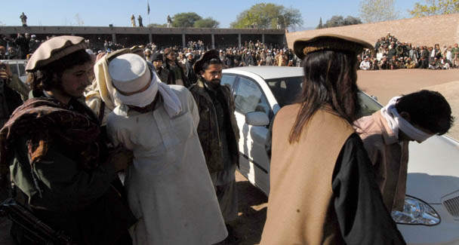
The Americans blame the extremists and terrorists for Pakistan’s current woes. So do Pakistan’s liberals.
Pakistan’s so-called Islamic parties and groups never get tired of blaming America for all the country’s problems. The military has traditionally blamed the politicians.
The Americans blame the extremists and terrorists for Pakistan’s current woes. So do Pakistan’s liberals.
In the context of the recent past and Pakistan’s history, Pakistan’s biggest tragedy and the principal reason for its break-up was and has been the axis of trouble between America, Pakistan’s army, and the religious parties.
Until and unless the axis is broken, neither the reconstruction of the Pakistani state nor the so-called democratisation of Pakistan will bring peace or prosperity to the latter’s 170 million people, nearly eighty per cent whom live below the poverty line of $2 a day.
Pakistan’s elites have little interest in the reconstruction of the state because they have the most to lose if power is truly exercised by the people.
The army has no incentive to break the axis of trouble (a legacy of the great game) because it thrives on the perpetuation of conflicts in the region and the largess it receives from the United States.
The Americans cannot afford to antagonise the army for the simple reason it is the only power that matters. And the mullahs? They have thrived due to a combination of factors. Most important among the factors is the failure of the so-called mainstream parties to provide honest and credible leadership.
It is customary to blame Zia and his successors, including Musharraf, for the growth of the Frankenstein forces of extremism and terrorism, but the buck does not stop there.
In many other countries, for example, in Latin America, the unholy alliance between the local military, rightwing forces and Americans undermined democracy but the nationalist and democratic forces eventually triumphed because they had capable and credible leadership.
Pakistan has been cursed by civilian and military leaders who are too eager to follow the US agenda. From Ayub to Kayani, there is not a single army chief who can claim to have pursued Pakistan’s strategic interests independent of US goals in the region.
Since US interests have largely been military and revolved around the containment of Russia and China in the region, its most natural ally has been the military at the cost of democracy and democratic governance.
Politics has been demonised to a degree that save for incompetent and allegedly corrupt individuals like Mr Zardari or Mr Nawaz Sharif, or creations of the establishment like Altaf Hussain or Maulana Fazlur Rehman, few wish to navigate the treacherous and murderous waters of stormy Pakistani politics.
It is easy to say that we need democratisation and decentralisation of power and the provinces should be given full autonomy. But how? We have had many elections since 1985 after Ziaul Haq imposed martial law in 1977 but virtually nothing has changed.
It is even more ironic when otherwise well-meaning intellectuals and civil society leaders lecture about democratic governance and the fight against extremism as if these were the only important issues.
Some believe the judiciary offers some hope. An independent judiciary is an oxymoron in Pakistan’s current objective conditions. The so-called revolt by some in the judiciary against Musharraf was a manifestation of a power struggle inside the establishment.
The judiciary is as much part of the collapsing Pakistani state structure as some of the big media personalities, some whom also openly admit to have been offering advice to the powers that be.
The ugly reality is that the business of the state and politics has become a mafia enterprise with the usual mix of big money (read business, drugs, land) interests and crime.
This criminal enterprise has the active support of the Americans who find it convenient to use a corrupt instrument that a puppet state is, be it military or quasi-military. Either in its pure form or in a diluted form; that is, in a coalition with some corrupt politicians.
Many developing countries have passed through this phase. But the will of the people ultimately triumphs. So Pakistanis must not despair.
However they need to be clear that the forces of oppression and corruption have thrived not only due to the support from the US but also due to the fact that the people themselves have allowed autocratic and corrupt forces to divide, coerce, silence and deceive them.
The people must unite. But for a movement to succeed in Pakistan’s current conditions, it must and has to involve, mobilise and relate to the masses and not just the educated few.
It is therefore the need of the hour that all citizens think seriously about what is the crux of the issue. The country needs freedom from corrupt leadership (civil or military) and America and the axis of trouble.
It is not the sole privilege of any political party or a civil rights group to fight for this. This should be the common goal of every Pakistani who wants to see the rule of the people.
The two main obstacles to the creation of a free, just and democratic Pakistan are the establishment (including its civilian collaborators) and America. It is logical that Pakistanis raise their voice against both as well against the religious extremists.
From Ayub Khan to Yahya to Ziaul Haq to Musharraf, it is the United States that has sided with the generals as it historically did in all developing countries. To expect that a democratic movement can succeed without confronting the dictatorship’s biggest and most powerful supporter is hoping against all hope.
If civil society and journalists forget this and continue to focus on issues like the repeal of the 17th Amendment, it is unlikely that such an agenda would capture the imagination of the masses who are quite aware of who really pulls the strings in Pakistan.
Until and unless a movement emerges that appeals to popular sentiment and represents the people’s real aspirations to create a genuinely democratic state, Pakistan’s chances of survival in its current state are slim.

