A learning experience
By Dr Ashar Jamelle
Sunday, 18 Oct, 2009 | 01:18 AM PST |
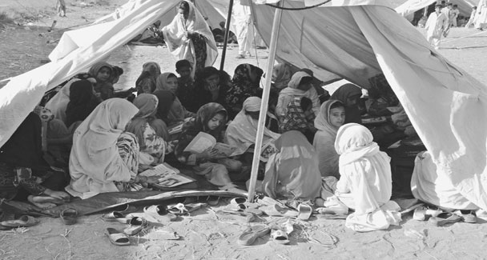
Life is all about learning. In its fullest form it teaches you to be kind, compassionate and to care about those who are in need. In fact it is a constant reminder of our existence if we are able to focus on things around us to make life worth living.
That is what all religions teach us and that is what our elders prepare us to experience life at close quarters.
As a student, whether at school or university, we train ourselves to become what we aim to achieve. The things that we learn through history like the trial and tribulations, triumphs, disasters and the tragedies suffered by mankind over the centuries in the form of natural calamities like earthquakes, landslides, flood or through man-made disasters inflicted on innocent people make us wonder why on earth do humans have to suffer so much. It is at times like this that you wonder whether life is even worth living. But experiencing things first hand makes you realise that whatever you have been trained and educated to do should not go to waste.
As a young man belonging to the medical profession I am aware of what happened during the partition of India. Stories of massacre of the innocent and migration of millions along with the suffering encountered in the East Pakistan crisis or that of the World War victims and killing of hapless people in Bosnia and Kosovo in former Yugoslavia brings back memories of horror pain and trauma that people experience in life.
It is even more painful and heart-rending to experience it at our own front door and see people become refugees in their own country like what recently happened in Swat through the atrocities committed by the self-styled bandits called the Taliban.
I just could not bear lying comfortably in my bed when the lives of others were being shattered before my eyes. I thought to myself I have to give back something to society which prompted me to get into action. And there could have been no better thing than a note from a school friend which triggered a plethora of things and sleepless nights about the IDP situation. I called a doctor who used to work with me in Karachi and was now stationed in Peshawar for some clear information. He provided a graphic description of the critical medical and financial condition of the IDP’s in the camps.
I decided to go and join my colleagues in Peshawar as soon as I could gather enough funds, which I could take with me. Asking for money does not come naturally to me ... I felt like a broken record going to all my friends and relatives asking for donations (and I mean everyone … on Facebook too!).
Initial lukewarm responses to wholehearted enthusiasm was the order of the day as I went from individual to individual. What I discovered came as an education to me that in a country like ours there is no shortage of consensual and charitable people as long as they know where the money is going.
I was not prepared for all those warnings from everyone discouraging me from going there myself. The warnings weren’t unfounded. The airport was shutdown amid concerns for commercial flight attack threats. But I was determined after a sizeable amount started amassing. People had trusted me and I trusted in God.
My intentions were now clear — collaborate and support the work of the doctors from Ghandhara University in Peshawar. These doctors are some of the many unsung heroes. They were in the camps every Sunday and on any holiday. They received wired donations from the rest of the country and they honestly and usefully used that money where immediately needed. Initially the doctors focused on needs at the schools where the IDPs were taking refuge. When the government started taking initiatives at the schools, they shifted the focus to villages and other locations of concern.
The plan was that I would join the doctors in their medical camp. If I reached early in the day, we would distribute funds, see patients in the camp and then be on time for the World Twenty20 cricket final that night. I flew to Islamabad and drove to Peshawar from there the next morning at 5.00am. There was unexpected rain on the way which seemed like a welcome and good omen.
I met with the medical team on the outskirts of Peshawar. I also saw their full-size bus with that week’s supplies. It was so overloaded that it leaned to one side. Everything on it was very important. Each bag on it had all the basics — milk, sugar, flour, rice and medicines.
We followed the bus to the outskirts of Mardan and a village called Takar. The doctors had already surveyed the area and they knew that these people were in need.
The selfless villagers in Takar had opened the doors of their homes for the IDPs but they also needed help to support these homeless guests. We were impressed at finding out that the villagers had registered each and every person. So an organised distribution began after following the lists, methodically. We set up a free medical camp for women and children.
The children tugged at my heart. Many had blue eyes, blonde hair. They were all very beautiful, innocent and not used to the sweltering heat. Each sick child received a toothbrush and toothpaste, which became a hit with them. It made them less nervous to see the doctors and I was really touched that a simInternally displaced children attending class in a makeshift school.
ple colourful toothbrush had them so excited.
We saw 500 patients in all under conditions where we were without electricity and dispensed the needed medicines and supplies. Our stamina came from the moist eyes showing their gratitude each time they accepted a bag of supplies or some much-needed medicine. Despite being victims, the villagers were thoughtful enough to make us a hearty chapli kebab meal and offered us tremendous hospitality, which will remain a cherished memory with us.
We had finished the distribution and seen everyone who had lined up at the medical camp. We were very tired but felt happy to have served humanity.
The people we served are now safely back home with lots of work needed to re-establish. They had become refuges in their own homeland. There is a lot still to be done for the innocent people in the middle of circumstances that are not their fault. We plan to continue raising funds for the rehabilitation efforts and for a noble cause.
The experience has been a great insight for me and I discovered that it is easy to criticise, point fingers at the government and remain too frustrated to do anything at all. If you are focused to do something for a noble cause, there are always people around to back you.
I hope this narrative of my experience inspires readers who are overwhelmed to not be afraid and go to the source of need to help. As my friend said … solving this problem is going to take all of us.

