Ability has no gender
By Moniza Inam
Sunday, 23 May, 2010
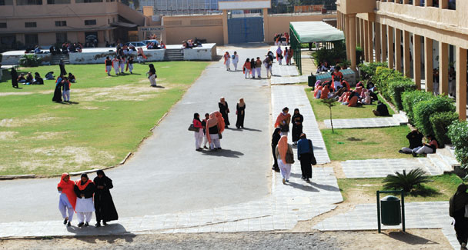
“The surest way to keep people down is to educate the man and neglect the woman. If you educate a man you simply educate an individual, but if you educate a woman you educate a family.”
— Dr J.E. Kwegyir (1875-1027)
Of late, Pakistan’s education system has been under the scrutiny of the comity of nations due to various reasons. The international community is concerned about the lack of quality education, the widespread madressah education and the extensive illiteracy.
The other very important, however, less-talked about fact is that the present education system is not gender sensitive and, by and large, excludes girls and women from mainstream education as well as employment opportunities.
This issue is not peculiar to Islamabad. It is, in fact, a regional issue as female disadvantage is a persistent feature in South Asia and survival itself is highly gendered in these societies. Pakistan lies within a geo-political zone stretching from North Africa to northern India which is known for some of the most severe forms of patriarchy in the world.
Patriarchy has used many accessible tools to differentiate and subdue women in Pakistan; and education is one of their main controlling devices. In recent times, the critical link between the status of women in society, particularly at the literacy level, and a nation’s economic growth, is well-documented. Education is one of the fields where discrimination on the basis of gender has been very stark and pronounced.
Education is universally acknowledged to benefit individuals and promote national development. Achieving gender equality in education means that boys and girls will have equal opportunity to realise their full rights and be able to contribute to, and benefit from economic, social, cultural and political development.
Consequently, gender sensitive social order entails creating opportunities for men and women to understand how patriarchy and gender stereotypes work in families, community and society, the limitations they place on girls and boys, men and women, and the social, economic, political and emotional costs that society must bear.
Coming to Islamabad, it is an open secret that Pakistan lags behind in education and literacy within the South Asian region and gender gaps remain an issue of concern. According to Pakistan Economic Survery 2008-09 statistics, the overall literacy rate is 56 per cent, with 69 per cent for men and 42 per cent for women. The Gender Parity Index (GPI), another measure to determine inequality between sexes, was 0.64 in 2006-07. One of the most important raison d'être for this dismal performance is the widespread and pervasive poverty which hinders the access to education and promotes gender inequality and exclusion.
This view has been endorsed in Unesco’s Education for all -- Global Monitoring Report Reaching the Marginalised-2010. It states: “Poverty exacerbates the gender divide. In Pakistan there is no discernable gender gap for the wealthiest urban households, but only one-third of girls from the poorest households are in school.”
Elaborating the link between poverty and education, former Director of Women Studies Centre and founding editor of Journal for Women Studies/Alam-i-Niswan Dr Tahira Aftab explains: “In order to make some meaningful changes in the lives of millions of disenfranchised women, there is a need to make the education system more equalitarian and accessible, as well as gender sensitive.”
As we have observed, women and girls in the lower stratum of society are exploited on different pretexts. The education system should be geared to meet the requirements of the times and should prepare female students to compete in the job market, adds Dr Aftab.
The other very significant truth in this regard is the prevailing conformist and patriarchal mindset that divides men and women into two separate arenas as women have not been considered as indivduals in their own right. As Harris Khalique, a poet who advises national and international institutions on governance and public policy issues, rightly states: “This is the outcome of the prevalent faulty gender roles in which girls are supposed to be fine homemakers and boys are assumed to acquire excellent education and income generating skills. It is this denial of women as equal beings that has seeped into all facets of life including education.”
Pakistan is a signatory to various international obligations such as Education for all (EFA), Millennium Development Goals (MDG), etc., which are the guiding principles for the international community. The six EFA goals have gender as a theme, which cuts across all the goals especially goal five that envisages to achieve gender parity and gender equality by 2015.
MDG’s third goal is to promote gender equality and empower women and its target was to eliminate gender disparity in primary and secondary education preferably by 2005 and in all levels of education no later than 2015.
However, as United Nation’s Millennium Development Goals Report 2009 states clearly that four years after the target date gender parity has yet to be achieved. When this statement is evaluated in the context of the South Asian country’s performance, the results are not up to scratch since Islamabad fails miserably on both counts.
Elaborating the issue, Arshed H. Bhatti, who is associated with Civil Junction, a social enterprise working for the opening up of a political social environment, has rightly pointed out: “There are four possible areas where women’s access and participation can be increased in the education sector and system: (i) More enrolment in primary and secondary schooling; (ii) recruitment of more female teachers, particularly at the primary schools; (iii) staffing of more females as education managers (at all levels of management from primary to university) and (iv) increasing both access, enrolment and opening more management positions for women in the technical and vocational education and training.”
Till the end of the Mushraf era, the federal government had “talked a lot” but could not take many significant steps. However, there were some donor sponsored programmes where incentives were offered to attract more young girls to schools.
“One that I know of is the Unicef-World Food Programme’s joint initiative where cooking oil was distributed as incentive to the families of young girls attending school for 20 days a month. But it was only in the 10 poorest districts,” adds Bhatti.
The government, civil society, academia and all the stakeholders should work together to determine ways and means to promote and include a gender-sensitive approach in the educational system of Pakistan at the institutional and policy level. The approach would contribute in making our society more just and inclusive, as well as more prosperous and egalitarian. It would help sound the death knell to the pernicious patriarchal system; a structure that is at the root of all injustice and all social distortion.
The prevailing system works against the interests of women, who form the majority of the population, and other marginalised sections. Pakistan’s making some progress on this issue would entail positive implications for the growth of democracy and gender equality.

