Economic survey uncovers pathetic picture of education
By Jamal Shahid | From the Newspaper
(12 hours ago) Today
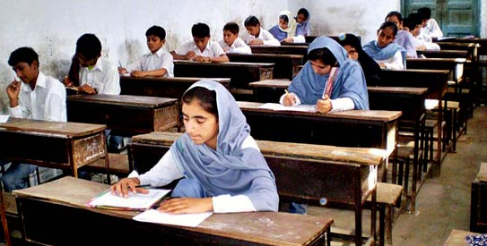
Parents are apprehensive in sending their daughters to school where there is no boundary wall, electricity, water, and toilet facility. - Photo by APP (File Photo)
ISLAMABAD: More than half of all rural children in class five in Pakistan are at least three levels behind their grade in reading English and Urdu texts in schools, according to the Economic Survey of Pakistan 2010-11.
“Overall percentage of rural children in class 5 reading a class 2 text in Urdu/Sindhi was 52 per cent while for the English text it was 42 per cent. This meant that more than half of all rural children in class 5 in Pakistan were at least three grade levels behind,” said one of the survey`s main findings on education.
It said 43 per cent of the government primary schools did not have safe drinking water and 55 per cent were without proper washroom facilities – problems that have tagged along for decades and not adequately addressed. The survey asserted that education was central to the “development strategy of an economy” playing a vital role in human capital formation.
Speaking on condition of anonymity, officials of the Federal Directorate of Education (FDE) were quick to respond to the findings. “How long will we keeping hearing about problems that have existed for decades and not properly addressed,” said a senior FDE official.
Another pointed out how the government had been neglecting the country`s top most priority. “This is exactly why private schools have opened up in every street, charging exorbitant fee for something that cannot be categorised as quality education,” he said, adding that enrollments in Madrassas were increasing because education system was itself a victim of ill-will in the country.
Sketching a dismal picture, the survey explained that the situation of education sector in Pakistan was not encouraging due to poverty and “depressing economic conditions”.
But above all the survey explained how extremely high portion of the education budget was spent on recurrent heads, mainly comprising salaries in contrast to the meager amount spent on quality improvements, such as teacher`s training, curriculum development, supervision, monitoring etc.
Although the survey, like in the past, emphasised it was necessary the proportion of development spending on education must be increased, large number of institutions across the country were still missing basic infrastructure facilities in this day and age.
The quality of existing learning environment was evident from the fact that nearly 16,000 government schools had no buildings, more than 53,000 had no boundary walls, more than 54,000 schools had no provision of clean drinking water, more than 58,000 were missing latrines and children got education in nearly 100,000 schools that had no electricity.
Despite the fact that the Higher Education Commission (HEC) endeavoured in reshaping human capital with better skills and expertise, the government had reduced its development budget to Rs9.2 billion in 2011-11 compared to Rs11.3 billion in 2009-10 from Rs16.4 billion in 2008-09 due to continued financial vulnerabilities, the survey said.
In 2010-11 allocation made under Public Sector Development Programme (PSDP) made for the Ministry of Education`s 86 programmes and projects stood was a little over Rs5 billion. Of which Rs1.7 billion had been released up to January 2011.
However, as under the 18th amendment the ministry had been devolved, no further releases were made.
The ongoing projects and programmes were to be operated by the provincial governmental or relevant ministries in which they have been transferred.
According to the survey, the overall literacy rate (age 10 years and above) was 57.7 per cent (69.5 per cent for male and 45.2 per cent for female) compared to 57.4 per cent (69.3 per cent for male and 44.7 per cent for female) for 2009-10. Literacy remained higher in urban areas (73.2 per cent) than in rural areas (49.2 per cent), and was more prevalent among men (80.2 percent) compared to women (65.5 per cent) in rural areas.

