Educating the nation
By Ismat Riaz
Sunday, 21 Mar, 2010 | 01:03 AM PST |
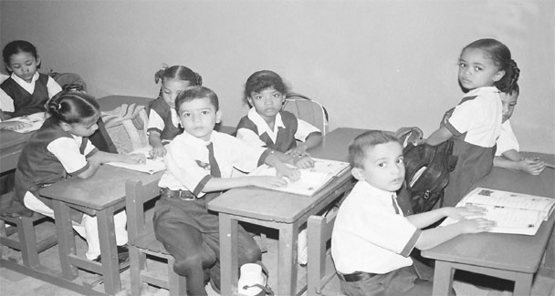
THE cry for educating the nation is not new. It has been an elusive dream for the last 62 years. In 1947, while addressing the nation, the Quaid-i-Azam Mohammad Ali Jinnah had given direction to his new-born state by listing three priorities. He said that the “three main pillars which go to make a nation worthy of possessing a territory and running a government … One is education … Next, no nation and no people can ever do anything very much without making themselves economically powerful in commerce, trade and industry. And, lastly, when you have got the light of knowledge by means of education and when you have made yourselves strong economically and industrially, then you have got to prepare yourselves for your defense …”
The Quaid had clearly advocated mass education of the nation as its first priority. In fact, he was against an elitist concept of schooling which he often criticized while reiterating the need for mass education as the foundation of a “viable social structure in the long run.”
In 1912, Mr Jinnah had given a speech in the Imperial Legislative Council regarding the Elementary Education Bill. He had spoken of the neglect of elementary education by the British Indian government by emphasizing that “in no country has elementary education become universal without compulsion.”
The British Indian government was slow in implementing a drive for universal education which prompted Mr Jinnah to remark boldly: “I say it is the greatest stigma on the government of any country in the world to show that after 150 years of rule, as is the case in this country, you have not given knowledge and light, nay even the three rupees, to more than six or seven per cent of the population in this country.”
Here, Mr Jinnah was referring to the British system which had served its own needs through the English education system of schooling and university education while neglecting the indigenous system of elementary and primary education that had flourished before British rule. Leitner’s Report on Indigenous Education in the Punjab of 1882 confirms this as there were 28,879 villages and nearly as many schools. The report goes on to mention that even in a backward area of India there was one school for every 19.65 males. Female literacy was equally good as they were taught at schools or tutored at home depending upon the economic prosperity of the girls’ families.
The reason for the drop in the education of the masses under colonial rule may be attributed to the modern English education system, which became “a vehicle of administering the Raj more efficiently.” The indigenous institutions such as the madressahs of the Muslims and pathsalas of the Hindus fell out of favour while those that served colonial interests better were encouraged.
A study done in 1998 revealed: “The areas that now constitute Pakistan had in place a very sound and firm tradition of providing education on the basis of self-help by beneficiary communities a little more than a hundred years ago. This system provided universal literacy to males and females … it was the deliberate destruction of the traditional system by the British, which led to the collapse of universal literacy.”
To correct the dismal literacy rate of 10 per cent inherited by Pakistan at its inception, the First Educational Conference was held in 1947. Fazl-ur-Rehman, the Federal Minister for Education, said that the government would adopt the following measures — free and compulsory education should be introduced for a period of five years and technical education should be reorganised to build the country’s future economic life (Ministry of Interior document).
The state had accepted the responsibility of educating the nation by introducing the concept of compulsory and free education within a certain time limit. The educational policies that followed were sound but implementation lacked political will leading to corruption in an area where the future of the country was at stake. Successive governments did not prioritize education of the masses for a better economic base and a secure Pakistan.
The haphazard growth of the private sector in education from 1979 onwards led to a decline in the public sector schools which began to attract only the marginalised sections of society.
Philanthropic people have put up schools for poor children such as The Citizens Foundation, Hira, Read and Dil Foundations while the madressahs provide free board and lodging along with literacy. However, today’s population is touching the 180 million mark in Pakistan. More and more children need to be in schools and the number of school-going population is nearly half of Pakistan’s total population.
Such a formidable task for a failing public school system may be nigh impossible. Nevertheless, the task of educating almost 70 million children can only be taken up by the state. Like most countries in the world, the Pakistani state is legally, morally and politically bound to educate its citizens.
Despite the philanthropic role in educating the poor of the country, the state’s responsibility for education cannot be lessened. Mosharraf Zaidi, an eminent scholar, praises the philanthropic effort for education but cautions that “More than anything else, it is the efforts of philanthropists and social entrepreneurs that deserve our unreserved admiration, and our unflinching moral support.
“However, what they do not deserve and must never get, is the status of somehow representing a solution to Pakistan’s most egregious problems — one of which, most definitely, is educating its young.”
Educating the children of Pakistan is now a matter of survival and the state has to deliver. According to the latest statistics, 40 per cent of Pakistan’s population now lives below the poverty line. Education has to be provided free by the state at least up to the secondary stage of schooling. To encourage enrollment, it must be made compulsory for every child to attend school and the provision of a free lunch during school hours should be mandatory for school administrations.
This time round the people of Pakistan have to be participants in the reform effort keeping up the sub-continental tradition of the community taking up the responsibility of ensuring quality education in the schools within their jurisdiction. Each city, village, town, district and tehsil has to take up the challenge of educating its young for the future of the country.
The state’s role should be to focus on education for the next 10 years and successive governments must not stop or hinder the reform effort. In fact, each government must nurture and expend time and effort to keep the ball rolling. The portfolio of education must be kept clear of political appointments and its working should be in the hands of committed educational experts.
No amount of foreign assistance can make the difference in the education field unless and until the people of Pakistan take ownership of the reform effort. The day they do, the deed will be done.
The writer is an educational consultant based

