Literacy Day: Education not on govt’s priority list
Tuesday, 08 Sep, 2009
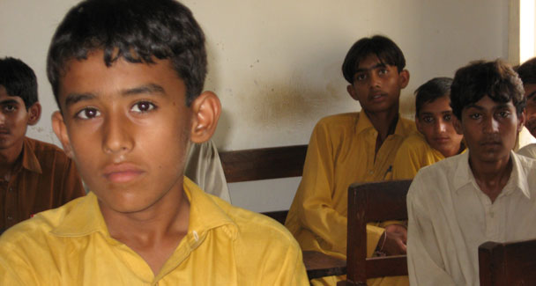
According to Pakistan Social and Living Measurement Survey for 2007-08, the overall literacy rate (age 10 years and above) is 56 per cent (69 per cent for male and 44 per cent for female). Also, the pupil-teacher ratio has increased at primary level but decreased at secondary level during the last five years. -File photo
ISLAMABAD: The International Day of Literacy on Tuesday would hardly make any difference for Pakistan as here education has always been low on government’s priority.
Public expenditure on education as a percentage to GDP is lowest. The trend of investment in education in terms of GDP has been 2.50 per cent and 2.47 per cent in 2006-07 and 2007-08 respectively and it is 2.10 per cent during 2008-09.
This year, International Literacy Day puts the spotlight on the empowering role of literacy and its importance for participation, citizenship and development. ‘Literacy and Empowerment’ is also the theme for the 2009-2010 biennium of the United Nations Literacy Decade (2003-2012).
While the empowering role of literacy and its significance for development have been recognised worldwide, there are still 776 million illiterate adults in the world and 75 million children out of school whose rights and needs remain unfulfilled. Literacy, in fact, is by far the most neglected goal on the Education for All (EFA) agenda.
It is a recognized fact that the implementation of all education reforms and plan of actions for EFA involve huge financial resources which put heavy burden on countries such as Pakistan with its meager and limited resource base. It is evident that Millennium Development Goals (MDGs) and Poverty PRSP targets cannot be achieved if the current level of budgetary allocation as percentage of GDP is maintained.
According to Pakistan Social and Living Measurement (PSLM) Survey for 2007-08, the overall literacy rate (age 10 years and above) is 56 per cent (69 per cent for male and 44 per cent for female). When analyzed provincially, literacy rate in Punjab stood at 59 per cent followed by Sindh, 56 per cent, NWFP 49 per cent and Balochistan at 46 per cent.
Among the major thrust areas of education sector reforms is the quality of education for which various strategies have been evolved and implemented. Almost all teachers have required academic and professional qualifications. Pupil-teacher ratio has increased at primary level but decreased at secondary level during the last five years. Public expenditure on education in real terms has increased threefold, according to ‘Education for All, Mid-Decade Assessment Country report on Pakistan' submitted to Unesco.
The report says in terms of percentages, figures are not higher due to increase in the base of GDP. Public expenditure on education as percentage of GNP has been doubled.
It says the public expenditure per pupil at both primary and secondary level has registered a substantial increase as well. A nation wide Programme has been launched to address the missing facilities in schools such as drinking water, electricity, toilets and boundary walls.
It says national investment in education sector has witnessed threefold increases in absolute terms since 2001-02. With the rapidly widening of GDP base though the increase in terms of GDP contribution appears smaller but the increase in real terms is substantial.

