The real future of Pakistan
Bina Shah
Tuesday, 07 Apr, 2009 | 08:24 AM PST |
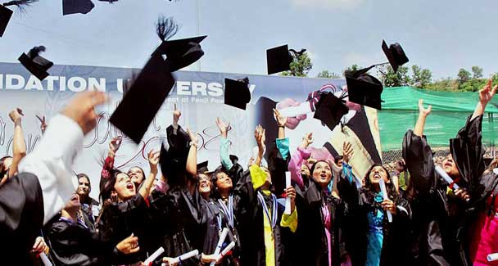
Students at a Pakistani university celebrating their convocation. — APP

Media Gallery
Artisans at work

DAWN FORUM
Swat operation: Is it on the right track?

WRITING is a solitary profession, so most of us writers take up jobs that serve the dual purpose of getting us to maintain our links with the outside world and earning the income that our books can’t earn for us.
Although some writers have lucrative day jobs, many of us end up teaching — what else? — writing, language or literature at universities, passing on our expertise to a younger generation who hasn’t yet figured out that there is very little fame, prestige or money in this artistic discipline. I’ve been doing just that for the last several years at a university in Karachi; this semester I have been teaching 36 social science students the art of ‘Advanced Analytical Writing.’ This basically means learning how to write research papers, but I’ve been clever about sneaking in elements of creative and narrative writing into the curriculum.
Still, their major project was to write a research paper, complete with proper citations and referencing, but I wanted to be creative with the topic, so I assigned them a 15,000-word paper that had to answer the following question: ‘How can the students of Pakistan make a difference to the world around them, and what practical steps must they take to improve Pakistani society?’
The process of learning how to write a research paper is agonising, and teaching it is just as agonising as learning it. We started from the ground up: how to write a thesis statement, a single sentence that encapsulates not just the subject but your attitude towards the subject; this statement must then be proved by a combination of the writer’s arguments and solid research to back his or her assertions.
We learned how to outline a paper: most Pakistani students are never taught this all-important skill of organising a paper, although it’s something that American students learn in middle school or junior high school. We went through the process of writing a first draft, second draft and final draft; I taught them the technical aspects of citation and referencing and warned them against plagiarism. Six weeks later, my students handed in their research papers to me, and I sat down to read and grade them, familiar from our weeks of revision with what they had written, but curious to see how they had crystallised their final thoughts and reflections on paper.
I have to say that what I read impressed me to no end: the students were able to assert strong thesis statements and argue them with sophistication, intelligence and maturity. They shared unique insights and expressed optimism for the future of Pakistan in a way that would put our jaded cynics to shame. They were realistic about the problems that our society faces, but they had fresh ideas, original thinking and an eagerness to work hard in order to make a difference to the country that we, the present responsible generation, are going to leave them. It may be a pitiful inheritance, but these students are no less proud of this country and no less willing to take over its stewardship when the time comes. And they are ready to face their responsibilities in a way that I never expected to see.
Social awareness was at the forefront of their minds: ‘Students should develop their social and political consciousness and understand the role of the university in bringing about broader social change,’ wrote Iqbal Shadab. ‘Only as social and political revolutionaries can the students of Pakistan bring about positive change in their country.’ Iqbal feels that students have a responsibility to be cognisant with the world around them, too. ‘The role of students is to immerse themselves in the study of history, politics, revolutions, the global economy, mass media and philosophy. This…will build the intellectual base that will enable [students] to think critically and analyse the present scenario.’
Getting down to specifics, my students identified three major areas where Pakistani society needs the most improvement on an emergency basis: education, gender equality, and political leadership. Speaking up for female empowerment, Nida Soomro said, ‘Students should devote their time to teach the unprivileged women of our society…[they] should organise awareness programmes, workshops and seminars to make women aware of [important] issues…they should carry out lectures for parents to make them aware of the fact that education is as important to girls as it is to boys.’
Added Saadia Bakhtawar, ‘Students can work in community schools as students, teachers, community mentors…they can establish new shelters for women victims of domestic violence…they can train women [as] journalists and organise community radio stations [to] produce programmes on gender equality and women’s rights.’
At this university, social science students are required to undertake an internship which helps them realise the value of ‘practical knowledge, not just professional degrees,’ as Jehangir Iftikhar wrote in his paper. Batool Safri interned at Aahung and taught underprivileged women about the dangers of unsafe abortions. In her opinion, ‘students must join NGOs and educate women and girls in rural as well as slum areas of urban cities. Students should not only teach them primary and secondary education, but also make them aware of using contraceptives, the consequences of unsafe abortions, HIV/AIDS and discourage early marriages.’
Kiran Waheed worked at the Manzil Education Foundation to help underprivileged children. For her paper, she interviewed the head of Manzil, Shazia Mirza, herself a student who combined an academic life with a commitment to community work. Kiran believes that ‘educating underprivileged students is the only way the students of Pakistan can change the world…students need not go far to teach the underprivileged masses. They can simply start with educating their domestic servants…or give private tutoring sessions at home. Even if students dedicate an hour out of their schedules to educate someone less fortunate than themselves, they will…have a sense of pride and attachment to society and other Pakistanis.’
The words of Hiba Raza, who wrote about patriotism, will remain in my mind long after the grades are given and the papers become part of their academic records. ‘Instead of running away from the system and just abusing those who are ruining it and the country, we have to understand that this is our land….Be a patriot, believe in those three words, ‘unity, faith, and discipline’, and work to improve the nation.’
After reading their papers, I’m convinced that these students and thousands more like them all over the country are the real future of Pakistan. When the time comes for them to take on the responsibilities of stewardship of this great country, I have no doubt that they will amaze you too.
The writer is a Pakistani novelist
binashah@yahoo.com

