Imagination unlimited
By Gulrukh Tausif
Sunday, 22 Nov, 2009 | 02:30 AM PST |
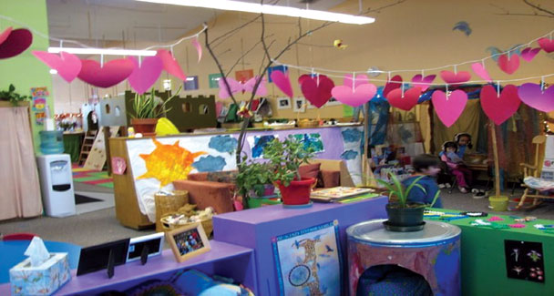
Our children will inherit a world that seems replete with social, economic and political problems. Whether it is about tackling poverty, recession, agronomy, energy crisis or caring about endangered species, melting glaciers, environmental pollution or meeting the demands of a burgeoning population, we need our young generation to be quick thinkers and creative managers. We need them to be able to think out of the box solutions and come up with original and productive answers to many problems that beset our country today.
This is why it is extremely important to foster creativity and originality in our school children so that they can become independent, flexible and resourceful adults of tomorrow.
Rote learning and text book memorising has no place in educating children of the 21st century. Unfortunately, this is still a norm in the majority of schools of Pakistan today.
Every child is born with the potential to be a creative thinker, but along the way this God gifted talent gets suppressed and subjugated. The school syllabus, our method of instruction and examination system leaves no room for curiosity, imagination and inventive thinking. School administrations bemoan lack of funds and teachers lament absence of facilities but the truth is that it is not difficult to nurture or promote creativity in children. If given an outlet, they have it in abundance. All that is needed is a different approach and committed teachers to make it possible.Some easy, simple and low cost ways to enhance creativity in schools and class rooms are as follows:
1. After each lesson, involve children in general discussions by asking abstract questions. For example, what would happen if there were no rivers? Why trees are of different sizes? What if the sun did not come up for one day? What if apples were pink and cucumbers purple? Such questions stimulate free-thinking and flow of imagination.
2. Involve children in the activities which stimulate creativity and fantasy. Tell each child to write the name of an animal or a bird on a piece of paper, fold it and drop it in a box. Then ask them to pick a piece. Tell each child to pretend to be that animal and tell his life story to the other children, starting with “I am a fish” or “I am a parrot.”
3. The same can be done for various professions like plumber, gardener, farmer, cobbler, barber, etc. Encourage children to develop their characters by recognising and appreciating the hard and necessary work people do around them.
4. Occasionally, take the children outside in the courtyard and tell them to make a list of all sights and sounds that they see and hear around them. Tell them to classify their lists under “good” and “bad” and then discuss ways of improving the bad things. For example flowers and sunshine can come under the good things and litter or smoke under bad things.
5. Give children a blank piece of paper and ask them to draw whatever they see outside and what they wish their world to be like. Refrain from criticism but evaluate their work on their ideas and creativity.
6. Have a “What can be done challenge” for slightly older children. Ask the class to list the challenges that face us today like illiteracy, poverty, pollution, lack of tolerance, dowry, etc. Divide the class into five or six groups and make them come up with causes, effects and solutions of such problems. Encourage children to write reports and essays and have them published in newspapers.
7. String-along-a-story is also a fun way of enhancing creativity. Take six to eight words consisting of a main character, a colour, an animal, a place, a building, a bad character and a situation (lost in jungle, going shopping, driving in car …). Ask children to develop a story using these guidelines and give it a happy or sad ending. Encourage them to describe the character, location and the villain and let them have fun with words.
8. Alternatively, give them an opening line and tell them to construct a story from that situation. For example, “On a dark, stormy night, I saw a strange light …” or “Ali was walking down the street when …” You can also tell the children to look out of the window, one by one, for three minutes each and tell the whole class what they can see. This encourages the child to put his observations into words.
9. For each month, choose a theme and ask children to collect, write or craft things according to that theme. For example, December can be about Quaid-i-Azam or the winter season. Tell children to write poems, essays, short stories, draw pictures, make crafts, collect newspaper cuttings, etc., related to these themes. Each child can make a different contribution according to his/her talent. At the end of a month, have a class exhibition and share all gathered information with the rest of the school. Such activities allow each child to bring out his best and take pride in his creative talents. Some children are good writers, others draw well and some are good artisans and each unique gift should be encouraged and praised.
10. Books other than text books are essential for school-going children. If funds are a problem, the school administration should request newspapers to donate children’s magazines to school. Otherwise, each class must have its own mini library where the children can read and discuss books.
Creative classrooms are fun for teachers and students alike. Having a stimulating curriculum with exciting class activities keeps the students alert and interested. Charts and bulletin boards on school walls are an excellent way to provide children with an impetus to participate and excel in their creative talents. A little encouragement, some praise and an opportunity to indulge in their favorite hobbies goes a long way in enhancing creativity in children.

