Kings and queens at school
By Zaffar Junejo
Sunday, 11 Oct, 2009 | 12:58 AM PST |
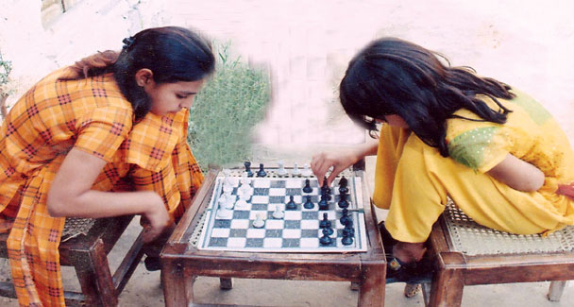
“Move the pawn!” said a bystander. “No suggestions, please!” exclaimed the teachers. The game had entered a critical phase. There was pin drop silence. The much-involved crowd gathered around and was keen to find out who would win and who would lose. And then they heard what they had been waiting to hear all along — “Check!” The game was over. The students and mothers cheered and the school atmosphere became charged with the applause that followed. Chess is a regular feature at the Khadija Khanum Daudpota School (KKDS), located in a tiny village in the north of Sindh. The school is a project of Transformation & Reflection for Rural Development (TRD).
Scenes like the one described above have been a normal occurrence at the school for the last four years. Chess is a component of the school’s curriculum. Ms Rozina, one of the teachers at the school says: “The idea to use chess as an educational tool dates back to 2005 when Director Academics, Air University, Islamabad, Dr Isa Daudpota suggested starting chess here. The teachers, though reluctant to initiate the project at first, began it somehow with Rs5,000, which they used for buying some chess sets as well as for hiring a chess trainer Mr Zulifqar Shah.”
Ms Munwar and Ms Salma, participants of the first trained groups, recall: “We were reluctant to learn the game at first as we had heard somewhere that chess was a violent game where you killed pawns, horses, bishops and kings and queens. But that was a silly notion. It is a strategic game, coaxing one to think.”
The school management, after the passage of a year, noticed that the exam results of chess-playing children were far better when compared to those of non-chess playing students. On the other hand, they also noticed a positive change in the personalities of chess-playing teachers. “The game was generating many positive changes,” Ms Samina, the school’s headmistress recalls.
The same year, Mr Lyen Curtus, Director International Programme, Pro-Literacy www.proliteracy.org was requested to prepare a brief analytical report by comparing the chess players with another group. Mr Lyens’s report revealed: “The chess players were reflective, able to think on parallel lines, visualise upcoming situations, float options and behave responsibly.”
By 2008, chess flourished. Just about everyone in the village was taken in by it. One day Shahzad, a student of class six, asked his teacher how she thought the game helped them in their studies. “Although we did have some clues to the query but we still couldn’t come up with an authentic answer. We didn’t know what to say,” says the headmistress.
Finally it was resolved that the school should go for an independent evaluation focusing on how chess supported education. Director, Teachers’ Development Centre, Karachi, Mr Abbas Hussain, was engaged to accomplish the task. He carried out his assessment with the help of Howard Gardner’s model of multiple intelligences. His report concluded: “KKDS children have performed better and with more intelligence on the tasks than the government school children. The school deserves our applause and commendation, and indeed support at all levels.”
Chess in a school in rural Sindh reminds me of the success of Venezuela’s Learning to Think Project through which they trained some 100,000 teachers. The projects’ lifespan was four years. But it produced encouraging results. For instance, studies show that chess accommodates modality strengths, creates a thinking system, gives students difPhoto by Arsalan
ferent alternatives, fosters interest and promotes mental alertness.
The game nowadays is taught as a subject in 30 countries including India. The pilot project of Ahmedabad district, Gujarat, has achieved promised results. The project introduced chess as a subject for eighth and ninth standard students in over 1,500 schools of the state government last year.
The value-added aspect of KKDS’s initiative is that it has creatively mingled learning with chess. Meeting the school’s chess players — teachers, students and mothers, too — was an interesting experience. When asked to prepare a list stating in what areas chess complemented them, the subjects after some discussion concluded that it helped increase their spatial awareness, numerical abilities, verbal aptitude, learning, problem-solving skills, reading levels, concentration, self-discipline, and socialisation skills. During our discussion, some students while waving their latest Photo by writer
Photo by writer
result cards said that they secured 90-plus marks in mathematics along with getting ‘A’ in most other subjects as well and it was all thanks to being good at chess.
The chess experience of Khadija Khanum Daudpota School is a cost-effective and innovative idea that can be compared to India’s Hole in the Wall Project, which has opened new vistas for slum children in the area of computer literacy. Something like it can also be considered for the poor children of Pakistan in order to help them in the area of mathematics and logic.

