Learning the Japanese way
By Noor Jehan Mecklai
Sunday, 13 Jun, 2010 | 02:58 AM PST |
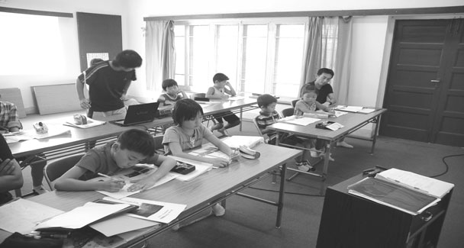
Before the advent of the aging population, “three score years and ten” was the phrase traditionally used to describe the average human lifespan, “a score” denoting the number 20. And the Karachi Japanese School, having clocked up over 40 years of existence is well on the way to completing its first 70 years.
However, comparatively few people are aware of its existence, known to the Japanese community as KJS, and sitting amongst the bungalows of PECHS. Whenever there is a sufficient number of Japanese companies and other organisations, including of course a consulate-general, an embassy and so on in a foreign country, and therefore a sufficient number of school-age children, the Government of Japan is obliged to provide a school to educate them from shogaku ichinensei (grade one of primary school), to chugaku sannensei (grade three of junior high school), since these are the years of compulsory education in Japan, where children usually begin school at age six and have to study till they are 15.
When youngsters have finished their compulsory education, the government is no longer obliged to provide schooling, and therefore if a child is still abroad due to the father’s posting at that stage, though some may elect to attend an international school or some such institution locally, it is usual for mother and child to return to Japan for the entrance examinations to senior high school. This may be either a private or a government school. There is intense competition for places in the best of either category, though naturally the fees for even the most excellent of the public high schools are considerably lower than those for private ones.
People sometimes ask me if I, as a teacher at KJS, can help them to gain admission for their children, but I have to explain at such times that adequate knowledge of the Japanese language is the most mecessary prerequisite, since the curriculum is the same as that of schools in Japan, and the medium of instruction is Japanese.
With the frequency of intermarriage these days, it is not uncommon to see one or two half-Japanese children adorning the ranks of our very cute students. However these children too, even if not actually born in Japan, must be fluent in the language and familiar with the culture of that country. Now and then, children of completely non-Japanese parentage and nationality have been admitted to the school, since due to the demands of the father’s employment or some such circumstance they have lived for some time in Japan, have been to school there, and understand the language, culture and syllabus.
Well, apart from “The Three Rs” (i.e. reading, writing and ’rithmetic) and other formal stuff, what occupies the cute and loveable students of KJS? — Cute and loveable? —Yes, really, and in fact as the Karachi Japanese School is not what you’d call enormous, there is ample opportunity for the teachers to give individual attention and love to these young people, and to develop a tender concern for their special needs, almost as if they were extra parents.
One of the most obvious ways in which individual attention can be seen in the assistance given towards preparation for the annual research presentation, in which all students, from tiny ichinensei upwards participate in the second term. The object of this exercise is to develop the ability to think of questions related to the chosen topic, then to think of possible answers, and ultimately to discover how near to the truth the original suppositions were. Thus the children start to develop problem solving and research ability, and the techniques of approaching people people in various walks of life for their cooperation. The teachers guide them in ways of doing their research, and in offering their presentations.
So last year the cutest little boy I’ve ever seen presented his findings on autorickshaws, and to this end a rickshaw driver was invited to the school, where he showed the boy all the parts, described the manner of assembly, and showed how this three-wheeled vehicle is driven. So while not actually possessing a driver’s licence, and whizzing round the neighbourhood in fine style, this little lad is now an expert on rickshaws, and can tell at a glance which ones use petrol and which use CNG.
A musically-inclined senior girl once delighted us with her presentation on the harmonium, which plays an important role in the music of the Indian subcontinent, showing us with the aid of slides, electronic pointer, dissertation and demonstration, how this instrument is made and how it is played. And the following year this very shy girl gave a presentation on the sitar, after a series of lessons and information sessions given by a local sitar nawaz at school.
But how do these non-Urdu-speaking children manage to gather information? Having decided to find out about the shalwar kameez a couple of years ago, one of the boys took a note written in Urdu with him, when he went in the company of a teacher to see how they are made, what cloth is suitable and so on. Or if these local people do not speak English, then either the schoolbus driver or the secretary, who is also Pakistani, will go along to interpret. Besides talking to a tailor, the student buttonholed passers-by to ask about details of style in the gents’ shalwar kameez.
On another occasion a boy went to the market with a placard hung around his neck, with a few questions for the public on it like, “What are your two favourite dishes?” Arising out of this and other sorties, he gave a mouth-watering presentation on biryani, a firm favourite among Pakistanis. Not that he actually handed out plates of the stuff to the assembled parents and dignitaries on the great day, but during the course of his project he would now and then bring back to school free samples to be shared out at lunch time.
It is marvellous to see how well these children have been trained in the art of presentation, and in the use of modern technology in the form of presentation aides. Furthermore, a by-product of all this is the understanding that our dreams can be realised if we pursue the right course, and that people are willing to help us do so, particularly if we approach them with a smile and with confidence.
Another important annual project involves mangrove plantation, in which the students learn the importance of mangroves to the ecology in a half-day exercise under the auspices of WWF. After this comes the beach cleaning trip to that part of the French Beach where turtles come annually to lay their eggs.
The cleaning is done about seven to 10 days before the turtles arrive, the reward being the chance to watch these creatures in the careful perpetuation of their species. The children are thus taught a little more about reverence and compassion for the creatures of the wild, another aspect of the broad and thorough education given by Karachi Japanese School.
As a footnote, let me say how thoroughly heartwarming it was to see the whole teaching staff assembled in the school entrance hall, to welcome the students individually with a hearty, “Ohayo gozaimasu!” (Good morning!), and an effectionate smile as they alighted from the schoolbus on the morning of June 7th, having sailed through the sodden city, and up the river rendered by the rains in the road that runs past the school gate, the day after Cyclone Phet had threatened Karachi. Good old KJS!

