Need for an inclusive approach
By Zaheer Ahmad Minhas
Sunday, 29 Aug, 2010 | 01:44 AM PST |
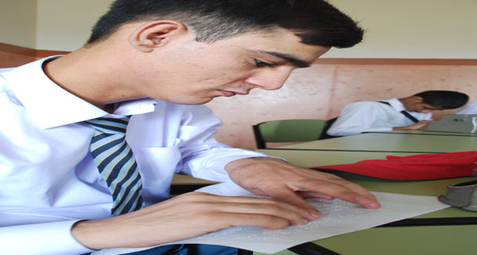
The main purpose of education, as we all know, is to expose and nurture the potential and talent of an individual to the highest possible level. Positive permanent change in human behaviour is also known as education. A guiding light, it creates concord, harmony and awareness among individuals of society.
Education should be moulded in such a manner that it should play all these key roles in the society. Since education works on a broad spectrum, special education is a vital aspect catering to the social and educational needs of special children.
Children with disabilities may have been neglected and marginalised in the past, creating a huge communication gap between special and normal children not to mention the inferiority complex and adjustment problems accompanied with this. But that is no longer the case. There are different kinds of special education institutions working with the aim of delivering proper education to children with a variety of special needs. Flourishing mostly at the primary and secondary level, the schools or centres led to raising different problems and issues pertaining to special education at higher secondary and upper levels.
The concept of “Inclusive Education” specifically came up to address such issues. Based on the right of all learners to quality education that meets basic learning needs to enrich lives, this is a way of teaching where special and normal children are taught together in the same classroom. The focal rationale of this kind of teaching is to enable special children to adjust and play their active role in society.
In order for this to happen, teachers, schools and systems may need to change so that they can better accommodate the diversity of needs that pupils have and that they are included in all aspects of school life. It also means identifying all those barriers within and around the school that hinder learning and participation, and reducing or removing those barriers.
Inclusive education is a process of enabling all students, including previously excluded groups, to learn and participate effectively within mainstream school systems. It is about bringing a change to normal schools for the improvement of the entire educational system. This means changes in the curriculum, changes in how teachers teach and how students learn, as well as changes in how students with and without special needs interact with and relate to one other.
Inclusive education practices reflect the changing culture of contemporary schools with an emphasis on dynamic learning, reliable assessment practices, applied curriculum, multilevel instructional approaches and increased attention to diverse student needs and individualisation.
The focus is on schools, centres of learning and education systems to change so that they become caring, nurturing, and supportive educational communities where the needs of all students and teachers are truly met.
Now let us have a look at the inclusive education practice in Pakistan. Though the very concept emerged in Pakistan at the start of the 21st century, there are a few private schools along with all the madressahs here that have unknowingly been practicing it for a long time. On the other hand, despite having much know-how of it along with numerous resources at hand on the government’s part, its practice in the government-sector schools is really being taken up.
There has been a lot of research carried out regarding its essence, application and the outcome along with the teachers’, parents’ and students’ perceived success of inclusion. And the results of all those studies have remained doubly encouraging as almost all the studies conclude that inclusive education is remarkably triumphant and effective in the whole world and it would certainly prove so here as well. But although policies have already been formulated at the government level, their application still remains a question mark.
There is a looming fear that the teaching and non-teaching staff of special education departments at the federal and provincial level would become unemployed if we take to inclusive education. It happens to be the main reason creating impediment in its application. Sadly the enforcers consider the staff problems worse in comparison to the problems faced by special children when going for higher education.
It is high time the concerned authorities take the initiative to implement inclusive education in government educational institutions. The special education department should be dissolved and the services of its staff should be brought forward to the mainstream education system. Since teachers of the special education department are paid double than the salary of an ordinary teacher the endeavor can also save a whole lot of revenue, which can be spent on improving the infrastructure, quality and standard of our mainstream educational institutions.
The writer is lecturer at Government Degree College,Sohawa, Jhelum.

