Our educational showrooms
By Urooj Sadiq
Sunday, 04 Oct, 2009 | 01:53 AM PST |
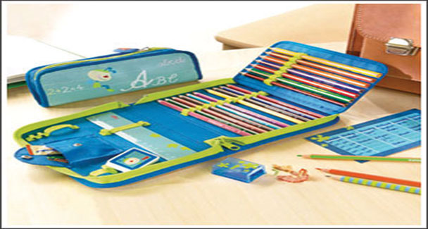
With the marrkets flooded with all kinds of expensive and showy goods these days, our children are driven more towards the material display of their stationery and personal belongings rather than acquiring and quenching the thirst for knowledge.
This innocent psychological warfare raging within our classrooms has cast a deep effect on the personality of children especially of toddlers and adolescents. Thus creating a strange array of competition, which involves not just basic stationery items, but electronic gadgets as well.
Step into the world of the little angels and you’ll discover a heaven on earth. Dwell deeper and you’ll realise to your absolute shock and horror that these innocent souls are victims of show off and fashion — in terms of stationery. Pencils, pens, glitter pens, glue, felt-tipped pens, tempo markers, pencil boxes, bags, lunch boxes, water bottles, fancy pencils, highlighters and God knows what else these delightful little creatures indulge themselves in and invest their parents’ money into.
Both vanish with time as these fanciful little objects breakdown, too, and their tastes change from time to time. But it affects their parents and those children who cannot afford such fanciful, alluring objects, but are forced to admire them for vantage properties.
Stationery is typically classified as office equipment. The word originates from the Latin “stationarius” defined as “a place where something is located”, which circulated during the 13th and 15th century in the manuscript culture. Wikipedia describes the term “stationery” as referred to all products sold by a stationer, whose name indicates that his bookshop was on a fixed spot, usually near a university, while medieval trading was mainly ambulant, by peddlers (including chapmen, who sold books) and others (such as farmers and craftsmen) at non-permanent markets such as fairs.
Stationery was of utmost importance during the Victorian Era as ladies tended to give manuscript items a place among finery and beauty with emphasis on etiquettes. Variety of paper including those with embossed designs, etc., were very famous among the aristocrats, as they were inspired by the French whose love for the finest was impeccable.
With the passage of time the word stationery was diversified into things used in the office. Binders, separators, post-it tags, etc., became a common usage and the world got used to new and flamboyant articles being displayed on their office tables.
Stationery holders were next, arriving in plastic and then in a combination with wood. Rulers were equipped with calculators and multiplication tables were pasted for reference behind them. Soon calculators were called scientific and we stopped using our brain.
Visit Saddar today and you’ll see a new array of stationery items flooding our marketplaces and bookstalls. They come in various shapes and sizes not to mention a multitude of colours, hence they are a favourite among children and the best part is that they are extremely cheap. Talk about killing two birds with a single stone.
From clutch pencils to refill pens, erasers shaped to look like whistles and hippos and even dolphins. One child came up to my sister and said: “A boy has got a bomb with him”! Scared to death, my sister had a look at it and realised to her utter shock it was a pencil shaped like a dynamite.
Flat pens, pens with bubbles, bells, fluffy feathers, etc., have become a common interest for the students of today.
Once bags open up you find pencil boxes in all shapes and sizes. With characters ranging from Disney’s fairy tale princesses, Shrek, Garfield and Scooby Doo to Bratz, Power Puff Girls, Tom and Jerry, Ninja Turtles, Harry, Ron and Hermione and goodness knows what else is in these huge sacks shaped like briefcases, camp bags and even a trolley on wheels.
And the list does not end here. You’ve got wax crayons and water colours that come in bottles and tubes and painting markers that blend in with water. There is an entire shop once you are in a class, especially a kindergarten section. At the secondary level you have electronic dictionaries that come in all shapes and sizes, with or without pronunciation and ranging in price from Rs2,500 to 4,000.
Scientific calculators enter the portal from class VI onwards and students use them frequently, even if told not to. PSP III and Game Boy are compared after the school gets over so that there is no danger of being caught and the “little thingy” being confiscated.
Since the gentry in our schools is mixed (due to provision of scholarships in different high standard schools as well) and due to the fact that a minority of parents believe that such display of wealth is a waste of time and money, many students that hail from middleclass families tend to develop an inferiority complex, which leads to stubborn behaviour in kids with ages six and up along with tendencies to emotionally blackmail their parents by crying and screaming. Such disorders if, once developed may remain with the children throughout their adolescence years thus strengthening their roots within the child’s psyche and continuing throughout the rest of their lives.
Also children, whose excessive demands are always met, be it day or night become vicious, careless and carefree in nature with no compassion for human feelings and no stop to their desires. Thus small steps lead to bigger untamed issues that create a strange workforce striving hard for luxuries and the latest gadgets instead of education and finesse in life.
The responsibility of schools and parents comes foremost at this stage. All such items that are fancy and tempting as well as delicate to handle must not be permitted. Moreover if any student brings along with him to school any such item, the administration has the right to confiscate it. School rules and policies must be strict about this issue or else such autonomous display of wealth and ignorance will continue to dwell and create an unbalanced situation in our classrooms, where children will strive for material holding rather than concentrate on their studies.
It is not surprising to note that nations seeking advancement in science and technology including our neighbour India have a box full of pencils, which the children use in class and there the price of stationery is within the easy range of every child. Such matters need to be looked into before this culture tends to increase and take our educational institutes by force.
Even now the wave is at its peak and needs to be handled with care. I wonder what the parents will say about this. Of course I expect the majority to shout that my article is a violation of basic children’s rights and if they can afford such things for their children, they must provide them with their wants not needs. I forgot that they too were kids once, kids with parents who displayed flamboyant natures. Chip of the old block, eh — this muddle’s too deep and dangerous to step into.

