Motivating teachers
Dawn Editorial
Saturday, 07 Nov, 2009
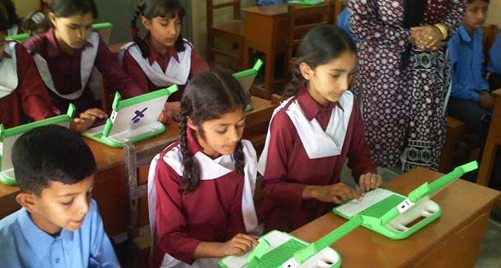
Teachers should have the capacity to motivate students to think rationally and seek knowledge as a life-long pursuit.
One of the most essential elements in education that determines quality is the competence and commitment of the teachers who convey knowledge and values to their students. It would not be wrong to say that the teaching sector forms the weakest link in the educational chain in Pakistan.
As academic standards declined over the years, it was inevitable that teachers who were products of this decaying system would be the ones affected most adversely. Not only did this malaise impact on their pedagogic skills and knowledge, it also robbed them of their motivation. Hence it is a positive sign that education authorities in various provinces are attempting to address this problem. While the National Education Policy focuses on in-service training of teachers to improve their standards, others are offering monetary incentives in a bid to motivate teachers to do their best.
It is in this context that the Punjab government deserves to be commended for recognising the key role of teachers and taking the initiative to institute awards of Rs50,000 each for 1,000 teachers/head teachers for their performance. Although the criteria have been defined and seem fair enough on paper, much will depend on how they are applied in practice. Given the corruption in our society, one hopes that this will not become another avenue for bestowing favours on the protégés of those who wield power at different levels.
There is, however, one quality which cannot be quantified but is more important than the yardsticks spelt out for the award. It is a teacher’s ability to motivate his or her students. The best teachers are those who are able to mould students into knowledgeable, caring human beings that can become an asset for society and the state. They should also have the capacity to motivate students to think rationally and seek knowledge as a life-long pursuit.
One hopes that the Punjab government as well as other provincial administrations will devise ways and means of mobilising their teaching cadres with incentives other than monetary gain so that they can pass on their motivation to their students.

