To Teacher with love ...
By Nyla Daud
Sunday, 18 Oct, 2009 | 01:18 AM PST |
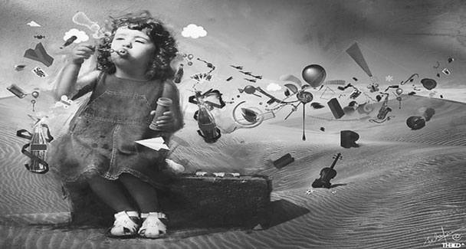
Many moons ago, when a little eight-year-old girl was packed off to boarding school in Murree, the single most pressing issue on her mind at the time was language. Belonging to a “do as you are told” generation, she had felt no compulsion whatsoever in finding out the details of what it was going to be like in a crowd where verbal and textual communication was to be strictly in English, whereas her world so far had been dominated by Urdu.
Making do with the smatterings of English passed down through an elder sister, the girl managed to get by in her new surroundings. She made friends, too, and gradually became an active participant in the lessons and games. And before she knew it, she too was pulled into the whispered conversations after lights out, sharing the carefully-hoarded tuck behind the matron’s back, of simply turning the bath tub over to produce a gushing sound in order to give the impression of having taken a bath when the cold weather dictated truancy and of reading Rupert comics in torchlight under the bedclothes. But there still existed a snag … the English composition class.
Then something wonderful happened at school. The kind old British lady, after giving the class an exercise to do, called out her name. Very self consciously, the child walked up to the teacher who appeared to have hailed from another planet in comparison to the child’s own world at home.
It would be the same everyday. Day in and day out, she would be confronted by closed doors behind which lay a universe populated by persons from a different universe. And now, standing beside the teacher’s desk, not really sure how she was to communicate with her, she got her first surprise. The teacher brought out a coloured print and the 15 minutes that followed were spent in their discussing the different aspects of the colourful picture.
Following the teacher’s actions, the little girl, too, closed her eyes while trying to describe the feelings evoked by the print. It was not easy to frame the sentences, most of which were grammatical tragedies, but somehow the teacher appeared not to take notice as she listened to what the girl had to say with interest.
Back on her seat later, the child went into a reverie while playing again in her mind what she had heard from the teacher and connecting it to that print. Picking up her pencil then she began to write. There were of course mistakes in her composition that day but some weight seemed to have lifted from her little heart as she managed to write more than half a page of sentences.
It has been years since Miss Ivy Preston left for her eternal abode but she lives on even today … in every newspaper or magazine column that I write for, in every interview or book review I do, in every feature I develop … my teacher lives on.
Each time I begin work on an assignment, I travel back in time, inhaling the musty air of the Murree classroom where standing on unsure, trembling legs, I got to open for myself a magical world. Urged on by the gentle, but purposeful perseverance of a teacher, my imagination … the inherent companion to every child’s person … had been called into play. As the term progressed all of us in class moved on, putting our imaginations to use, making up stories for the composition class, learning the rules of grammar by creating faces for the nouns and verbs and adjectives, memorizing the correct spellings by drawing mental pictures of words. By the time the school notice board carried a notification about an end of year story writing competition, I had acquired the confidence to go for it.
The result brought with it a tiny diary as a prize for what I now think of as an imaginary collective of people, actions and the weirdest of plots! But the more prized result was being called into Miss Preston’s study that evening and being handed an autograph book with her signature on it. That autograph book has now become a legacy of sorts for today so many years later my own grandchildren love to hear about the teacher who taught their grandmother how to weave stories.
I come from a generation of women for whom even an elitist education does not necessarily lead to a career. But those early lessons in bringing the imagination to play laid the basis of my career as a freelance journalist. Today as I fight the valiant battles of looming deadlines, my strength lies in shutting tight my eyes to draw a mental picture just the way Miss Preston had taught me to and then the words start pouring out, giving shape and sense to whatever it is that I have to say.
As I pen this tribute, my heart carries a heavy burden for I had seen in yesterday’s paper a news item about a teacher in Sialkot, who while punishing his elementary school pupil, twisted the boy’s hand so mercilessly that he broke his bone. However, we find solace in knowing about the recently-launched teacher’s training courses by the Punjab government’s Directorate of Staff Development where they have given priority to mentoring teachers and educating them about their role as the builders of the nation’s future.
Let us hope that in the coming times our schools will produce people who will narrate stories of teachers who made their lives.

