The deciding factor
By Rabia Rahim
Sunday, 08 Aug, 2010 | 01:28 AM PST |
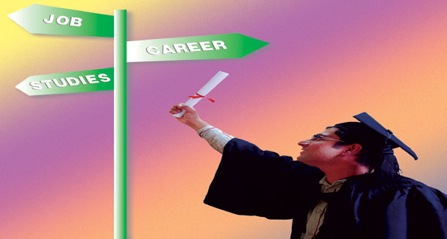
Salman Rajan, a student of Political Science at a public-sector university in Karachi, decided to leave his university and switch over to LLB right in the middle of his undergraduate studies. His reasons: “My expectations fell with the realisation that there was no proper grading system at the university ... only the sycophants were being promoted.
“Also I feel Political Science has no worth left due to the exploitation of merit. Students with 50 per cent marks, who fail to get admissions elsewhere, easily got in at my university. Leave alone a student society, there was neither a journalistic nor a scientific society for the students. Is that how you treat a discipline held in high esteem at universities such as Harvard and Oxford?”
University education is the most important phase of any student’s life. In all dimensions, one’s personal growth is directed towards achieving their aspirations at the university level. But keeping in view the case of Rajan, the uncertain shifts show the insecurities of students soon to enter professional life.
Here is a bit of effort to compile students’ issues, which may affect their decision-making process.
Toheed Pasha, a student at a private arts institute spoke his heart out: “I find no freedom of expression and in that matter no creativity of course. The teachers and institute have their own restrictions. There is nothing common in our domains of understanding. The problem with art students is that in a majority of the cases the parents do not have any idea of their children’s skills and the teachers cannot judge whether a student would prove to become a good sculptor or painter in the long run.”
Toheed explained his being a student of graphics, making him a part of designs: “I have my mental maps but the teachers have not transferred to us a sense of producing those designs. We have absurd scenarios where a design student is asked to formulate a board game rather than design it. It is sad to see fourth-year students doing it.”
He added: “The issue with art schools is that they do not have right teachers. I believe art cannot be taught, it is implemented. The teachers, too, have deteriorated it by seeing it just as a profession.
“Another important aspect I want to point towards is that the design students are given social issues to work with for their thesis. But why? How do they see the involvement of design in it? How are we going to know the designing of products and strategies to make them sellable?
“Above all the other miseries, our institute is not converting the four-year diploma into a degree. Neither does it make placements for internships, nor does it have any other means to promote its students’ work. How are we going to be valued in the market?” He concluded.
Moving on, the very first statement from a medical student of a prestigious public-sector medical college came out as: “There is no studying at the college!”
She elaborated: “I do not like attending the lectures, they are useless. When I know I have to do the actual learning myself, it just makes everything hectic.”
She added: “We start our hospital rotations in third year. What we learn there does not correlate with the academics at college. We do not get anyone to explain us things. Naturally our grades fall. Medicine is not a well-paid profession in our country anymore. The majority of students are after US MLE or PLAB but this option cannot make space for our entire batch of 300 students.
“I would say that the personal initiative of students is important. There are many who cannot detect the basic symptoms of jaundice or anemia. Students should also take the initiative to run after the doctors to learn more.”
She added: “There is no immediate plan for medical students. Everything is part of a long process, which lessens the security in this profession. Other professions have much more to offer. Students become tired at a point with passing exams, the only motive left with them.
“Still I would say that if there is something positive going on at college, it is the motivation from the very good students. That keeps you moving on.”
It is important to note the not so different perspective of external mindsets in our system. Aisha Ahmed is one such overseas student at a renowned private business school in Karachi. According to her: “The unfriendliness of the non-facilitated system starts just after landing at the airport. There is no transparency at any level, not even for a single query. There is no person accountable and procedures are carried out randomly.”
Aisha shared: “I approached my brother’s university for his degree with an authority letter in hand, but the administration personnel there kept denying him the degree. It was a case of emergency for my brother, who was not in the city and the conflict could not be resolved until the involvement of the vice chancellor. Later, the same personnel pulled out the degree from a drawer right next to him. In our structure, the biggest fear is of approaching the right person.”
She continues: “Students here are a lot courageous but there is no facilitation structure for them. The problems of transportation and documentation though a usual part of their life also create havoc.
“Political affiliations in education and the job sector have deteriorated merit and in such a scenario of non-competency the morale of students, too, falls drastically.
“This in turn results in non-productivity. I am specialising in Human Resources and there is a big deal of scope there but no substantial work being done really.”
And finally a student of Social Sciences from a public university in Karachi coins her concerns: “The most unfortunate aspect is the tagging and branding packaged with a public university. No matter how bright and competitive a student, he or she will be taken under the tag of public university in comparison with a private university student despite being less competent.
“Students here hardly have any opportunities. Why are subjects such as Anthropology, World Religions or Astronomy not being offered in an approachable way? I do not find the options open to me according to my will. In a population of 20 million, initiating a single department in a far-sighted corner or offering a minor course is not really an opportunity for the masses.
“For matters internal to the university, the dearth of counseling on choice of subjects and numerous other problems has left the students with a jigsaw puzzle to solve. There is no outlet to complain about administrative issues, course problems or issues with teachers. Not every student can reach the media in order to raise his or her voice. Though the departments have student advisors, how many students actually approach them and get their issues resolved.
“The atmosphere of learning lacks the freedom to register our opinions. There is a dire need for teachers’ evaluation at the university level, which can definitely remove a majority of ills from the system. Politics among teachers and bias among students is all based on personal beliefs, sects or ethnicities. They simply take away the right of investigation from a student, which happens to be the very first principle of learning. Studying at university becomes meaningless then.”
The suppressed culture of education is deviating worthy students from their inclinations. The incapacities of the education sector need to be addressed with a farsighted approach.

