The international connection
By Nyla Daud
Sunday, 03 Jan, 2010
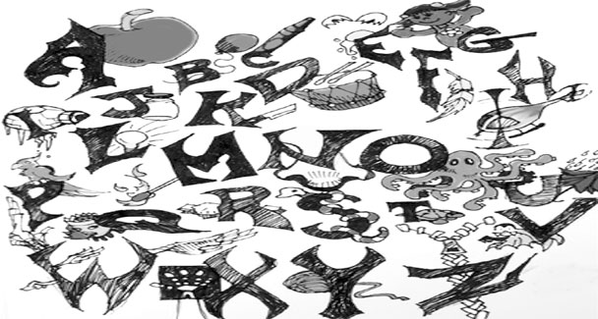
Perhaps ironical but it is a hard-core fact that instead of bridging the socio-psychological gaps between the various segments of society, education in this country has emerged as the greatest defining factor in class segmentation.
The upper elite schooled at English-medium schools and the children of a lesser god, who go through the state-run schools with Urdu as a medium of instruction, represent two major social divisions. The paradox smacks of an even greater incongruity when, although the mother tongue — in our case Urdu — is universally acknowledged to be the best medium for conceptual understanding and consequent success, it becomes a handicap for native speakers and writers at the point of entry into any profession or career.
The loss becomes greater at the global level. Thus education, which should be seen as a critical factor for reducing poverty and long-term income inequalities, has worked the other way round for us.
One does not have to be a space scientist to realise that English continues to monopolise the entry points in almost all professional institutions, and in the army and selective civil services. The same goes for multinational corporates, private sector employment and prestigious foreign scholarships. It is small wonder then that the Punjab government, starting from the April 2010 academic session of its schools, has decided to switch to English as a medium of instruction right from class one. In the Sargodha district alone, 50 government schools have been renamed as the Excellence Schools with the express purpose of making a success of the decision. Previously, it was only a select public sector schools that were routinely switching over to English as a medium of instruction from class six onwards.
While government edicts have their own way — in this case an ambition of raising education standards and bringing them at par with global demands so that our children can connect with the world — the question remains whether a change in the medium of instruction will produce the desired result given that so far school education at the public sector institutions has been hardly anything to write home about.
There are detractors who, quoting from contrary Chinese, German and French experiences, believe that abandoning the mother tongue will lead to nowhere. At parallel is the current theory about the needs of globalisation where English appears to be the standardised medium of communication at all levels from the academic to the professional or to the achievement of any progressive goal.
Indeed James Tooley in his recent book on how the world’s poorest people educate themselves makes sufficient cause for English medium schools. The Beautiful Tree, a painstakingly researched book on the subject of educating the impoverished in third world countries, categorically states that any parent in whatsoever position, feels the need for an education for his or her child that will enable his offspring to move above the parents’ circumstances. Also that most such parents feel that learning to write and speak English fluently is one way to this end. English connects people to the world, is the mantra, and for good reason, too.
It is in the same vein that public sector educators and managers endorse the government’s decision. There are teachers like Kausar Perveen Tarar of the MC Girls High School, Sargodha, who, in spite of all the odds — students with no English language support at home and little state of the art teacher ability to teach in a foreign language — genuinely believes that the move is for the better. “I can recount numerous cases in my teaching experience of 35 five years where the parents have moved their wards to smalltime private schools just because they offered English as a medium of instruction. Of course some parents are wary of what the change portends but we have now actively launched campaigns to convince them that the change can be managed and that it will be taken in their stride by the children. We are telling them that as teachers we will be responsible for acclimatizing the students.”
Happily Tarar’s optimism and motivation is also reflected in the attitudes of a lot of government school educators like Obaid-ur-Rehman from district Rajanpur who believes that since a teacher’s basic job is to develop and instill concepts, it becomes irrelevant in which language that is done.
“It is a good teacher’s responsibility to make every effort to instill concepts into his students’ minds notwithstanding the language of communication, because a teacher will remain a teacher under all circumstances.”
At the management level, Education District Officer, Narowal, Shahzad Ahmed Awan, who is currently writing a doctoral dissertation about ‘The assessment of the development of attitude towards teaching amongst prospective teachers’ feels that the change will generate no major crisis since teaching is all about attitude.
“Thus if the medium of instruction in government schools is going to be English, we have to train teachers to re-construct their approach to the job. This should be no problem as the government’s ongoing Continuous Professional Development framework includes a proactive approach to teachers’ training.”
Awan, who is a double Masters’ degree holder in Science Education as well as Educational Planning and Management, believes in the inherent ability of the human mind to change. Thus he is not at all disturbed by the major change portended in the system, except that the new system is going to require a rethinking of how teachers deal with their charges and how various subjects are taught in a foreign language.
“We should look at the possibility of inviting linguistic experts to talk to in-service teachers besides encouraging them to focus on self-improvement exercises. This can be followed up by placing observers in classes where they can evaluate the mistakes made by the teachers as they teach in English to later mentor them for improvement. Another possibility would be in-school exercises during which better teachers could be deputed to share their knowledge with their peers.”
English or Urdu, whatever the case, one thing is certain – the Pakistani student stands at the crossroads with a serious need to connect with the world. That policy maker so far have not been able to provide him the launching pad to this end is an obvious reality; all the more reason that English be given a try. But not for the sake of experimentation please!

