The ripple effect
By Nagina Imtiaz
Sunday, 30 May, 2010
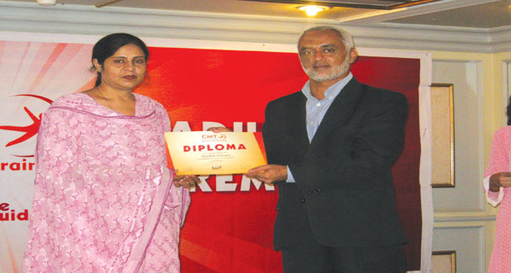
There is a silent revolution taking shape across Pakistan from a little studio in a bungalow converted into an office in Karachi’s Gulshan-i-Iqbal town.
Educational Assessment, System and Training (EAST) is a brainchild of Mr Rayed Afzal. Its online training department is the first of its kind live training platform launched to provide training of the most modern teaching techniques to pre-primary school teachers all over the country through video conferencing.
Born in Kuwait from where he proceeded to the US for higher studies at the age of 17, Mr Afzal returned to Pakistan from Texas some 18 years ago with a dream to give something back to his homeland. “I came back here as the World Bank’s chief education consultant for Pakistan,” says the educationist and entrepreneur, who never went back.
It was during his work with the World Bank that got him thinking about the need for educational assessment, curriculum development and research in Pakistan.
“It is an internationally-proven fact that 80 per cent of our personality is developed by the time we reach the age of six or seven. Therefore when thinking of curriculum development we wanted to focus our energies towards early childhood education. Together with our research department, we designed a pre-primary level curriculum that met the British national curriculum standards,” says Mr Afzal with pride.
About their textbook series called Butterfly in English and Titli in Urdu, Farah Khan, a senior coordinator with EAST, says it has been specifically designed for the pre-school level by their fulltime research department comprising teachers, researchers and artists. “The books are also accompanied by teachers’ aids to help them teach the way they are meant to be taught to the little ones. That is why we often get this feedback from our registered schools — that after studying from the books, the children go home smiling and come back to school smiling the next day, too.”
“The kind of study material we were introducing was earlier available only to 50 or 60 elite schools here but we wanted to make it available to the every class of society because the country cannot progress if international standards are limited to just a portion here. But a syllabus meeting international standards also called for teachers’ training based on those standards,” Mr Afzal points out.
He elaborates: “See, once we have come up with the books by getting the best curriculum developers, illustrators together, what will a teacher, say in Jarawala or Mingora do with them? They won’t be able to make the best use of our curriculum without some training in the methods of teaching the materials.”
EAST has offices in seven cities of Pakistan with the head office and research hub in Karachi and other centres situated in Multan, Sialkot, Faisalabad, Lahore, Islamabad and Mardan. But with their staff comprising mostly of some hardworking female teachers, it is not that practical to go to far away locations for the purpose of imparting training to the teachers there. So Mr Afzal devised a way to remedy the situation.
“Thanks to Dr Atta-ur-Rahman, who set up the kind of infrastructure that made use of broadband internet for educational purposes here, we decided to also use the broadband to reach out to the remote areas of the country while sitting in our studio right here,” he says.
“The schools at the other end only had to get a computer, which had them spending around Rs12,000; a broadband internet connection costing about Rs2,000; a webcam and two speakers making it into a rough combined figure of Rs20,000 at the most; and they were all set to have our teacher trainer in their school via live video conferencing.
“The method was both feasible and practical and the benefits that people are reaping from the technology are endless. Doing it live also encourages the teachers at the other end to ask questions if they need to be explained about something further,” explains Mr Afzal.
About who is financing the project when the schools registered with them are getting their own equipment and the online training is free, Seemeen Siddiqui, a trainer at the head office said: “No body is financing it really. The books are bought from us, but the training that goes with them, such as study modules, assessment tools, counselling and learning disability treatments, is free. Besides that we also provide separate diploma courses in Child-centered Montessori Training (CMT) for which there is a nominal charge. Currently we are also providing training to teachers from the Aga Khan Education Foundation, The Citizen’s Foundation (TCF) and Society Education Welfare (SEW). We are not a money-making venture. We believe in making a lifelong investment in our children’s future.”

