The science of canteens
By Dr Noman Ahmed
Sunday, 15 Nov, 2009
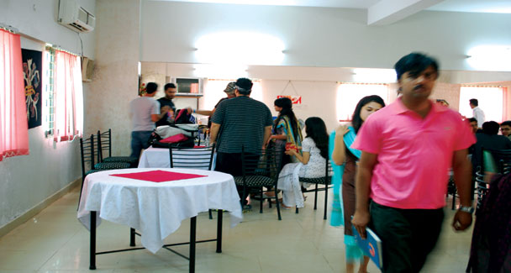
Healthy eating habits are an essential part of the rational lifestyle. One learns about them at home and respective educational institutions. Every school, college, university or training institute has a range of facilities catering to this fundamental need. Canteens, snack corners, cold spots, tuck shops, eateries, messing facilities and the like constitute the usual typology.
Observations show that eating outlets have many common characteristics. They are happy places where young folk can be spotted in groups, munching and chatting around in a carefree manner. For many students the time spent in the canteen is the best part of the day’s cycle. But there are many important issues that can be considered in order to make these eating outlets and their physical surroundings aesthetically appealing, lively and efficient.
School canteens are normally housed in small room-like spaces with external counter openings. Due to shortness of widths and vastness of bantam clients, the canteens may not be able to serve all aspirants. Many children throng the window only to return disappointed. Depending upon the dimensions, the counter space can be expanded by stretching out in the semi-open or open space. This shall help serve a large number of children who normally storm the place at one time. A temporary collapsible counter can add to service efficiency.
As school canteens have less than half an hour to reach out to their clientele, skilful and efficient staff is needed to make the most out of recess time. A proper seating plan is also vital. Students tend to take up every available nook and corner. The school managements can develop innovative seating profiles by recycling old furniture and props. With some thoughtful effort, small spaces can also be made to house a large number of pupils. Basic input in landscaping, furniture arrangement and colour scheme development can change the feel and experience of any dull surrounding.
Scarcity of space is often cited as a problem by such schools that function in converted residences or compact accommodations. But intelligent usage of space can generate interesting solutions. An input from an architect can be very useful.
Maintenance of health and hygiene standards in the canteen management is a crucial issue. The process begins from the staff. A proper and periodic health examination of all those handling the food is a must. All must be screened by a doctor for fitness.
An efficient supply chain for food
articles is a pre-requisite in canteen management. Long storage time in dilapidated conditions renders the food items hazardous for consumption. Rodents and parasites tend to swarm such isolated nooks. As a norm, all school canteens must be cleaned comprehensively and painted/white washed during the summer and winter vacations.
In the private school chains of elitist orientation, the quality of food items is generally satisfactory. Well-known branded articles are put on sale. The problem mostly remains with canteens in government schools and small-scale private outlets where sub-standard and old food stuff is often doled out to the innocent pupils in order to maximise the profits. Unbranded and stale articles are also regularly sold out. Operators argue that they sell such items to suit the affordability of pupils. This is an invalid excuse. There are many ways in which appropriate and healthy food articles can be transacted within the affordability limits.
Manufacturers and suppliers of repute have many combo deals available for budget sales. A pro-active attitude is required from the school managements. A great deal of improvement can be brought in the quality and sale price by directly linking up with wholesale outlets or the manufacturers. Several NGOs have support programmes for improving the nutritional status of school children. Aman Foundation has been extending a food supplementation programme in schools within the less-privileged localities in Karachi. Creative combination of essentials such as milk with other items can help evolve very interesting options.
As folks grow up, their level of independence demands expanded facilities. College and university canteens need a special response. Eating outlets cannot be complete without sufficient seating facilities. The spaces must be properly designed to also live up to the weather challenges. Semi-covered lawns and terraces as part of the landscape, make up the most sought after spatial choices.
It must be considered that the college/university administrations normally desire that students focus on studies and remain on the campus. The degree of attraction shall improve if lateral attractions such as working canteens with a pleasant rendezvous are devel
oped. Visibility of space, shade/sun protection, appropriate landscape, hygienic menu and gender-sensitive profiles are a few design considerations. A user survey can be very helpful in improving the quality and aesthetics of these outlets while designing new facilities or renovating the existing ones.
The management of a canteen is generally considered as a mundane affair by school, college and even university administrations. Thus the bulk of work is handed down to contractors without much supervision. This approach needs to be changed. Choice of operators, routine performance checks, staff scrutiny, and price checks are a few essentials that require the management’s input.
It must be remembered that healthy and satisfied students are the most-desirable asset for any institution. And canteens play a vital role in achieving that milestone.

