Violence on campus
By Huma Yusuf
Sunday, 25 Apr, 2010
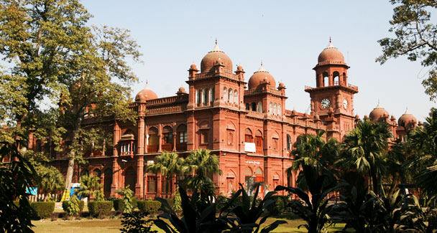
The Punjab University should revive a healthy culture of student politics on campus. Although the govt lifted a long-standing ban in March 08, no student union elections have been conducted. History has already shown that democracy is the best antidote to the IJT’s shenanigan, the group, which was known to terrorise progressive students in the 70s, was trounced in student elections, most notably in 78, 83 and 89.
By now Pakistanis are accustomed to ‘non-state actors’ — nebulous creatures that are blamed for the nation’s ills and help the government defer the burden of accountability. In a nod to these elements, we learnt this month that the violence and intolerance that permeate this country’s campuses are the work of ‘non-student elements’.
This coinage comes from the Punjab University (PU), which re-opened recently as a 19-day faculty boycott came to an end. The faculty was protesting the beating — many describe it as attempted murder — of a professor. As is well known by now, Prof Iftikhar Baloch, the principal of the College of Earth and Environmental Sciences and chairman of the committee on discipline, was severely beaten by dozens of members of the Islami Jamiat Taleba (IJT), the student wing of the Jamaat-i-Islami. The IJT activists were responding to the expulsion for ‘rowdy behaviour’ of five of their crew a day earlier by the committee.
Prof Baloch’s horrifying encounter with a student mob landed him in hospital, and sparked outrage among faculty and students who declared that the IJT had held the PU campus hostage for far too long. As the faculty boycotted classes, there were calls to purge PU of the IJT.
Some of the four main accused in the attack on Prof Baloch were arrested (after Punjab Chief Minister Shahbaz Sharif personally intervened). When the university re-opened, the vice chancellor used a conciliatory tone — he emphasised that the administration was not prejudiced against any particular student group, and rather than continue to point fingers at the IJT, blamed the recent unrest on ‘non-student elements’.
But on online forums, many in the PU community are asking why the university’s administration has not taken stern action against the IJT. There is a prevailing sense that a ‘golden opportunity’ has been missed to rein in this intolerant, militia-like group.
Thanks to coverage in TheNewYorkTimes, the issue attained global proportions. That esteemed paper read the showdown between Prof Baloch and the IJT as a microcosm of Pakistan, where “an intolerant, aggressive minority terrorises a more open-minded, peaceful majority”. In pointing out that the PU incident reflected the broader Pakistani reality, the paper was spot on. But by reading recent violence through the lens of extremism, the paper limited the scope of its own interpretation.
No doubt, the IJT is a rightwing group with extremist views on music and mingling of the sexes. But the April 1 violence was not ideologically motivated — it was a reaction to the disciplinary committee’s decision to expel IJT members. As such, the incident was not a case of extremism vs liberalism; rather, it was a case of thuggery vs democracy, of rule by the fist vs rule by the law.
Members of the IJT did not beat up Prof Baloch because they have a skewed interpretation of Islam. They beat him up because they believe brute force is the only effective tool in a broken system. In other words, the IJT attack was yet another manifestation of the widely held belief that violence is the best form of coercion.
In light of this, the university administration’s response — to boost campus security — seems inadequate. A new chief security officer along with 30 trained guards has been appointed and provided with equipment such as surveillance cameras and walkie-talkies. A 150-strong contingent of police has raided PU hostels in search of IJT members. By focusing on security, the PU administration is stooping to the level of the IJT. Rather than fight fire with fire, Pakistan’s leading intellectuals should be grappling with difficult questions about how to return values to our educational system. How do you encourage youngsters to find negotiated solutions to a conflict? Can teaching methods that encourage critical thinking help students better judge the actions of their peers? The university should be asking itself why a dreaded student group has been able to supplant the administration in its leadership role.
Indeed, none of the university’s actions imply that it expects, even requires, the IJT to change its modus operandi. Bold actions are needed to emphasise that brute force is unacceptable on campus. As a start, the administration can relocate the music department — which has been operating in the basement of the Alhamra Arts Council since the IJT deemed it ‘un-Islamic’ — back on campus. The administration can also allow canteens to stay open during prayer time and set their own prices (the IJT insists that businesses close for prayers and runs ‘price-control committees’). It is only by confronting the group that the administration can teach its members to respond in a measured way.
The PU administration also needs to regain the trust of the student body. To achieve this, it must conduct a transparent inquiry into the alleged politicisation of certain faculty members. Moreover, the university can retroactively take action against the IJT in previous incidents of violence. Most importantly, the administration should ensure that those charged with beating Prof Baloch are served speedy justice.
Above all, the PU should revive a healthy culture of student politics on campus. Although the government lifted a long-standing ban in March 2008, no student union elections have been conducted. History has already shown that democracy is the best antidote to the IJT’s shenanigans — the group, which was known to terrorise progressive students in the 1970s, was trounced in student elections, most notably in 1978, 1983 and 1989. The more violent the group became with Gen Zia’s backing, the more effectively other students came together to sideline it using the power of their vote. Allowing student politics to flourish will ensure that the progressive forces win.

