When fun and learning join hands
By Zarina Patel
Sunday, 14 Jun, 2009 | 07:31 AM PST |
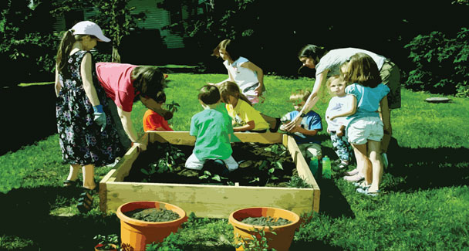
After a hectic and tiring session of school examinations, students all over are now looking forward to amusing activities and programmes during their vacations. But as the mention of vacations brings smiles to their lips, they bring on deep frown lines on parents’ foreheads.
Holidays serve a vital purpose of refreshing tired minds. For students they mean enjoyment without worrying about having to attend school the next day. For the parents, it is an ideal opportunity to rejuvenate their relationship with their offspring but they have to make time in order to do that. Not being able to do so brings on feelings of guilt that are so very difficult to shrug off.
Students throughout the academic year have to follow a scheduled timetable of waking up early and going to bed early, too, in order to do that. But vacations bring a temporary change, a short break necessary to revitalise energy in order to study more efficiently after the reopening of schools. After all, repetitiveness and redundancy reduces creative thinking and inspiration. So it is always wiser to utilise this break by encouraging your children to learn new skills and abilities.
Mustafa is among some of the lucky ones whose parents had preplanned his vacations. They arranged a complete plan for their child’s time off. “We planned for him to use this time of the year to groom manners. Apart from the extra curricular activities and picnics, we are teaching him the importance of good manners. This includes table manners, greeting visitors and placing his books and toys back in their proper places, etc.,” his mother informed.
She further added: “The skills children learn at this time of the year remain with them forever. It is an excellent time for Mustafa to learn social skills so we have planned small gatherings at home to make him a social person.”
School break is the best time for parents to create eco-friendly awareness. Children love to play in sand and mud, so choose gardening this summer as a tool to encourage them to learn how to appreciate nature as well as keep their environment healthy.
Working out in the garden with parents would also help teach children to cooperate with each other. Not only does the activity help build an aesthetic sense in the child, it also provides fun while refreshing the mind. It can also be a source of building the child’s confidence as he would surely feel proud when visitors to your place appreciate his hard work in the garden.
Outdoor activities are a great way of acquiring social, spiritual, physical, and psychological experiences that bring long-lasting positive changes in children’s life. According to a research, children who participate in outdoor activities, show a significant gain of personal development, i.e., self-reliance, communication and self-esteem.
Children if allowed to do as they please have been known to pass the long days of summer in front of the television or computer screen. Consequently, their attentiveness changes to laziness, making it difficult for the parents and teachers to restart their learning process after the vacations.
Outdoor games such as cricket, football, basketball, tennis and swimming ensure physical fitness while exterminating summer boredom. According to an expert, outdoor games help children learn to get along with other children, resulting in their becoming good team members.
Rae Pica, author of A Running Start: How Play, Physical Activity, and Free Time Create a Successful Child, says: “Outside light triggers the synthesis of Vitamin D and stimulates the pineal gland, the part of the brain that helps regulate the biological clock and is vital to the immune system.”
There are ways to keep the children busy even at home. Books are the most efficient tools here. Then educational computer games too can come in handy.
“I have planned to help my son overcome some of his educational weaknesses this summer. I want him to read a lot of books and then practice writing reviews and summaries,” says Zohaib’s mother.
One of the best indoor activities for children is to assign them small household tasks such as room cleaning, folding the day’s washing and setting the dinner table. Such tasks evoke a sense of responsibility.
When it comes to entertainment combined with education, there can be no substitute for traveling. It is a physical exercise that also builds traits of discipline, confidence and tolerance.
It does not matter whether you travel outside the country or to some local destination. It is organised planning that makes the trip a memorable and worthwhile experience.
Traveling with a purpose is always beneficial for the child’s healthy mental and physical growth. Mrs Ansa, another parent, has decided to visit her relatives in Lahore this summer. “My visit to Lahore is a move towards healthy social development for my child. It will give him an opportunity to interact with our relatives and also get acquainted with our cultural heritage,” she says.
Just as prior knowledge of a subject makes it easier for a student to understand it, he can also enjoy traveling if he has a basic knowledge of the area’s geography, weather, etc., before visiting a new city or place.
Financial problems have forced many families to put their vacation plans on hold. However, they can opt for other affordable outdoor activities and side trips such as visiting amusement parks, theme parks and zoological gardens. The learning advantages of visiting a zoological garden are more than any parent realises. It is the best opportunity to come in contact with real life things they have only read about in books. It is a chance to experience the natural habitat of many beings. They learn how wild animals live, how they behave and act while collecting a treasure of happy memories to share with their friends in the classroom later on.
The parents’ busy schedule often hinders trips. Busy parents can register their children in summer camps. Several five star hotels and educational institutions offer fun-filled activities for children such as swimming, skating, crafts, martial arts, horse riding, sailing, etc., to pursue during the summer. Some institutions also offer crash summer educational programmes to improve students’ handwriting and vocabulary as well as other educational weaknesses in a fun way.
This year encourage students to work for the welfare of needy and elderly people, both at home and in your vicinity. Children love to help others. A psychologist points out: “Young children have a natural tendency to care for others. The process of putting that care into action really starts within one’s own family as children become conscious of the needs of their parents and siblings.”
Children love keeping pets and they have a lot of time to spend with them during their summer vacations. This practice of regularly feeding and caring for animals brings out a sense of responsibility that develops attitudes of kindness and patience.
Due to their entensive nature, summer vacations, to say the least, offer multiple educational benefits, giving your children an opportunity to develop new skills and healthy habits. So do try to make the most of this time.
zaripatel@hotmail.com

