A growing gulf
By Tariq Fatemi
Thursday, 28 Jan, 2010
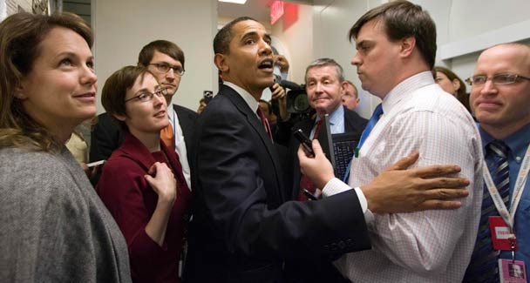
One cannot but be saddened at how much Obama’s administration has reneged on its commitments.

It is not only in domestic politics that President Obama has wavered between keeping faith with his followers and placating the opposition. In the field of foreign policy the disappointment has been greater, especially in the Muslim world.
Recalling the uplifting words of his inaugural address and the assurances held out in his Cairo speech, one cannot but be saddened at how much his administration has reneged on its commitments.
It is, however, on Pakistan and the region that the administration’s confusion is most visible. While asserting that it views Pakistan as an important friend and vows to build strategic ties with it, Washington has pursued policies not dissimilar to those of the Bush administration. The language is gentler, but the impact is no less harsh. This was evident in Obama’s Afghan strategy speeches, which focused primarily on military measures, rather than on political initiatives.
America’s refrain that Pakistan ‘do more’ strikes a jarring note, especially when the army has launched massive operations in difficult terrains against heavily armed militant groups. At the same time, the drones continue to cause more than an irritating hum in our ears; they are demeaning, while indicative of our leaders’ acceptance of America’s disregard for our national sovereignty.
The growing anti-American sentiments in Pakistan are not confined to the parties; these are shared by many liberals. The Pakistani leadership has demonstrated naivety in its dealings with the US, with many of our leaders convinced that the road to power in Islamabad lies through Pennsylvania Avenue. They have therefore ignored the counsel of their own professionals. Of course, this has been more pronounced with the authoritarian rulers.
It is therefore not surprising that while Pakistan has ‘served’ America’s interests at critical times, forging strategic ties has been a difficult exercise. In particular, the Americans have tended to take Pakistan for granted.
A recent example was Defence Secretary Robert Gates’s remarks in New Delhi, where while praising India’s restraint and ‘statesmanship’ after last year’s strike on Mumbai, he warned that if a Mumbai-like attack were to take place again it would not be “unreasonable to assume that India’s patience will be limited”.
Not surprisingly, it caused a stir in Pakistan, for Gates is much too experienced to make such an off-the-cuff remark. It was even viewed as irresponsible with some fearing that India could take it as prior approval for action in such a situation. In any case, Gates’s statement appeared to run counter to the US policy of advocating restraint for both countries.
Gates added to Pakistan’s misgivings when he lauded India’s “extraordinary” support to Afghanistan. He should have known that India’s expanding presence and growing influence in that country and its reported involvement in unfriendly activities in Balochistan, have contributed to growing tensions between the South Asian neighbours.
Thus his assurance that the US was committed “to a stable, long-term, strategic partnership with a democratic Pakistan” had little impact, as was his claim that both countries were learning what “it means to be long-term allies, partners and friends”. He had to engage in damage-limitation, praising Pakistan’s military offensive and hinting at the possibility of the US giving drone technology to Pakistan.
Gates said that the main focus of his visit would be “to provide reassurances to the Pakistan side that we are in this for the long haul and intend to be a partner … far into the future”. But then again, this was followed by an ill-advised public articulation of a desire that the army consider expanding its military operation to North Waziristan, which was rebuffed by the army’s spokesman.
Our own leaders would do both countries a lot of good, if they could muster the moral strength to tell the Americans that while we would like to see Pakistan-US ties strengthened, this cannot be achieved by the US remaining oblivious to Pakistan’s core interests. That we do not expect the US to intervene, on our behalf, in our differences with India, but nevertheless want Obama to remain faithful to his pre-election support for the Indo-Pakistan normalisation process and a peaceful resolution of the Kashmir issue.
Instead, in its anxiety to court India, the US has chosen to give it a good character certificate as regards its motives towards Pakistan. The fact that India has kept its troops on our frontiers, and more recently, its army chief has spoken of a conflict under the ‘overhang of nuclear weapons’, have been brushed aside by the US.
That India is a much bigger country, with enormous economic and military potential on which the US is counting in any future confrontation with China is a fact; but the US cannot act in a cavalier fashion with its allies.
Earlier, the Bush administration had signed, against the spirit of its own laws and international commitments, an agreement to sell India nuclear reactors and equipment which threaten to disturb the strategic balance in South Asia. Pakistan’s request for a similar arrangement has not only been rejected, Islamabad is also being pressured not to consider Iran’s offer of gas sales.
Gates wrote about the US “commitment to a stable, long-term, strategic relationship, based on shared interests and mutual respect that will continue to expand and deepen the profile of Pakistan”.
If that is the case then the US must appreciate Pakistan’s security concerns on its eastern frontier and help it overcome its debilitating energy shortage, by the sale of civilian nuclear technology, of course with the necessary safeguards. Pakistan, too, will have to reinforce its struggle against the militants, pursue a dialogue with India and promote peace and stability in Afghanistan.

