An aimless fight
By Kuldip Nayar
Friday, 02 Oct, 2009
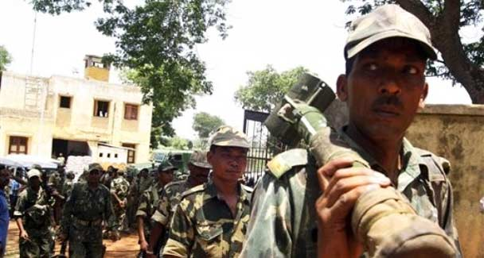
When the police increases manifold, the question is: does the increase reflect a failure of political will or a helpless dependence on force? –Photo by AP
Even after 62 years of independence, democratic India is in the midst of at least five internal mini-wars. The main ones in Nagaland and Kashmir have been there since the dawn of freedom.
The armed struggle by the extreme left Naxalites (Maoists) and the secession movement of the United Liberation Front of Assam (Ulfa) are three decades’ old. The trouble in the northeast, particularly in Manipur, goes back to the 1980s.
While these wars may not threaten the country’s integrity, they are nevertheless a drain on India’s economy. Their worst fallout is the lessening of liberalism which is India’s proud possession.
When the police increases manifold, the question is: does the increase reflect a failure of political will or a helpless dependence on force? In the land of Mahatma Gandhi, this point is indeed relevant because people all over the world are watching how the country is measuring up to moral standards while dealing with uprisings.
Whatever the why or how of mini-wars it is clear that the problems have been allowed to pile up, with the expectation that the passage of time would solve them. Yet today when these challenges pose a danger, the sword is being unsheathed to tackle them. The government knows no other way.
The Manmohan Singh regime may have inherited these problems. But the Congress which has ruled the country for more than five decades is most to blame for allowing different situations to prevail because the party has been opting for the status quo. What is required is vision and sagacity over brute force and a sense of self-righteousness.
Unfortunately, New Delhi has come to believe that power alone can solve all prickly problems. The result is that the administration in the country has developed authoritarian methods. More and more policemen are being recruited and even action by the commando force is being contemplated. Stringent laws are being added to an armoury of harsh measures. There is less hesitation to use even the military.
It is an aimless fight since the genesis of problems has not been understood. Top army officials have told the government many a time that the solution is political, not military. Yet the government continues to follow the same old formula of force and more force. The government has to have a different, more humane approach.
This does not suggest that those who indulge in violence or organise a rebellion against the state should go unpunished. In fact, the atrocities committed by them are unpardonable. But these elements should not force us, wittingly or unwittingly, to create conditions which restrict the space an ordinary person occupies or violate the spirit of the constitution.
Both the security forces and the so-called liberators are reducing India to a banana republic. People are picked up on suspicion or killed in false encounters. The government resents interference when human rights activists or intellectuals take up a case.
When there is a proliferation of policemen to serve the whims of rulers and when the administration itself comes to believe that force would solve the problem, excesses are natural.
This is precisely what happened during the emergency (1975-77). The police became an instrument of tyranny and carried out orders which were illegal, unconstitutional and inhuman. Yet none of the perpetrators was punished. Today the rulers and security forces are behaving in the same way as if they are not accountable. At that time we lost the sensitivity to differentiate between right and wrong and, today, between the moral and immoral.
The state has powers to declare a place a ‘disturbed area’. By doing so, the government gives untrammelled powers to the security forces. They become a law unto themselves and bring ‘order’ according to their own methods.
How one of the mini-wars involving the Maoists is sought to be fought was detailed by Home Minister P. Chidambaram before the Editors’ Guild India a few days ago. The Maoists reportedly control some 2,000 police stations out of 14,000 in the country and there are many districts where the government’s writ does not run. If development is the way to stop the Maoists’ appeal to the people in backward areas, Chidambaram explained, the territory had to be taken back to enable the government to build roads, schools and health centres.
No NGO or intellectual is opposed to the government taking police action to retrieve the territory under the Maoists. There cannot be a state within a state. Yet one would like to know why the government did not make development efforts when the territory was under it. The Maoists’ sway is the consequence, not the cause. Lately, sympathy and support extended to the Maoists have lessened because they are killing the innocent.
Chidambaram’s presentation would have carried more weight if he had listed the steps his ministry had taken to ease the rigours of preventive and other laws. The Armed Forces (Preventive) Act which has given the security forces the authority to shoot a person on mere suspicion is too arbitrary and should be amended forthwith. The ministry would win laurels if it were to bring about legislation to make it obligatory to have a judicial inquiry after every ‘fake’ encounter.
If the report that the government may strafe the Maoists’ stranglehold by the planes is correct, it would be the height of folly. The entire population in the area would be alienated. Pakistan resorted to bombardment in certain areas of its territory. It only stoked the fires of revolt. Violence is bad per se. It does not provide any solution. What really matters is the people’s support won through the ballot box.

