India’s challenge
By Ayesha Siddiqa
Friday, 08 Jan, 2010
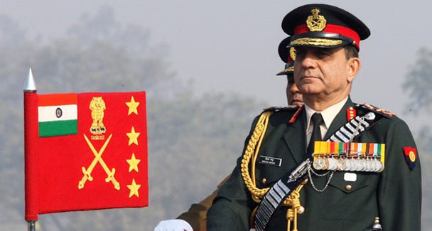
Indian Army chief General Deepak Kapoor inspects the guard of honour during the Army Day parade in New Delhi.
The statement by Indian army chief Gen Deepak Kapoor regarding his army’s capacity to fight a two-front war upset a lot of people in Pakistan. Both Pakistan’s army chief and the chairman of the Joint Chiefs of Staff Committee rebutted such superfluous claims.
Pakistan’s military high command did not mince its words in dissuading its Indian counterparts from giving any thought to ‘military adventurism’, and highlighted the severe implications of this and of the Pakistan military’s capacity to respond.
Such exchanges represent the heightened tension between the two traditional rivals. For many political pundits the year 2010 does not bode well for bilateral ties. The tide of peace and amity has been reversed even though people thought that the peace process, started during Musharraf’s reign, was ‘irreversible’. At that time, one of the major reasons for hope on both sides was that a possible deal could be negotiated between an elected government in India and a military dictator in Pakistan, who, it was assumed, could carry his institution along in reaching out to New Delhi. Now things are back to square one with hawks on both sides intensifying tensions.
Kapoor’s statement and its response from Rawalpindi is not the last time that such an exchange will take place. Needless to say, such exchanges do not bode well for peace in the region.
The Indian army chief had spoken of a capability that India desires but does not possess at the moment. Taking on two neighbours militarily and ensuring a ceasefire on its conditions is New Delhi’s dream. But it does not have the capacity to translate this into reality. In fact, India does not even have the capability to successfully try out ‘cold start’, its strategy to allow the Indian military to strike specific targets inside Pakistan and pull back without incurring a high cost. The basic assumption is that if India targets terrorist training camps or headquarters in Pakistan and pulls out without holding Pakistan’s territory or annihilating its military, Rawalpindi will have no excuse to deploy nuclear weapons.
Theoretically, such an adventure is possible because it is based on another calculation that the Indian army will not waste time in regrouping but would already be regrouped to carry out a strike. Official sources believe that activating ‘cold start’ could mean Pakistan deploying nuclear weapons at forward positions or keeping them ready for use. Such a situation would result in India deploying its arsenal as well, making the atmosphere highly charged.
Thus far, the Indian strategy is not in place. It requires complete inter-services harmony and would essentially be a joint services operation which could only succeed if well simulated. So far, there is no indication that India has this capacity. There are internal problems in establishing a new force structure. The establishment of this would indicate that headway is being made in bringing necessary changes to the organisational structure.
So, should Pakistan just laugh off Kapoor’s statement? It would be wiser to understand the nuances of the statement which are more important than the actual content of what he said. It basically indicates the shifting of plates in terms of civil-military relations in India. This is not to suggest that the Indian military is getting ready for an internal coup or that it could take over politics or even wage a war on its own.
However, Kapoor’s statement is one of the many symbols of the growing significance of India’s military in the country’s security and foreign policy paradigm, particularly as far as Pakistan, China and the US are concerned. It is no longer the military of Nehru’s days that sat silently waiting for orders from Delhi as it saw the Chinese army creeping into areas India considered part of its territory.
The modern-day Indian military has access to the media and has managed to build a partnership with it to get its message across when it is in need of public pressure on the political government regarding a particular issue or policy. Furthermore, the military’s overall significance in military security decision-making has increased for a number of reasons.
First, the current lot of Indian politicians is comparatively less skilled to deal with security issues than their predecessors and so tend to seek advice from military officers on security issues. Second, given India’s desire to become a global player and its acquisition of modern technology to achieve this objective, the significance of the armed forces has increased. Third, India’s security partnership with the US has bolstered the Indian military’s significance. Finally, (as in Pakistan) senior commanders who retire from the service find jobs in think tanks. This has allowed them to influence the national security discourse in the country.
For instance, the Federation of Indian Chambers of Commerce and Industry recently published a report on national security and terrorism proposing extreme measures. Thus, senior retired military officers and hawkish civilian experts drive the thinking of businessmen and traders who are key to peace in the region. This is indeed unfortunate and depicts a reduced capacity of the civilian sector in India to take on or oppose the military’s perspective.
From Pakistan’s perspective the important thing is that Indian politicians might find it difficult to go against their military’s opinion in case there is a crisis in the future. Not to forget the fact that both the Indian and Pakistani military have changed qualitatively as far as their class structure goes.
Greater indigenisation of the officer cadre and troops has meant larger numbers from the lower, lower middle and middle classes. One of the distinguishing features of these classes is their sympathy for socio-cultural traditions that have a significant religious flavour. Consequently, the men in uniform might view matters of war and peace differently.
Such factors as mentioned above are difficult to quantify but have a greater bearing on military planning and decision-making than what one would imagine. Under the circumstances, any misadventure or misperception could cost heavily.
These are two neighbours who do not know or understand each other and this makes an accidental conflict or some other dangerous miscalculation possible. Perhaps it is time that the two rivals began to understand each other.

