India's Middle Class Hungers for Undemocratic Change

Support for a dangerous piece of anticorruption legislation can skew political debate in the world's largest democracy.

By SALIL TRIPATHI
Annasaheb Hazare is an unlikely middle-class hero in India. He wasn't part of the Indian cricket team that won the World Cup earlier this month. He doesn't own one of the teams of the lucrative Indian Premier League cricket tournament currently underway. He isn't a Bollywood star either. He is a septuagenarian self-described Gandhian known for his development work in the western state of Maharashtra.
And yet he recently dominated the news cycle in India. He went on an indefinite fast to force the Indian government to appoint a committee that would examine and propose changes to draft legislation to establish the office of a national ombudsman to tackle corruption. He succeeded in five days' time: On April 9, the government caved in.
Last Saturday, a committee met to begin drafting a bill. This week, the composition of the committee is becoming controversial. Some have assailed the personal integrity of a few of its members who belong to civil society groups, and even questioned why they belong on this committee.
Judging by the way Mr. Hazare's fast drew support from industrialists, Bollywood stars, social reformers, activists and many students and professionals, this was quite a moment for the Indian middle class. For the first time the current generation of 20- or 30-something working Indians—only dimly aware of Mohandas Gandhi through the symbols and landmarks to his memory across the country—had encountered a real activist who, like Gandhi, was willing to sacrifice his life for a larger national cause.
The cause in question, a war against corruption, has resonated in the past year. Thousands of Indians have marched in demonstrations, enraged at various acts of corruption. Two high-profile cases are key: the way contracts were awarded to stage the Commonwealth Games held last October, and the way licenses were issued for the next generation of cellular telephony in 2008.
While these cases of grand corruption are important, Indians face millions of instances of daily, petty corruption. The municipal officer demands a bribe from a hawker; the bureaucrat refuses to register a land title or a marriage; the traffic cop beats the rickshaw-driver who can't afford to pay his weekly installment, known as hafta. These inconveniences at best and affronts to dignity at worst make corruption a rallying cry.
View Full Image
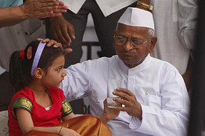
Associated Press
Anna Hazare breaks his fast after successfully blackmailing the Indian government.
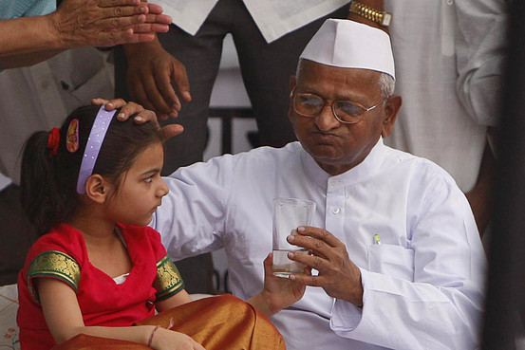
Such corruption also proves corrosive for business. The World Bank ranks India at 134th out of 183 countries for the ease of doing business and Transparency International puts it at 87th among 178 in its corruption perception index. Economists have noted that the way forward to reduce corruption has to be to decrease the discretionary power in the hands of these bureaucrats and politicians, while streamlining and clarifying the laws that empower them.
The irony here is that Mr. Hazare's struggle might hurt the fight against corruption. He wants an anti-corruption ombudsman with sweeping powers to investigate cases, demand prosecutions, and in some cases, deliver verdicts. That works in Hong Kong, through the Independent Commission Against Corruption, but that's because its economy is not micromanaged, and laws are applied fairly by a very competent civil service. In India, which still hasn't fully recovered from its dirigiste past, a new set of rules begets another one, and bureaucracy easily expands.
This expanding bureaucracy and body of rules is anyway hard for the citizenry to keep accountable; this ombudsman will add to these woes. Many constitutionalists and lawyers have expressed concern that the office of the ombudsman—from what we know now, in the preliminary stages of drafting the legislation—would be able to prosecute any public servant, including perhaps members of the independent judiciary, but would neither be elected popularly nor appointed by a popularly elected official. Rather, one proposal is that he would be anointed by a committee that would include Indian Nobel Prize and Magsasay Award winners, as if those Oslo, Stockholm and Manila anoint are worthier than other Indians. All this bypasses democratic norms of checks and balances.
Such details don't deter Mr. Hazare's supporters, some of whom have said that they want the corrupt to be "executed." This is moral enthusiasm from parts of the middle class, thousands of whom have signed Internet petitions and held candlelight vigils in protest. The highly competitive and breathless electronic media in the country have stoked the fire, likening downtown Delhi to Egypt's Tahrir Square.
For one thing, this comparison insults the brave men and women of Egypt. More importantly, the middle-class revolutionaries miss the fundamental point of the revolutions rocking the Arab world: they are against unrepresentative, unelected dictatorships. With all its flaws, India is a democracy that regularly holds elections. The real danger is that this accountability, however limited it might be, might be replaced by the tyranny of an unelected ombudsman. That's curiously welcome to Mr. Hazare's followers who yearn for a perfect messiah and don't trust the democratic process to deliver such an outcome.
To an extent, such disdain is symptomatic of India's middle class who, judging by the voter turnout in the middle-class strongholds of south Delhi and south Mumbai in the past decade, hardly participate in the electoral process. The apathy is partly due to cynicism, that Parliament is irrelevant to their lives, and the laws the state passes are to be ignored, and partly due to snobbery—of not wanting to wait in a long queue to vote, particularly if the queue includes lower-income people the elite don't like to mix with. But the middle class also perceives that its vote simply doesn't matter in an electoral system where voters continue to vote for party candidates with, say, a criminal record—who end up defeating competent, independent ones with a clean record. The recent corruption woes have only heightened this disgust.
This is not to suggest that demonstrations by the middle class are wrong. Democracies are meaningless without them. But when such protests are led by unelected members of society whose only claim to legitimacy is a claim of moral superiority, and when that is combined with essentially blackmail—accept my demands or I will end my life—it changes the nature of democratic debate.
Mr. Tripathi is a writer in London.

