An unequal position
By Kuldip Nayar
Friday, 17 Jul, 2009 | 01:02 AM PST 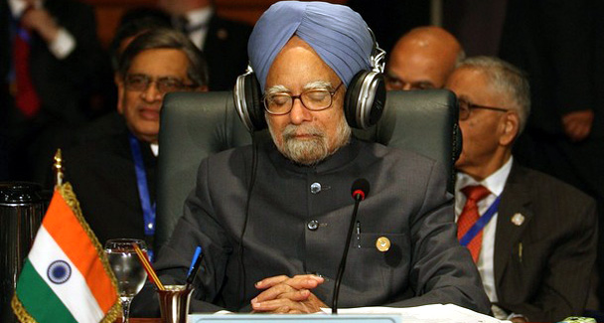
No power in the developed world will take India seriously if New Delhi does not win the confidence of its neighbours. - File photo of the Indian PM at the NAM Summit in Egypt.
NO doubt Prime Minister Manmohan Singh now has a voice at the G8. He made headlines by asserting that the developing world has borne the burden of the global financial meltdown which was the doing of the developed nations.
But world leaders did not lose sleep over this. The very fact that India is invited to such meetings — a forum of leading world powers — indicates the importance the country has assumed.
Despite another G8 meeting, carbon emissions, mainly responsible for climate change, will continue to be discharged by the industry in the West to the detriment of the world. So, exploitation continues. To sustain their standards of living, developed countries are still impervious to the needs of the developing world.
However, the G8 threw some crumbs of farm aid at poor nations. But it has not struck them that the deadlock at the World Trade Organisation is because of the farm policies they pursue. They subsidise their farmers and other inputs and insist that developing countries open up their markets. Local agricultural produce is at a disadvantage because it does not get even a fraction of subsidies enjoyed by farmers in France and America.
Needless to say, the developing world’s population consists mainly of agriculturists. It is a pity that New Delhi is beginning to wilt under the pressure of the developed world. The deadlock in Doha is over agriculture produce. Former commerce minister Kamal Nath, although found wanting in many ways, was at least firm about not giving into the unequal position prevailing between the developed and undeveloped worlds. India would let down developing countries if it were to allow subsided farm products from the West to flood markets in South Asia and Africa.
The problem with the Third World is that all the levers of financial power lie with the World Bank and the International Monetary Fund that are dominated by the developed world. The same applies to political forums like the UN Security Council. However liberal some leaders, like presidents Obama and Sarkozy, may be, they are on the same side when the chips are down.
It was insulting the way in which the G8 passed a resolution in the presence of Manmohan Singh that India would have to sign the discriminatory NPT if it wanted nuclear energy unfettered. Obviously the resolution has America’s backing. This means that President Obama has different ideas about the Indo-US nuclear treaty and is not bound by what President Bush’s administration had undertaken in this respect.
But the record of cooperation among the developing countries is not too impressive either. It was with great fanfare that the idea of South-South cooperation took shape in the 1980s. It was no other than Manmohan Singh who had prepared a report. But it was not discussed or implemented.
The Non-Aligned Movement lost its raison d’être once the Cold War was over. However, its meetings still convey the message that the Third World has a platform from where it can to raise its voice. That may not have much impact but it has some influence. India’s vast pool of manpower should come in handy if it does not mix economics with politics.
India has to prove its bona fides as a developed country in the region. But it is distant from all its neighbours. Understandably, its differences with Pakistan are political. But India is not seen as a friend in Nepal or Bangladesh either. Our size may be forbidding but maybe it is something in our attitude and behaviour that deters our neighbours.
Pakistan’s army chief Gen Kayani still fears an attack by India. How can Pakistan or for that matter other neighbours feel comfortable when our defence budget has gone up by around 38 per cent? It may be only 2.6 per cent of GDP but that is a lot in the context of our neighbours’ economies.
In any case, no power in the developed world will take us seriously if we do not win the confidence of our neighbours. Self-righteousness is not a good trait. When some of our neighbours contend that New Delhi has hegemonic tendencies, their claims may not be unfounded. We should examine why we gave up Gandhi’s approach after his assassination.
Take the case of the Baglihar power project in Kashmir: we did not agree to the points raised by Pakistan until a World Bank expert told us to revise it. Similarly, Bangladesh has objected to the construction of the Tipaimukh dam in Manipur. I hope New Delhi will pay heed to Prime Minister Sheikh Hasina’s words: ‘We have signed the historic Ganges Waters Treaty, ensuring fair share of its water. We will be able to resolve the Tipaimukh issue also.’
However, it is also incumbent on our neighbours to cooperate with India and not create situations to which New Delhi may react adversely. New Delhi is unhappy that Islamabad has not done enough on the 26/11 attack on Mumbai and has taken up the release of Hafiz Saeed as a test case.
Pakistan should not let him go unpunished. Still if New Delhi were to adopt measures to accommodate neighbours and revive Saarc Manmohan Singh’s voice at G8 would be more powerful. He would not have to lobby for membership in the Security Council. Imagine India’s strength if all countries in South Asia were to back it.
The writer is a leading journalist based in Delhi.

