Not through the gun
By Kuldip Nayar
Friday, 09 Apr, 2010
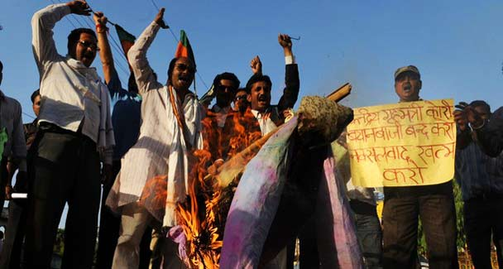
Opposition Bharatiya Janata Party (BJP) supporters chant slogans as they burn an effigy of Indian Home Minister P. Chidambaram in Allahabad, following an attack on security personnel by Maoist guerillas in the eastern state of Chhattisgarh. Indian authorities vowed to hit back at Maoist rebels who killed 76 police in a brutally effective attack that undermined a months-long government offensive against the insurgents.
Not many Indians are happy with the prevailing system. Too many disparities have come to be entrenched and too many people have been driven to live on the margins. Crime has been politicised and politics criminalised.
The question that faces the nation is how to change the system. Should it be with the gun as the Maoists and their sympathisers in civil society have come to believe or should the people decide through the ballot?
This question has become more pressing after the Maoists went on a killing spree. The recent tragedy in the deep forests of Dantewada in Chhattisgarh where 76 policemen were killed is adequate proof that the Maoists are out to capture power through the gun.
What is worse is that they not only planned the attack but also managed to take away all arms and ammunition from the police. This underlines the fact that the Maoists have improved their tactics and weaponry. On the other hand, the police remain ill-equipped, under-trained and ill-served by the intelligence.
This carnage is the Maoists’ way of conducting an armed revolution. When India won freedom under the leadership of Mahatma Gandhi, it did not fire a single shot to oust the mightiest world power. The Mahatma had the power of the people behind him. The poor, the illiterate and the backward were all with him. In fact, most of the affluent were on the British side. The bureaucracy too was part of the imperialist power. Still the Mahatma won.
If the Maoists represent the poor, the illiterate and the backward, let them prove so, not by egging them on to use the gun but through elections which are held fairly and independently. This needs persuasion, patience and arguments to win people over. The Maoists believe that the gun can do the job. This was the language of the imperialists also.
What the Maoists do not understand or realise is that the state has many more guns and can ultimately silence the other guns. The rulers may not be to their liking but they have come through a process where people have queued up before the booths to cast their vote. If the gun is the way to throw them out, then the guns or the other methods the rulers use to curb the Maoists are justified.
Violence in today’s world is out of place. Even limited violence can prove dangerous. In India where there are so many fissiparous tendencies, violence can result in anything. Trigger-happy groups or some other forces can try to seize power when the arbiter is the gunman. Hitler ruled Germany through his cadres who espoused democracy but used violent methods to eliminate opponents.
Bhagat Singh was also a revolutionary. He too believed in armed struggle. Yet, he never preached violence. Nor did he or his organisation, the Hindustan Socialist Republic Army, behead anyone. The Maoists have much to learn from him. The British hanged Bhagat Singh because they were afraid of his philosophy, not him.
What did killing mean to a revolutionary? Bhagat Singh explained it in his own words: “We attach great sanctity to human life; we regard man’s life as sacred. We would sooner lay down our lives in the service of humanity than injure anyone.” There was no revenge, no vendetta, no brutality.
In his article, Philosophy of the Bomb, which Bhagat Singh wrote at the age of 21, he said revolutionaries do not shun criticism and public scrutiny of their ideals or actions. They welcome these as chances of making those understand who have a genuine desire to do so the basic principles of the revolutionary movement and the high and noble ideals that are a perennial source of inspiration and strength to it. But the Maoists are running away from talks. The killings do not tell what they stand for.
Bhagat Singh’s passion was to write in his notebook the quotations he liked from different books. After reading R.H. Tawney’s The Acquisitive Society, Bhagat Singh said that the acquisitive society “was a reality”. The reason why people from the Tawney age adopted the socialist creed was the degrading economic and moral conditions under which so many people lived at that time. He underlined the contradiction between political freedom and economic dependence and underscored the necessity of freedom for economic improvement.
The history of all societies, Bhagat Singh argued, was the history of class struggles. It was a fight between those “who do not work” and “those who do”. It had been caused not by subversion or conspiracies and astute political leaders, but by the same inexorable social laws that destroyed previous systems like feudalism in Europe. He never mentioned violence.
Bhagat Singh wanted to awaken people to their plight and organise a mass movement of workers, peasants, students and youth. The Maoists can reflect on how their armed revolution is degenerating into senseless violence.
I do not like all the things that Home Minister P. Chidambaram does. But in the case of the Maoists, he has gone quite far to initiate a dialogue. He has not asked them to give up their arms or ideology. He has only told them to renounce violence. If they were to do so, the central government would talk to them.
Meanwhile, the government would do well to stop industrialists and businessmen from appropriating the natural resources which constitute the tribals’ wealth. They should be made partners in ventures which come up to utilise the resources. The Maoists have been harnessing the grievances of tribals for their armed revolution. Once the tribals know that they have control over the natural resources, they will stop supporting the Maoists.
In the name of revolution, the Maoists are getting money and weapons from questionable sources. They cannot play with the Indian polity, however wanting the government may be. The rulers can be ousted in elections. The Maoists are making the mistake of equating government with India.

