Problems galore in Bangladesh
By Kuldip Nayar
Friday, 18 Sep, 2009 | 08:02 AM PST
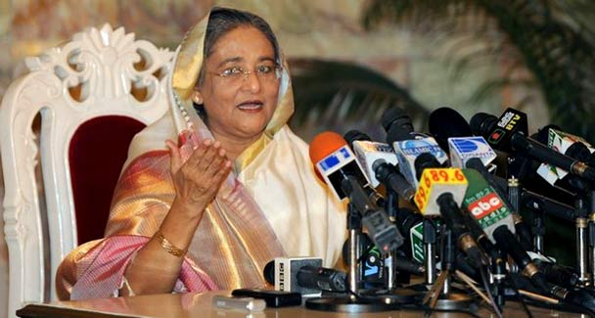
The exasperated nation has gone back to the beginning and given more than two-thirds of parliament’s seats to the daughter of the founder of Bangladesh, Sheikh Hasina. —AFP/File Photo
IT was a feeling of humiliation that gave impetus to the people of erstwhile East Pakistan to build a country of their own. That was some 38 years ago when Bangladesh was born.
Scant resources and a large population did not affect its determination to convert the country into ‘Sonar Bangla’. But gradually a mood of uncertainty set in.
The first blow came when Sheikh Mujibur Rahman, the father of the nation, was assassinated. He had the support of the people who were willing to offer any sacrifice. The second blow was the military-inspired coup that destroyed an open and democratic society. Elements were unleashed which drove the liberals – and their ideals – to the wall.
Bangladesh needed unity to develop. But it witnessed periods of military rule and authoritarian regimes. Then there were the ever-battling begums, Sheikh Hasina of the Awami League confronting Khaleda Zia of the Bangladesh Nationalist Party (BNP). The exasperated nation has gone back to the beginning and given more than two-thirds of parliament’s seats to the daughter of the founder of Bangladesh, Sheikh Hasina. Still, political unity has eluded the country because the BNP has boycotted parliament.
Some developments are ominous. Islamist extremism is rearing its head again. Jihadis are sprouting here and there. That the hanging of Bangla Bhai and his fundamentalist colleagues in 2007 did not evoke any protest is a healthy sign. But he was more of a killer than a religious figure.
The manner in which the fundamentalists have joined hands with the BNP indicates that there is an attempt to mix religion and politics. The Jamaat-i-Islami is their supporter, although it has reluctantly conceded that the liberation struggle contributed to independence. The Awami League may find these forces capturing the imagination of the common man despite the liberal temperament of Bangladeshis.The other unfavourable development is that Bangladesh, preoccupied with the problem of finding hundreds of thousands of jobs, has neglected its borders. It has become a haven for all the banned organisations in India, Sri Lanka and even Myanmar. They operate from Bangladeshi soil and find it safe to do so. These organisations include the United Liberation Front of Asom, the Liberation Tigers of Tamil Eelam and other lawless groups.
A concerted fight against them is what Bangladesh Foreign Minister Dipu Doni promised Indian Foreign Minister S.M. Krishna when they met in Delhi a few days ago. She has signed an agreement to combat international terrorism and crime.
India has, in turn, allowed border markets and given Bangladesh 1,000MW of power, apart from developing the power grid connectivity. After straightening things with the West, India was the first country to which Sheikh Hasina sent her foreign minister to assess how far New Delhi was willing to accommodate Dhaka. It is apparent that Sheikh Hasina cannot be satisfied with an agreement on power. She expects wider and closer economic cooperation.
In fact, after the creation of Bangladesh there was a joint planning board of New Delhi and Dhaka. An outline was prepared on how the economies of the two countries would be dovetailed to benefit each other. Everything has remained on paper since the assassination of Mujibur Rahman. True, New Delhi has its own limitations. But it has a larger economy. It can do much more than it has promised. Perhaps New Delhi can encourage private investors to pump money into Bangladesh or set up joint ventures to produce what India requires.
India has exacted a price in the shape of Dhaka’s undertaking to go after the extremists operating from its soil. But as Sheikh Hasina found during her earlier stint in power, it is not easy to fight them when they have supporters in both countries. Drug trafficking by the militants gives them an income of millions. It is difficult to demolish their network or that of criminals, smugglers and religious bigots because those who use them wield political power as well.
The steps that Dhaka takes against them may stoke anti-India fire, which is already burning fiercely. The anti-Pakistan feeling has been replaced by an anti-India feeling. Still, Dhaka has to face the situation. It cannot be seen running with the hare and hunting with the hounds. Bangladesh knows that the failure to tackle the terrorists operating from its soil may cost the country dearly.
New Delhi expects much more than Dhaka can deliver. India also wants it to give its transit rights to reach its north-eastern states and facilities at the Chittagong port for exports. Talks on such matters soured relations in the past. New Delhi will have to sell them to the people of Bangladesh with reason and convince them that these measures are to their advantage.
There is apprehension in Bangladesh over the Tipaimukh Dam project located near the confluence of the Barak and Tuivai rivers in Manipur. Why not suggest a joint board of engineers from India and Bangladesh to supervise the project to remove any doubts?
India needs to reflect on why all the neighbouring countries have distanced themselves from it. No doubt its size deters them. But more than that, their feeling is that New Delhi is becoming increasingly conscious of itself as an emerging world power. It tends to throw its weight about in such a manner that the neighbours are having doubts about its bona fides.
New Delhi must do some introspection because it is not that all next-door neighbours have turned hostile. They are suspicious, something which India must remedy by its deeds.

