Not through force
By Kuldip Nayar
Friday, 30 Oct, 2009
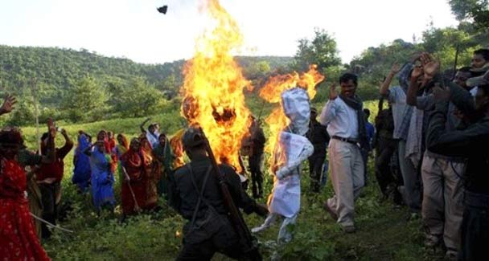
Villagers watch as armed Maoists burn effigies of India’s ruling Congress party President Sonia Gandhi, Prime Minister Manmoham Singh and Home Minister P. Chidambaram, at Dumariya block in Gaya district.
India is in the midst of a familiar debate: how far should a nation use force to protect the rule of law? The question has arisen because the Naxalites, the extreme leftists, have come to control almost one-sixth of the country where the civil administration had failed. Their area has come to be termed as the red corridor.
The central government has woken up to the challenge to its authority rather late. The Naxalites, also called the Maoists, formed themselves into a political party in the late 1960s when India began to have problems with China. The Communist Party of India (Maoist) had declared a war against the state a few years ago and has indulged in violence in a limited form.
Today, guerrilla warfare, has gathered so much strength and support, particularly in West Bengal, Jharkhand, Orissa and, to some extent, in Andhra Pradesh, that the Naxalites have joined issue with the state publicly and defiantly. They recently stopped the Rajdhani Express and detained the train for hours. Television channels were alerted to get endless publicity.
A few days earlier, the Naxalites released a West Bengal police officer with a piece of paper inscribed with ‘POW’ pasted on his chest, meaning that they had released a prisoner taken during the war between the Naxalites and the state. In fact, this was their reply to New Delhi’s appeal to them to abjure violence.
Civil society is overwhelmingly against their methods but generally agrees with their demand for the improvement of living conditions for the vast majority. (Twenty-two per cent of the country’s GDP is reportedly controlled by 20 per cent of the corporate houses). Society’s support on economic matters is turning into the Naxalites’ strength. Most people travelling in the hijacked train were impressed by the Naxalites’ protest and said so. The use of peaceful tactics was meant to convey that they did not use violence indiscriminately.
The armed revolution to ‘liberate’ the country and eliminate poverty are entirely different issues. The Naxalites have confused the two. One relates to the use of the gun, the other to development.
That the different ruling parties have failed to implement the directive principles of the constitution to remove deprivation is absolutely correct.
Yet, it is equally correct that democracy enjoins upon the people to pursue the rule of law, not violence. The Naxalites’ ideology that power comes from the barrel of the gun has been rejected. An armed revolution does not fit into the nation’s ethos, however frustrating the ways of democracy are.
The Naxalites are wrong when they believe that they have liberated one-sixth of the country. No doubt, they have given a better deal to the Adivasis, but the latter are also afraid to defy the Naxalites’ guns. And the state’s apparatus can neither give the Adivasis their livelihood, nor save their national resources.
In fact, whatever the Naxalites are trying to convey is only hardening the intelligentsia’s opinion against them. What, in fact, the Naxalites are re-emphasising is the theory of the survival of the fittest.
The central government which is fighting against the Naxalites is itself indulging in excesses. There are numerous examples of this. The northeast is littered with them.
The withdrawal of thousands of cases against the Adivasis indicates how the police had picked them up for petty theft like cutting wood. The women against whom the West Bengal government withdrew the cases to placate the Naxalites were above 75.
Mahatma Gandhi commended the bravery of revolutionaries and praised Bhagat Singh, Sukhdev and Rajguru who were hanged by the British, but differed in their methods. We have the example of Sikh militancy which lasted for a decade. It ended when people turned against those who were killing the innocent.
The Adivasis and some others are taken in by the Naxalites in particular areas because of the atrocities committed against them and because of the forced alienation of their land.
They were helpless. Nobody except the Naxalites reached them. If a landlord takes away a villager’s wife and keeps her in his house to abuse sexually when the husband pleads with him to return her and his children, what is the villager supposed to do?
Such examples can go on. In most tribal areas such an atmosphere prevails. The objection is not against the protest raised by the Naxalites but the manner in which it is being done. The use of violence may give them a temporary victory in a limited area. But this is not revolution and nowhere near the ideology of Marxism which is a quest for justice.
The two Indian communist parties have also said that Naxalites are not leftists, although the two praise Stalin who killed millions of innocent people. The ideology should not to be confused with force or the ambition to come to power without elections. The people’s consent is required. Justice loses its purpose when attained through force.
Violence in India can lead to developments which may go out of hand. There are too many fissiparous tendencies. The outcome can be anything — dictatorship of the right or India’s disintegration. That the system needs to be changed does not have to be overstated. When even after 62 years of independence, two-thirds of the people remain poor, the overhauling of the polity is essential.
Should the ballot box or bullet change this is the question. True, the ballot box has done little. But the fault is also that of the liberals. They got a chance in 1977 when the Jayaprakash Narayan movement with the slogan of parivartan (change) defeated the Congress in the 1977 Lok Sabha elections. It was a revolution indeed. And those who won wasted that opportunity.

