Anxious times for India
By Kuldip Nayar
Friday, 18 Dec, 2009
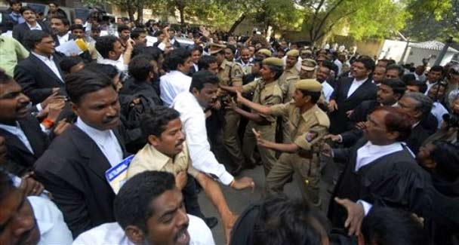
Indian policemen try to break a tussle between lawyers in support of a separate Telangana state and those against it, outside the High Court in Hyderabad, India.
I was information officer of India’s then home minister, Govind Ballabah Pant, when the Fazl Ali Commission submitted the report on the reorganisation of states in 1954.
While working on the proposals, Pant would often wonder why they had taken up the controversial task of redrawing the map of India when there were so many urgent problems facing the country. Fifty-five years later, the nation can rightly pose the same question. In fact, the problems have increased: insurgency, terrorism, price rise and unemployment.
Carving out Telangana from Andhra Pradesh in the south is not so much a problem as its timing. India was beginning to pick up the rhythm of development after recession. But the Congress party panicked over the fast unto death by K. Chandrashekhar Rao, chief of the Telangana Rashtriya Samithi, and conceded the demand even at midnight. Should it have done so at a time when numerous ethnic and linguistic groups want a state of their own? With 70 per cent of people living in dire poverty, the government’s first task should have been to find bread for them, and to let sleeping dogs lie.
Jawaharlal Nehru, India’s first prime minister, too had panicked when Potti Sriramula of Andhra Pradesh went on a fast unto death. That was when the Fazl Ali Commission was appointed. Nehru subsequently admitted that he made a mistake and should have attended to other problems before taking up the reorganisation of the states.
As for Telangana, the Fazl Ali Commission had recommended its formation because it felt that the territory, primarily the old Nizam state, was linguistically and culturally different from the rest of Andhra. The twin cities of Hyderabad and Secunderabad were pre-ponderingly Urdu-speaking and they did not fit into Andhra with the official language of Telugu. It is another matter that in the last 50 years the state has become integrated administratively and economically.
There was strong opposition when Nehru amalgamated Telangana and Andhra into the state of Andhra just as he forcibly merged Gujarat and Maharashtra into one state. Gujarat broke away but Telangana stayed a part of Andhra Pradesh, although the demand for separation did not die down.
The debate in the country is more about the hurried manner in which the central government has accepted the demand for Telangana. What was the urgency?
The message is that New Delhi can be bent if some determined elements come out on the streets. Violence has come to matter. Agitators justify it on the ground that their cause is ‘just.’ Burning public property or disturbing the law-and-order machinery is considered in order to achieve the goal. The tension is reaching as far as Assam.
I suspect that when the top Congress leaders, including Sonia Gandhi and her political adviser, Ahmad Patel, met to decide about the creation of Telangana, they had politics uppermost in their mind — how the decision would translate itself into votes.
The British were motivated by ‘imperial interests’ when they carved out states. The Congress is goaded by ‘political considerations,’ just as the Bharatiya Janata Party was when it created the states of Jharkhand, Chhattisgarh and Uttranchal a few years ago, carving them out of Bihar, Madhya Pradesh and UP, respectively.
The creation of linguistic states is understandable but applying the principle to accommodate every ethnic group is akin to playing with fire. Small states are welcome because they are more accessible to the people. There is a livelier sense of local needs and the government can appreciate them more realistically than the administration in large units. The governance is intimate and readily responds to the people’s needs.
But how small is the question. Economic viability and historical and cultural considerations too are relevant. All the three states which the BJP constituted for political reasons are on the drip which the centre sustains. They are known for corruption. Jharkhand has the distinction of electing corrupt chief ministers, one after another. One of them is behind the bars. The last chief minister, Madhu Khoda, reportedly made Rs4,000 crore in less than two years when fresh elections were called.
Finance Minister Pranab Mukherjee has announced that there will be no more states after Telangana. It is like bolting the gate after the horse has run away. How can the centre make such sweeping statements when it has capitulated under pressure in the case of Telangana? Already there are agitations and fasts in several places, all wanting a state of their own.
The government should have consulted at least the Andhra chief minister before announcing Telangana. It could have insisted on a referendum or resolution by the state assembly. It did nothing of the sort.
The question is a larger one. It is about the lack of development and an indifferent administration. Without having the basic necessities and an impartial police force as guardians, people increasingly believe they have only to exert pressure to get their demands acted on. (The Swiss cantons are the only places where it has been possible to realise the ideal of direct democracy.)
What the centre has done will create unrest in the country. The signs are already there. The appointment of another commission on the reorganisation of states would only open a Pandora’s Box. Even a small linguistic group might claim a state of its own. Many chauvinists would go on fasts unto death because that is the quickest way to achieve their ‘demand.’ This may tell upon the country’s unity.
Political parties should get together to consider how to reach out to the people who do not get any benefit from the system. Electoral reforms are needed to ensure that small groups have participation, maybe through proportional representation. The government cannot afford to ignore the fallout of Telangana.
The country is facing anxious times. However unthinking the Congress may have been in its decision, all political parties should help it at this time to put out the fires.

