It’s official: RSS is the boss
By Kuldip Nayar
Friday, 28 Aug, 2009 | 01:04 AM PST
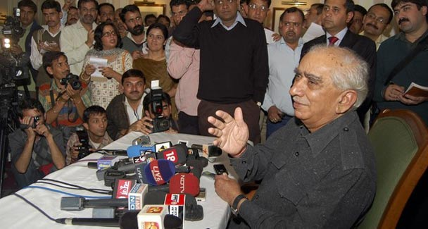
India’s former finance minister and member of BJP Jaswant Singh speaks during a news conference in Shimla. —Reuters
It was more than a storm in a teacup. Jaswant Singh’s book on Quaid-i-Azam Mohammad Ali Jinnah made more news than his expulsion from the BJP for writing it.
I witnessed the era of partition and before and think Jaswant Singh has been unfair to history. If blame is to be apportioned — a futile exercise after 62 years — all three parties, the British, the Muslim League and the Congress, in that order, are guilty.
It is a subject which academicians from both countries should discuss. Hindus and Muslims got alienated from each other and division became inevitable. Still it is a fact that many Hindus and Muslims left their homes hoping they would return once the frenzy subsided. This didn’t happen because both Punjabs ousted members of the community other than their own. And then there was so much bloodshed and destruction that they could not have gone back. When rulers in both countries accepted migration, which they had resisted earlier, it was all over.
The thesis that Jawaharlal Nehru, not Jinnah, was responsible for partition was only discussed in the media and the BJP. The reason why the debate really didn’t take off was because other parties didn’t participate. The attention is increasingly focused on the BJP’s internal fighting. Arun Shourie, an academician-turned-politician, has made the scene more sombre by hurling abuses at the BJP’s leadership, blaming the party president for everything. Shourie has appealed for the intervention of the Rashtriya Swayamsevak Sangh (RSS). The RSS spokesman has said that it can guide, not control. Even this studied remark shows that the boss is the RSS — an avowed exponent of Hindutva.
The RSS is the same organisation which was banned following Mahatma Gandhi’s assassination. Many BJP members, including L.K. Advani, the party’s top leader, have graduated from the RSS. For all his liberal credentials, Atal Behari Vajpayee stood at attention whenever the RSS held a rally of its adherents in Delhi to convey that even the then prime minister was not outside the party’s discipline.
The RSS has been anti-Jinnah from the day Pakistan came into being because its formation was considered ‘the cutting of Bharat Mata into pieces’. That explains why Advani’s praise of Jinnah during his visit to Karachi landed the BJP leader in trouble and he had to resign as head of the party at the instance of the RSS.
It is a paradox that when Vajpayee visited the Minar-i-Pakistan in Lahore, he wrote in the visitors’ book that the integrity and prosperity of India depended on the integrity and prosperity of Pakistan. Vajpayee got away with his remark because he was prime minister. The RSS could do nothing because it didn’t want to lose power. Any action against Vajpayee would have brought the government down.
Many years ago, soon after the emergency when I shared jail with RSS men, I was invited to address an RSS shakha — the only time I did. I told them if they wanted to undo Pakistan they should let Muslims in India feel like equal citizens and help them enjoy all that the Hindu majority did in terms of employment, economic betterment and accommodation. My argument was that the Muslims got distanced because they didn’t get their due.
The RSS has not changed its anti-Muslim philosophy. That is the reason why the BJP doesn’t get the community’s vote of 15 per cent. The Hindutva terminology is explained as nationalist. Yet in all Hindu-Muslim riots, RSS men have been found to be involved. What happened to the Christians in Orissa was the doing of the Bajrang Dal, the militant wing of the RSS.
It is a pity that the BJP has never stood on its own. The RSS gives it strength. Therefore, even the liberal elements in the BJP don’t speak out against the inveterate hatred of the RSS towards secularism. What was once the Jana Sangh became the BJP. The latter insisted on Jana Sangh members breaking away from the RSS as an undertaking they had given while merging with the Janata. Jaswant Singh preferred a Hindutva outfit to the liberal Janata. He has never questioned Hindutva or ever challenged the BJP’s role as a political face of the RSS.
Jaswant Singh was found wanting in taking a posture on Gujarat. He was critical of Chief Minister Narendra Modi and favoured the dismissal of his government without saying so openly. He has correctly recalled that while travelling with Shourie to Ahmedabad, Jaswant Singh asked Advani to suggest to Vajpayee the dismissal of Modi’s government. What Jaswant Singh hasn’t mentioned is the brainwashing of Vajpayee after which Vajpayee attacked Muslims in his speech in Mumbai by saying that they were making trouble wherever they lived.
The BJP and its ideology have been uppermost in Jaswant Singh’s life. He might have hummed and hawed but he continued to be a member of the party’s high command. What struck me most was his puerile assertion that he stuck to the principles he had imbibed at the military academy. The academy is a crucible where religious identities and communal bias of cadets melt.
My main disappointment is over the outcome of the party’s three-day brainstorming session a few days ago. I thought the country would know where the BJP was heading. It seems to have lost its way and does not realise this. After the meeting, all that BJP president Rajnath Singh said was that Advani would continue to lead the party for the next five, 50, 100 years.
I have nothing against Advani but the BJP needs to change its image. Hindutva is against the country’s ethos of pluralism as it excludes minorities. The BJP is losing space because it is going against the nation’s temperament. Despite knowing this, it can’t change because of the RSS.

