Mixing politics with religion
By Kuldip Nayar
Friday, 03 Apr, 2009 | 01:48 AM PST

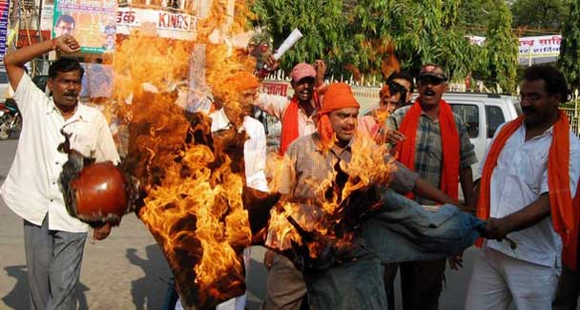
Religion has absolutely no place in politics in a democratic state - Reuters/File photo.
IT is rare that a minister involved in communal riots is arrested. But the Gujarat High Court has made this possible by cancelling the anticipatory bail given by a lower court to Maya Kodnani.
A member of the Narendra Modi cabinet, Kodnani had abetted and participated in the 2002 Gujarat carnage. She escaped justice for seven years. The Supreme Court sent its own investigation team to uncover instances of the murder of Muslims which had not come to light. Many more killings have yet to come to light.
Giving its observations on the Kodnani case, the high court said that “communal harmony is the hallmark of democracy. If in the name of religion people are killed, that is absolutely a slur and a blot on a society governed by the rule of law.” These words are lost on the Gujarat government. But they express the determination of a nation which has been trying to establish a pluralistic country since independence. Needless to say, the minorities will certainly take heart from the judgment.
Many Muslims in Gujarat have said they feel they may get justice. They now speak out, which is something they had not done out of fear. The high court judgment has once again proved that the din of the communalists, however loud, cannot drown secular voices. Yet the party has found a person who has no hesitation in making hate speeches or polarising society in Varun Gandhi who is Jawaharlal Nehru’s great grandson and Maneka Gandhi’s, the widow of Sanjay Gandhi, son. Domestic quarrels had made Indira Gandhi turn Maneka, whose husband Sanjay had literally run the government during the 1977–1979 emergency, out of the house. He too had an anti-Muslim streak. He bulldozed the Turkman Gate habitation in Delhi and forcibly transferred the entire Muslim population outside.
Varun Gandhi has said — and it is recorded — “Yeh panja nahi hai, yeh kamal ka haath hai. Yeh kat ... ke galey ko kaat dega chunaav ke baad…Varun Gandhi kaat daalega!” (This is not the [Congress] ‘hand’ this is the hand of the ‘lotus’. It will cut the throat of the (a derogatory reference to Muslims) after the elections…Varun Gandhi will cut it….) “Barey daraawne naam hotey hain inke.... Agar raat ko kabhi dikh jaayen to darr rahen hain…” (These people have such scary names…. If you ever see them at night, you’d be scared….)
Varun Gandhi, a BJP Lok Sabha candidate from UP, was first on the defensive, saying that he never uttered the words attributed to him and that the CD was doctored. The election commission asked the state government to take notice of his objectionable speeches. Fearing arrest, he first applied for anticipatory bail, but then the RSS parivar reportedly told him that he should offer to be arrested because prison would give him the halo of martyrdom and he withdrew the bail application. But the BJP and its extremist formation, the Bajrang Dal, used his appearance before the court to wage a pitched battle against the police. In the process they got uninterrupted live coverage on TV networks — something the saffron brigade and Varun wanted.
On the other hand, Maneka Gandhi made political capital out of the criticism voiced against Varun, claiming that it was a conspiracy of Congress and UP Chief Minister Mayawati. Then Mayawati ended the drama by detaining him under the National Security Act (NSA) which does not provide for a trial but an assessment by a screening committee, headed by a high court judge, for the extension of detention.
It can be argued that the NSA should not be utilised for matters relating to elections. The executive that invokes the NSA can be motivated by political considerations. At the same time, there is something in the plea that the speakers who try to destroy the very fabric of the country cannot be allowed to spread venom. The BJP feels that it is too severe a punishment for an instance of indiscretion. But should those who try to challenge the basic structure of the constitution — pluralism — get away with a court case which is bound to stretch on for months?
The BJP does not own what Varun has said because his utterance has spread a sense of horror across the country. People do not want to be classified as Hindus and Muslims. The BJP seems to realise this. At the same time, the party sees in Varun a younger Narendra Modi who plugs the Hindutva line with the same gusto and conviction. BJP leader L.K. Advani has said from the election rostrum that he wants his party candidates to show restraint in their speeches. Yet the BJP is projecting Varun as a hero even though he is hitting at the country’s unity. Advani’s ally, Shiv Sena leader Bal Thackeray from Maharashtra, writes in his paper Samana that he has “at last found a Hindu (Varun) speaking as a Hindu.”
The dilemma that the BJP faces is that it does not want to dilute its basic agenda, a Hindu nation, but finds itself pitted against the country which has grown secular in temperament. The party found to its horror after the last Lok Sabha elections that Congress, with its pluralistic credentials, won. Another consideration before the BJP is that it would have to find allies from within the contesting secular parties to reach the magic figure of 272 in the 545-member Lok Sabha. The National Democratic Alliance (NDA) it leads has already lost the Telugu Desam in Andhra Pradesh and the formidable Biju Janata Dal in Orissa. The Janata Dal (United) which is the BJP’s ally in Bihar, both in the government and at the election front, is a doubtful ally because it has declared that it would want all secular forces to join hands after the polls.
Yet the BJP has stuck to its basic philosophy of Hindutva. It should have learnt a lesson from Pakistan. Many believers in an Islamic state got radicalised through madressahs and other places where fundamentalism was doled out. Ultimately, they came to support the idea of a theocratic state and began to indulge in terrorism to establish one. What happened in Lahore recently is an example of what has taken place in different parts of Pakistan, to the bewilderment of its people.
Politics and religion cannot mix in a democratic state. The founder of Pakistan, Mohammad Ali Jinnah, enunciated this principle. Mahatma Gandhi sacrificed his life while upholding the same truth. It is another matter that neither the Taliban in Pakistan, nor the BJP in India have learnt any lessons. Theocracy blinds both.
The writer is a leading journalist based in Delhi.

