Where’s the idea of India?
By Kuldip Nayar
Friday, 20 Nov, 2009
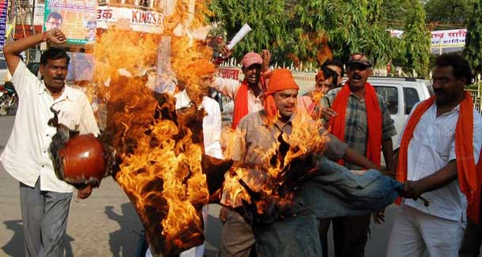
Shiv Sena activists demonstrate in Mumbai.
IT is happening too often. Parochialism is rearing its ugly head in Mumbai too frequently. The Shiv Sena is threatening to throw out ‘outsiders’ from Mumbai and the rest of Maharashtra.
Self-centred party chief Bal Thackeray has created a ruckus once again, this time dragging into controversy Sachin Tendulkar, the world’s best batsman, who said that he was proud to be a Maharashtrian but that he was Indian first. How should this remark irritate anybody?
I think it is time that Mumbai was made a Union Territory. Industrially and commercially, it is the hub of India’s financial activity. Delhi is a Union Territory because it is the centre of the country’s political activity. Why should Mumbai, which is India’s financial capital, have a different status?
People from various parts of the country have settled in Mumbai making large investments and contributing to business life their labour and entrepreneurship for decades. More money has come from others, not the Maharashtrians. Even population-wise, my impression is that the non-Maharashtrians are a bit up.
If nothing else, the contribution by ‘outsiders’ should shut up the Shiv Sena and its ilk, the Maharashtra Navnirman Sena, that they are a burden on Mumbai or that the jobs in the state should be given to Maharashtrians alone. This pernicious thesis, the son-of-the-soil articulation, was advanced by many states, including Maharashtra, before the Fazl Ali States Reorganisation Commission in 1955. It firmly rejected the various claims and held: “It is the Union of India that is the basis of our nationality.” In its report, the Commission said that “it (Bombay) has acquired its present commanding position by the joint endeavour of the different language groups”.
The proposal that Bombay should be constituted as a separate unit was first mooted by the Dar Commission when the constituent assembly was debating in 1949 the formation of linguistic states. The then ruling Congress party accepted the proposal for the reorganisation of states.
Prime Minister Jawaharlal Nehru took a fancy to the idea of keeping Bombay apart. He pushed it when Maharashtra and Gujarat were agitating against the commission’s recommendation to integrate them into one bilingual state. Nehru presented before the cabinet a proposal to have three units: Maharashtra, Gujarat and the city of Bombay. The then finance minister, C.D. Deshmukh, agreed to the formula in the cabinet. But he changed his stand following the furore in Maharashtra and submitted his resignation. Bombay was made part of Maharashtra.
Nevertheless, the linguistic states have not been of much help to the country. They are increasingly becoming ‘islands of chauvinism’. This was the danger to which Nehru drew attention after new boundaries were drawn on the basis of language. The BJP-run Madhya Pradesh is the latest one to announce that it does not want Bihari labour.
Unfortunately, the manner in which certain administrations have conducted their affairs has partly contributed to the growth of parochial sentiments. The rulers have an eye on elections, not realising that the idea of India gets defeated if people prioritise domicile considerations.
After the formation of states, it was understood that the regional language could be learnt after the recruitment. But now its knowledge has been made compulsory before a person is eligible for the job. This is making state services an exclusive preserve of the majority language group of the state.
The prosperity of some states like Maharashtra, Gujarat, Tamil Nadu and Karnataka has raised questions in UP, Bihar and Orissa, the economically backward areas, that they were not getting their due. Relations between the centre and the states have become strained on this count.
The country’s unity has been uppermost in the mind of policymakers. There have been a few movements here and there, raising the standard of autonomy. But the democratic system with a federal structure, established firmly after the introduction of the constitution in 1950, has taken the wind out of the separatists’ sail. Except for a few militants’ organisations in the northeast, the people’s heart is in the country’s unity.
In the late 1950s, the southern states felt that they were not getting their share. There were agitations and public rallies. Nehru was quick to convenethe National Integration Conference to discuss the various grievances. The conference appointed many committees to give their recommendations on how to bring about national integration.
Before they could submit the reports, China attacked India in 1962. All committees made just one comment: The Chinese invasion had united the entire country. Indeed, this was true because all dissenting voices died in no time.
The country had a jolt in the 1980s. The Akalis in Punjab revolted. The state was in the midst of militancy for about a decade. The Sikhs themselves turned against the militants who had made their life hell. Punjab is today a peaceful state.
The odd voice of linguistic chauvinism, the fallout of the reorganisation of the states in 1955, has been heard in some areas off and on. The real purpose has been to gain votes in the name of the ‘stepmotherly treatment’ meted out to a particular community. It must be admitted that slogans in the name of language or caste has helped.
The only state where parochialism has been constantly fostered by the Shiv Sena is Maharashtra. The group even won an election with the support of the BJP, on the slogan ‘throw out outsiders from Maharashtra’. Bihari labourers were beaten up, something which Raj Thackeray, nephew of Bal Thackeray, repeated after breaking away from the Shiv Sena.
No doubt, the basis of nationality is the Union of India. The states are but the limbs of the union. Yet the limbs must be healthy and strong. Some states have too many poor people concentrated in their territory. Yet what keeps India together is its diversity. By dividing the country into linguistic spheres or by injuring the rights of those who are in a minority, the parochial elements are posing a danger to the very idea of India. It is better that organisations like the Shiv Sena understand this.

