Shutting school doors on Muslim children in India
April 06, 2012 |

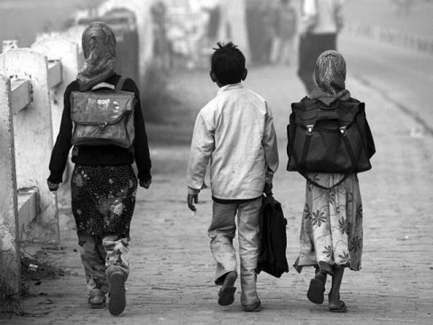
Hem Borker
That a news report in The Hindu titled “In Delhi’s nursery classes, Muslim children are a rarity” (March 19, 2012), found mention in the Rajya Sabha the same day, leading to “heated arguments” and a “verbal duel” in the Upper House, is symptomatic of the polarisation of public discourse on the education of Muslims. Almost any discussion on the subject slides into binaries: religious vs secular, exclusion vs appeasement, rights vs politics, reality vs rhetoric, and conservatism vs systemic discrimination.
A study
In 2009-10, as part of the National CRY Fellowship Programme, I had conducted a series of interviews with 20 Muslim families residing in Zakir Nagar, New Delhi, on the question of what shaped their schooling choices for their children. Unanimously, the parents regarded modern mainstream education as the single most important factor which safeguarded their children’s future and clearly articulated a preference for sending their children to reputed private schools. However their narratives echoed the contesting dilemmas many faced on account of “being Muslim”; dilemmas which illustrate the manner in which the increasing communalisation of social space subtly limits choices or renders them non-existent in something as fundamental as education.
“We want schools that do not discriminate against our children.”
This statement highlights the increasing sense of helplessness and exasperation parents feel at the difficulty their children face in gaining admission to private schools. Many talked about their “feeling” that private schools have some sort of a “prefixed quota of just this much and no more Muslims”; some parents cited how the neighbourhood points seemed to have marginal weightage in the case of private schools nearby, while others talked about having to use “jugaad” to get their children admitted saying that this was not an option available to the ‘ordinary’ Muslim.
Respecting minority sentiments
Many talked about consciously opting for Christian schools rather than the Hinduised regular public schools, as, at some level, Christian schools are “good” and respect minority sentiments. They also explained the choice in terms of pragmatism as Christian schools are generally convents, have a better command over the English language, and have a strong emphasis on discipline.
Parents shared experiences of their children being “unnecessarily picked on, classified in front of their peers and harassed by teachers.” In many of the interviews, parents repeatedly made references to derogatory comments made by teachers on the eating and dressing habits (headscarf or extra-long skirts) of Muslim children. This was corroborated by the children when I asked them about things they did not like about school. Many of them talked about how they did not like being singled out (on account of their religion), examples being a teacher adding “Miyan” to the child’s name while taking attendance (“I don’t know why my teacher keeps adding ‘Miyan’ to my name ... everyone has started saying that”) or the cricket coach’s insinuating reprimands (“Isko bouncer mat dena, sar tod dega ... ye sab garam mizaj ke hote hain”) or as a 10-year-old girl said, “Nobody in school wants to play hide-and-seek with me. Everyone says Muslims cannot be trusted with secrets.”
Parents described themselves as being very “conscious,” “mindful” and “careful” about the choices they were making vis-à-vis their children’s education - what the school environment was like, where to send their children to play or for dini talim. The choices available often lay at two ends of the spectrum - “excessively religious” people in the neighbourhood who kept on preaching Islamiyat or the excessively modern who tried to act like “everyone else.”
For many parents the biggest worry was how to straddle these two extremes. Their responses constantly brought up the dichotomy of the “Good Muslim” and the “Bad Muslim” and the difficulty they faced in ensuring that their children are brought up in “Muslim ways” without falling into the “conservative trap.”
In fact this concern was shared at various points in the interviews. Parents would juxtapose their own education back home (generally where they were a part of larger families in a more “Muslim milieu”) with that of their children’s education (in a nuclear set up in Delhi, where, as parents, they consciously tried to familiarise their children with the culture). Many parents mentioned how in their families, “family values” included orienting their children towards religion and conformity with a certain moral discipline. These situations often put the parents in an awkward position limiting their options to Muslim managed schools which respected their culture but did not provide the secular grounding required for the children not to feel alienated in the future.
Educating the girl
Many parents expressed the difficulties they faced in choosing appropriate schools for their girls. For parents, many of whom aspired to remain true to their native roots located in rural or semi-urban Bihar and Uttar Pradesh, it was difficult to locate schools which ensured that their girls could avail the benefits of a modern secular education that provided some degree of certainty of access to respectable marriages and, if need be, appropriate employment but did not corrupt them into western ways; an institution which was not co-educational, had a modest dress code and was located nearby to ensure that the parents could reach them quickly in case of a “threatening” (danga-fasad) eventuality. I noted that in the case of girls, unlike boys, in the event of an absence of a combination of these criteria the parents generally made compromises on the quality of schooling and sent the girls to nearby (often unrecognised) schools within Jamia Nagar which promised girls education (not co-education), held classes in Urdu and sometimes imparting dini talim, and had the salwar kameez as the uniform. But the drawback was that these schools were not necessarily recognised by boards such as the CBSE/ICSE or had classes up till class 12.
While these daily struggles are in no way representative of the Muslim experience of education, they do highlight the bad nature of the problem. On one side the policy discourse refers to educational backwardness as one of the main causes for real and/or perceived alienation of Muslims and acknowledges inclusive education as a panacea; on the other, these real life situations demonstrate the everyday issues Muslims face in accessing these very opportunities, leading to further isolation, exclusion and excessive reliance on “Muslim managed services and networks.” –The Hindu

