Consensus on Kashmir
By A.G. Noorani
Saturday, 15 May, 2010
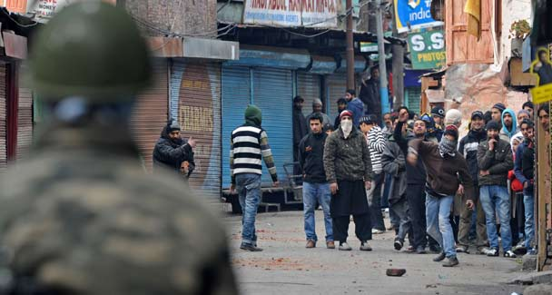
No settlement will work unless it is supported by a domestic consensus within India, Pakistan and Kashmir.

The India-Pakistan peace process must have a Kashmir settlement as its clear goal; but no settlement will work unless it is supported by a domestic consensus within each of the three parties — India, Pakistan and Kashmir.
All Kashmiris, separatists and unionists, are now agreed that the future of Kashmir cannot be decided without the concurrence of Pakistan. In India, the Bharatiya Janata Party (BJP) is sworn to oppose any initiative by the present government on any major issue, whether domestic or foreign. In 2004 L.K. Advani asserted that the Hindus would trust the BJP alone to forge an accord with Pakistan. In 2007 he and Atal Behari Vajpayee asked Pakistani visitors to wait till the BJP returned to power; it would give better terms. Both are false. The country will back Prime Minister Manmohan Singh who received a renewed mandate in 2009 which ends in 2014.
In Pakistan resentment against Gen Pervez Musharraf has in some minds rubbed off on his four-point proposal; understandably but not rationally. But, Nawaz Sharif has a formidable record of support for an entente with India and a settlement of Kashmir based on a fair compromise. While in office as prime minister, he told visiting Indian publicists: “We will all have to give up something. India will have to step back; Pakistan will have to step back; and so will the Kashmiris.” He clearly envisaged a compromise. In opposition he told an Indian correspondent on Dec 28, 1995 that he would “support to the hilt” any sincere effort by Prime Minister Benazir Bhutto to improve relations with India.
He repeated his commitment at least twice during the election campaign in February 1997. “This is now a part of my election platform,” he told his colleague Sartaj Aziz. As premier he met Prime Minister I.K. Gujral in Male in May 1997. The upshot was the joint statement of June 23, 1997 on a composite dialogue.
In 1998, a BJP regime came to power in India. Prime Ministers Nawaz Sharif and Vajpayee met in New York in September and decided to launch a back-channel. At the Lahore summit in February 1999 they decided to accelerate it. They agreed also that neither side would reiterate its extreme position — UN resolutions and Kashmir as a non-negotiable issue. Kargil flooded the channel.
What is the status of the Kashmir dispute today? Since 1990 even the US ceased to talk of the UN resolutions. In February 1958 Prime Minister Feroz Khan Noon met the US envoy to the UN, Henry Cabot Lodge, in Karachi. Ambassador James M. Langley recorded: “Noon made no mention of a plebiscite and it seemed to me that he was clearly thinking of a compromise which would provide for a territorial division between India and Pakistan.”
Noon was no traitor. A few months earlier on April 29, 1957, the UN mediator on Kashmir Gunnar Myrdal had, in his report, pronounced those resolutions as virtually obsolete: “The situation with which they were to cope has tended to change.” That was 50 years ago. On March 23, 1962 Ayub Khan was prepared to drop plebiscite if India offered an alternative. The Z.A. Bhutto–Swaran Singh talks (1962-3) centred on a partition line in Kashmir; not on plebiscite.
This is the reality which Nawaz Sharif faced in 1998 and Gen Pervez Musharraf at Agra in 2001. Any settlement of Kashmir must meet one clear test and conform to four limitations. It must be acceptable to all the three parties. The limits? First, no Indian government can accept de-accession of Kashmir and survive even for an hour. Secondly, no government in Pakistan can accept the Line of Control as an international boundary and survive, either. Thirdly, nor will the Kashmiris submit to the partition; and lastly they insist on self-rule.
All old notions of a ‘final settlement’ of the dispute come up against those four hurdles, a burden history has imposed. Four points bypass them. They are, as Manmohan Singh said, on May 2, 2008, “a non-territorial solution”; an agreed arrangement reviewable after 10 or 15 years. We no longer squabble over sovereignty; but proceed to improve the situation on the ground by concrete steps so that in actual practice the concerns of each side are met and the four limits are not violated either.
How? The first of the four points envisages that since “borders cannot be redrawn”, we can, as Manmohan Singh said on March 24, 2006, “work towards making them irrelevant — towards making them just lines on a map”. In effect the state is reunited, de facto though not de jure. Men, goods, and literature will move freely across the LoC. The Hizb leader Syed Salahuddin will return to his home in Srinagar. The entire scenario will change radically, to the benefit of Kashmiri.
Especially since this will be coupled with the three other points — demilitarisation, self-governance and a joint mechanism. Manmohan Singh described them as “institutional arrangements”. Pakistan will have a say on matters like water management. This arrangement will grow with time, and is open to improvement. For instance an All J&K Assembly, comprising legislators, can be set up as a purely consultative body on matters other than defence and politics. Precise arrangements can be stipulated to ensure free movement.
The former foreign minister Khurshid Kasuri has authoritatively established that such an accord was reached. Is it to be discarded because it bears the Musharraf tag? No responsible parent rejects a proposal for their daughter’s marriage because he or she disapproves of the boy’s father; especially if he is separated from the father, the daughter is none too young and other proposals are not in sight.
Syed Salahuddin endorsed it as a ‘first step’ on Feb 27, 2007, so did Mirwaiz Umar Farooq on March 20, 2007. Time is fast running out. Such an opportunity to clinch matters may not occur for long. As Mao advised Nixon on Feb 21, 1972, “You must seize the hour and seize the day.”

