Kashmir: no ideal solution
By Kuldip Nayar
Friday, 06 Aug, 2010
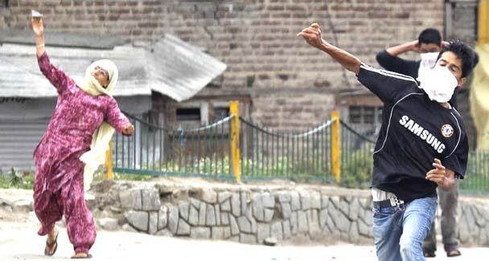
In this photograph taken on July 30, 2010, a Kashmiri woman joins protesters in throwing stones at police in Srinagar. Young men have led street protests and stone-throwing in Kashmir during 20 years of rebellion, but now many females have joined them. Dealing with female protesters is a challenge for the police and paramilitary troops struggling to control recent protests, which India says are instigated by hard-line groups supported by Pakistan. – Reuters Photo
What is happening in the valley lends credibility to the Kashmiri diaspora that met in Washington a few days ago to ask for an early, peaceful solution to the Kashmir problem.
I was one of the participants at the conference which was convened by the Kashmiri-American Council and Association of Humanitarian lawyers. Emotions apart, the diaspora was concerned over the future of the land of their origin.
All agreed, as is the general belief in India, that a delayed political solution of the Kashmir problem is responsible for the eruption of occasional violence or protests in the state. The participants expressed grave concern over the deteriorating human rights situation in Kashmir and demanded the appointment of a commission to investigate the causes of the current violence in the valley, where 43 people have died since June 11 when the present wave began.
I have no doubt that the mishandling of the situation and violation of human rights have contributed to the spread of defiance and destruction in the valley. But the youth were equally determined to pelt stones on security forces.
In fact, the reason behind such occurrences is the alienation of Kashmiris from India and New Delhi’s assumption that the people will ultimately come round to accepting the status quo if they were to find the governance just, honest and working for the betterment of the state. The situation has gone beyond that.
There is validity in the argument that the separatists are not allowing the situation to settle down. But the fact remains that people in Kashmir have given Srinagar and New Delhi many chances — the recent one being the year-old election in which they participated to the extent of 60 per cent — to sort out the problem of autonomy. But the two did not do so.
Where did things go wrong? My experience tells me that the more a political party, or the administration at Srinagar, goes nearer to India the greater is the resentment of people who want to preserve their own identity. A government which is seen challenging New Delhi is liked because it gives them a vicarious satisfaction of being independent.
Sheikh Abdullah, a popular Kashmiri leader, understood this. He did not question Kashmir’s accession to India but placated the Kashmiris by criticising New Delhi for eroding the state’s autonomy. For example, he would say that the Kashmiris would prefer to stay hungry if the atta from India was meant to trample upon their right to stay independent. It may have been a fiction but it worked.
Even Jawaharlal Nehru, the Sheikh’s friend and supporter in political battles against the Maharaja of Jammu and Kashmir, did not understand his rhetoric and detained him without trial in southern India for some 12 years. Still Nehru realised rather late that tampering with autonomy had taken the shape of separation and a strong pro-Pakistan tilt. He released the Sheikh and sent him to Islamabad. Unfortunately Nehru died when the Sheikh was in the midst of talks with Gen Ayub Khan, Pakistan’s martial law administrator.
Until then Kashmir was a problem between India and Pakistan. They held talks and fought wars but reached nowhere. The Shimla Agreement converted the ceasefire line into the Line of Control. But the two failed to go further because of their domestic compulsions. The Sheikh returned to power and entered into an accord with then Prime Minister Indira Gandhi that restored some autonomy which New Delhi had appropriated in his absence. But the Sheikh did not have a free hand because the bureaucracy and the intelligence agencies, by then strong, did not want him to succeed. They “treated me like a chaprasi (peon),” the Sheikh often told me.
His son, Farooq Abdullah, much less in stature, tried to retrieve the situation by asking New Delhi to go back to the terms of accession, the centre retaining only three subjects, defence, foreign affairs and communications. Successive governments at New Delhi felt that they could not go back as they feared a backlash. Former Prime Minister Atal Behari Vajpayee was the only person who foresaw the danger in not reaching a settlement. He set up a back channel which almost found a solution when Prime Minister Nawaz Sharif was ousted by Gen Pervez Musharraf.
I was reminded of the promise Nehru made to the Kashmiris that they would be given an opportunity to decide what they wanted to do with their territory. I told them that Nehru had rejected the demand for a plebiscite in his lifetime. His reasoning was that Pakistan by joining Cento and Seato, the two military pacts against the Soviet Union during the Cold War, had changed the context of the undertaking.
In the ’80s, the Kashmir problem became an issue. The Kashmiris too claimed a place on the table for talks on Kashmir. Rigged state elections in 1987 drove the youth from ballot to bullet which Pakistan was willing to provide. The following 10 years saw a running battle between the Kashmiris and the security forces. Thousands died on both sides. The result was a further hiatus between the Kashmiris and New Delhi.
Three things happened. One, the anti-India Kashmir leadership constituted a joint body, the All Hurriyat Conference. Two, a secular movement acquired an Islamic edge, particularly because of hardliner Syed Ali Shah Geelani. Three, the pro-Pakistan tilt changed into a resolve for independence, the slogan which Yasin Malik, the first militant in Kashmir, raised. Today that sentiment prevails in the shape of a demand that Kashmiris decide their own destiny.
The demand for independence may be genuine but it is not possible. I wonder even if Pakistan would agree to an independent, sovereign state when the chips are down. I opposed the demand at the conference in Washington on two counts: one, India will not agree to another partition on the basis of religion, and two, borders could be made irrelevant but not changed. I also cautioned that Jammu and Ladakh would not go along with the valley to the point of secession.
Yet it would be useful to find out what was the solution that Vajpayee and Nawaz Sharif had reached to make the former say: “We were almost there.” Former Foreign Minister Khurshid Kasuri announced at Delhi that they had reached a settlement. What was the solution? And the most important part is whether Kashmiris would accept it? Both India and Pakistan must persuade them to accept autonomy because independence does not seem to find favour in either New Delhi or Islamabad. It can tell upon India’s integrity. The Kashmiris should realise that independence is not an ideal solution.
The writer is a senior journalist based in Delhi.

