The Kashmir dilemma
By Kuldip Nayar
Friday, 11 Jun, 2010
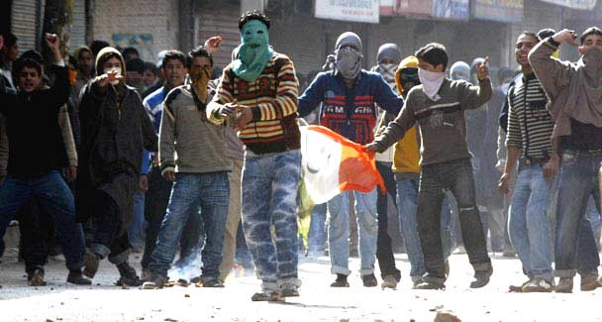
Very few movements in the world have been so determined and so sustained. –Photo by AFP
Gen Ayub Khan, when at the helm of the Pakistan government, is believed to have told Soviet Union’s Prime Minister Kosygin that if India were to come to a settlement with Sheikh Abdullah, heading the Jammu and Kashmir government at that time, Pakistan might accept the agreement.
Soon after, Sheikh Abdullah was detained for more than 11 years in India. He had reportedly asked New Delhi to make the terms of the Instrument of Accession good. The state had given to the centre only three subjects: defence, foreign affairs and communications.
Since then the All Parties Hurriyat Conference has jumped into the arena. Its agenda goes far beyond Sheikh Abdullah’s or, for that matter, that of the ruling National Conference. Unfortunately, the Hurriyat has split into hardliners and moderates.
Whatever its verdict on the government headed by Omar Abdullah, Sheikh Abdullah’s grandson, the latter has made the security forces accountable. The suspension by the army of a major and removal of a colonel from service for their ‘role’ in dubious encounters is not a small achievement. In fact, he has ordered an inquiry into fake encounters of the past, and strict orders have been given to the security forces not to violate human rights.
Hurriyat chairman Mirwaiz Umar Farooq said: “We expected the prime minister to start a bold political initiative on Kashmir but nothing of that sort has come through.” Obviously, the Hurriyat has not taken into account Dr Manmohan Singh’s message that the government was committed to pushing forward the process of negotiation.
The Indian prime minister wanted the Hurriyat to come on board before India held a series of ministerial-level meetings with Pakistan. It is naïve on the part of Mirwaiz to demand a public announcement on what the government has in view. A dialogue is the only way to hammer out differences. In the case of Kashmir, Pakistan is also a party.
True, Srinagar was shut and hundreds were on the street when the prime minister arrived there. But this is the exercise over which the Hurriyat has gone many a time before. People are tired. They see very little on the horizon. They have sacrificed nearly all that they had.
I think the failure of the Hurriyat is in having preferred the bullet to the ballot. They revolted when they, young and idealistic, witnessed elections in Kashmir in 1987. Indeed, the polls were rigged. But going across the border, getting training and returning with weapons was the reaction of angry, helpless people. Violence, as some Hurriyat leaders have realised, was not an option which could have yielded results. Coming into conflict with the state which is many times stronger was foolhardy.
Believe me I am not underestimating the sacrifices of the people. Very few movements in the world have been so determined and so sustained.
The Hurriyat should have returned to the ballot box after the violent agitation it had launched was having diminishing returns. In violence, the people in India witnessed a forceful cessation of Kashmir, considered part of the country. The Hurriyat movement was seen as a challenge to the country’s integrity.
The Hurriyat should have tried to capture the Jammu and Kashmir assembly. Instead, they propagated the boycott of elections. Their argument was that the polls under the aegis of the Indian Election Commission were not acceptable to them. They proposed supervision by UN observers. No sovereign country could have accepted this.
Had the Hurriyat leaders demanded that Indian human rights activists should be the observers, they might have had the consent of New Delhi. But would the Hurriyat have won? This uncertainty might have been the main reason for it not participating in elections which have their own dynamics. Popular agitators are not normally put in charge.
The Hurriyat’s tilt towards Pakistan, probably necessitated by the situation in which they were, has distanced it from India. That the solution of Kashmir is not possible without Islamabad is understandable. But the Hurriyat did not have to play the Muslim card. It only created further doubts in the mind of the majority in India. After the exodus of most Hindu Pandits from Kashmir, the valley has nearly 96 per cent Muslims.
But this is the Hurriyat’s weakness, not strength. Not having the support of the Hindu-majority Jammu and the Buddhist-majority Ladakh, the Hurriyat has forfeited the right to speak for the entire state. It should have at least wooed the Kashmiri Pandits, many still in camps, to return their homes. Some Hurriyat leaders have realised this a bit late. But the party as such still cannot pursue the matter wholeheartedly because a few among them do not want Hindus back till the Kashmir solution is finally settled.
Even in their demand, the Hurriyat has been equivocal. They have oscillated between autonomy and independence. Realising that Pakistan is equally opposed to independence, as India is, the Hurriyat wants a solution which is acceptable to the people of Kashmir. But that has not been spelled out. The fact that Jammu and Ladakh are nowhere in the picture means that the Hurriyat’s demand is only for the Valley. This brings the Hurriyat in conflict with what Manmohan Singh has said many a time that he has no mandate to change the borders.
After the 9/11 attack in New York, the scenario in the region from Afghanistan to India has changed beyond proportions. America and Pakistan one hand and India and Pakistan on the other are trying to come to terms with new developments. Kashmir too figures but in the larger context.
The Hurriyat might do better if it were to confine talks between Srinagar and Delhi till India and Pakistan reach a settlement on Kashmir. The Hurriyat should ask New Delhi first to restore the ante-1952 situation where Srinagar gave it three subjects: foreign affairs, defence and communications.

