WB doesn’t accept Kashmir as part of India
By Masood Haider
Wednesday, 23 Dec, 2009
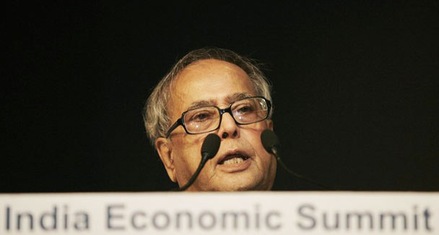
Finance Minister Pranab Mukherjee, pictured here, met Indian occupied Jammu and Kashmir’s Forest Minister Mian Altaf Ahmad, along with MPs from the state recently in New Delhi to discuss the issue.
UNITED NATIONS: The World Bank has refused to accept occupied Kashmir as an integral part of India and has insisted on a disclaimer from the Jammu and Kashmir government that funding for a project will not be seen as recognition of India’s territorial claim on the state.
The bank has put a ‘disclaimer clause’ for bankrolling a key project in the disputed state which indicates that funding of projects in disputed areas should not be used to endorse territorial claims, said a news report here on Tuesday.
‘If you have a query on World Bank’s decision on J&K, ask Prabhu now.’ This has been communicated to New Delhi by the occupying state government which wants the World Bank-funded Rs740 crore ‘Participatory Watershed Management Project’ to be completed.
Indian occupied Jammu and Kashmir’s Forest Minister Mian Altaf Ahmad, along with MPs from the state met Finance Minister Pranab Mukherjee recently in New Delhi to discuss the issue.
The government of the occupied state wants New Delhi to settle issue with the World Bank, which has refused to fund more projects in the state, treating it as a disputed territory between India and Pakistan. Mr Ahmad said the World Bank had raised the disclaimer issue last year after assessment of the project which was then at the funding stage.
He said if the centre pursued the matter; the bank could be convinced to give up the disclaimer condition. The World Bank was instrumental in committing India to allow the waters of the state’s three principal rivers — the Indus, the Jhelum and the Chenab — to flow unimpeded under the Indus Water Treaty of 1960.
Article XI of the treaty is quite emphatic that it will deal only with the water-sharing issue and its implementation will not acknowledge or waive any other rights other than those specified in the treaty.
In other words, it will have nothing to do with the territorial dispute between the two parties.
In the troubled history of India-Pakistan relations, the Indus Water Treaty stands out as a major success for which the World Bank, the third signatory to the treaty, deserves great credit. As party to the treaty, the bank created an $895 million Indus Basin Development Fund to which India contributed some $174 million.
This is the second time this year that India has had friction with a multilateral development agency over project funding in a state that has a border dispute.
An Asian Development Bank (ADB) country loan to India had run into trouble because it included funding for a watershed development project in Arunachal Pradesh — a point that was objected to by the Chinese at the ADB meeting. The World Bank had funded two projects in Jammu and Kashmir under the integrated Watershed Development Programme with Rs900 million from 1990 to 1999 and Rs1.98 billion from 1999 to 2005 without bringing up the disclaimer issue.
A team of the World Bank headed by Norman Piccioni had visited the occupied state from May 5 to May 12 last year to assess the feasibility of the Participatory Watershed Management Project.
The project is likely to cover 3,14,705 hectares for adopting integrated watershed management to reverse the degradation of the natural resource base and improve the livelihood of poor rural households in the project area.
The World Bank will finance 80 per cent of the project and the state government 17 per cent. Participatory communities will contribute 3 per cent.
If implemented, 1,74,250 households will be covered while 50,675 households will directly benefit from the project.
Overall, it is expected to benefit over a million people and generate 4.5 million person-days of wage employment besides providing jobs to 2,000 people regularly for seven years.

