City under seige
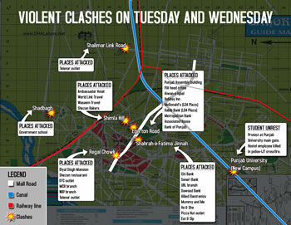
* Police cracks down on protestors on Tuesday and Wednesday
* Protests take place at Regal Chowk, Rang Mahal, Shah Alam Chowk, Mayo Hospital Chowk, McLeod Road, Thokar Niaz Beg, Kalma Chowk
* CPC says 10,000 police personnel deployed to stop violent protests
By Shahnawaz Khan
LAHORE: Enraged protestors damaged public property during several protests at various locations in the city on Wednesday.
Lahore Police cracked down late on Tuesday night on ‘troublemakers’ and arrested hundreds of people across the city. On Wednesday morning, a group of protestors came out at Regal Chowk on Mall Road chanting anti-government and anti-US slogans and stoning dozens of vehicles.
Meanwhile, police and paramilitary personnel tried to arrest the protestors, but they dispersed and escaped. Half an hour later another group of protestors appeared on Mall Road chanting slogans and stoning vehicles. They also succeeded in escaping when police and paramilitary personnel tried arresting them. Later, paramilitary personnel completely cordoned off Mall Road from Town Hall to Governor’s House.
A similar group of protestors appeared at Shoe Market in Rang Mahal and made shopkeepers shut their shops. They chanted slogans against the publication of caricatures of Prophet Muhammad (PBUH) by several European newspapers and against the government. They later moved towards Shah Alam Chowk where they protested and chanted slogans against Danish newspapers and the US government.
Later, protestors appeared at Mayo Hospital Chowk and entered a Muslim Commercial Bank (MCB) branch where they beat up bank employees and damaged bank items. The bank was closed after the incident.
In the afternoon, a Punjab University (PU) hostel employee was killed in crossfire between police and Islami Jamiat Talaba (IJT) protestors after which several groups of students protested and scuffled with police at several locations from the PU campus to Kalma Chowk. Paramilitary personnel cordoned off the entire area.
Protestors also appeared at Multan Road near Thokar Niaz Beg where they protested and tried to force traders to shut their shops. Police tried to stop them, but the protestors attacked the police who retaliated and baton charged the protestors, injuring several of them. The mob dispersed after police action and police took the injured protestors to Jinnah Hospital.
A group of protestors appeared at McLeod Road in the evening and forced traders to shut all shops. They also chanted slogans against the caricatures of Prophet Muhammad (PBUH) published by several European newspapers.
Police continued cracking down on protestors all day and arrested more than 150. Khawaja Khalid Farooq, city police chief (CPC), also held a special meeting later in the evening.
He said Lahore Police had deployed more than 10,000 personnel to stop violent protests throughout the city. He also assured traders and citizens that their lives and properties would be secure and that police would not let anybody resort to violence.

