Extra-legal killings
By I.A. Rehman
Thursday, 25 Mar, 2010
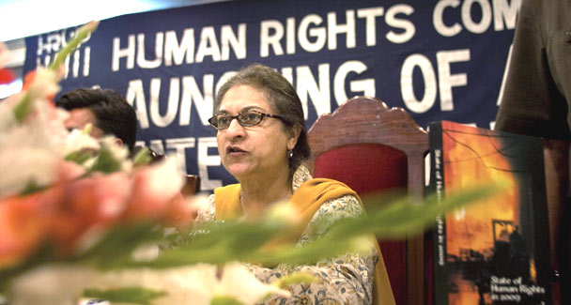
A new report released by the Human Rights Commission of Pakistan has recorded 226 encounter killings in 2009, with Punjab as usual leading the other areas with 181 killings (Sindh 31 killings, Frontier 13 and Balochistan one). The frequently voiced official complaint that civil society organisations exaggerate crime figures has proved to be baseless because the Punjab police chief has conceded that 253 ‘gangsters’ were killed during 2009 in his province alone. - Photo by AP.
Extra-Legal killings in so-called police encounters was again a major cause of concern of human rights activists in 2009, and in future the government’s efficiency as well as its respect for human rights will be judged by its ability to rein in trigger-happy police officials.
The Human Rights Commission of Pakistan (HRCP) has recorded 226 encounter killings in 2009, with Punjab as usual leading the other areas with 181 killings (Sindh 31 killings, Frontier 13 and Balochistan one). The frequently voiced official complaint that civil society organisations exaggerate crime figures has proved to be baseless because the Punjab police chief has conceded that 253 ‘gangsters’ were killed during 2009 in his province alone. He claimed that all but one of the 307 encounters were genuine and that 28 policemen also lost their lives.
These figures confirm the pattern of encounter killings observed over the past many years. For instance, in 1999 HRCP recorded 350 encounters in which 527 people were killed, 361 of them in Punjab alone. In 2000, the encounter killings declined to 192 (Punjab 94) and rose to 236 in 2002 (151 killings in Punjab). 146 encounters were reported in 2003 (195 people killed, 113 of them in Punjab) and in 2004, the number of encounters stood at 134 (105 killed). This pattern continued during 2005-2008. The fact that encounter deaths shot up in 2009 underlines the need for a study of the causes of the increase in police excesses during a period of civilian-political rule.
One important fact may be stressed straightaway — that police chiefs in all provinces are aware of fake encounters, though it may not be possible to blame all of them equally for blinking at the doings of their subordinate officials or explicitly ordering them to liquidate the ‘criminals’.
Mahmood Ali Khan Chaudhry, a former IG police and interior secretary, and one of the most upright civil servants Pakistan has had, has thrown light on the genesis of ‘police encounters’. In his memoirs, Of All Those Years, he writes:
“Before the murder of Kalabagh, when Ayub considered himself under threat of assassination, the new governor of West Pakistan, the retired general Muhammad Musa, ordered the wholesale arrest and disposal of violent criminals in the Punjab region. The IGP proceeded accordingly and fake encounters between police and criminals mushroomed. Hundreds of so-called criminals were rounded up and killed in cold blood during different kinds of encounters.”
As a DIG, M.A.K. Chaudhry did not act upon the IGP’s directive and was upbraided by him. The IGP sent copies of his note of censure to all the district SPs in the range. M.A.K. Chaudhry invited all the six SPs to give their views. “Each one of them was ready to go ahead and do what was being done elsewhere. One SP said that he had a notorious criminal in his custody, who he intended to lock up in a mud house and burn it down.” The DIG told the SPs that he would not allow any encounter deaths in his range and if any such death did take place, he would go to that district and “personally register a murder case against the SP concerned by name”.
One may point out, with due respect to M.A.K. Chaudhry, that encounter killings were institutionalised by Kalabagh, who included opposition leaders in the category of criminals liable to summary execution. The death of journalist Zamir Qureshi at the hands of hired assassins commissioned to liquidate Baqi Baloch or Ghulam Jilani Malik, or both, can hardly be forgotten.
While it is true that some police officials justify the encounter killing of notorious criminals in view of flaws in the justice system and court delays, there have been police officials who enjoy encounter killings as a pastime of the brave. Quite a few of them have been hailed as encounter specialists as if they are at a par with penalty-corner specialists.
There is no dearth of evidence to show that many encounters are staged after taking the victims out of places of detention and shooting them dead on roads and highways. The practice of aiming guns at the heads/chests of victims and the use of firearms that are not registered at the police stations concerned offer strong evidence that contradicts the police version of encounters. Besides, the story most commonly offered — that the encounter took place when the criminals tried to escape or fired the first shots — is not taken seriously by anyone.
Unfortunately, senior police officers have not paid due heed to the horrible consequences of their failure to eliminate encounter killings. Firstly, once encounter killings are accepted as a legitimate means of dealing with hardened criminals, the subordinate staff is emboldened to administer this policy for personal gain/satisfaction. Secondly, encounter killings by law-enforcing personnel persuade immature citizens to adopt this method of instant justice for settling personal scores.
One reason that extra-legal killings in police encounters have continued year after year is that the accountability mechanism has become dysfunctional. Each encounter death is supposed to be probed by a judicial authority. In many cases no judicial probe is ordered and where it is somehow ordered the proceedings are a travesty of the due process. The results of such inquiries are almost never made public. Attempts to persuade the authorities to release reports of inquiries are resisted with stubbornness worthy of a noble cause.
Part of the blame for this sorry state of affairs must be accepted by civil society organisations, especially the media. True, the media does take notice of ‘fake encounters’ but such stories are usually treated as crimes of a serious nature. The feeling of outrage that each violation of the fundamental human right to life warrants is rarely witnessed. And follow-up stories are seldom attempted.
Unless the state functionaries and the people both treat encounter killing as a most reprehensible form of murder and go for the culprits with the zeal noticed in campaigns against terrorists, extra-legal killings will continue to take a high toll of lives and bring Pakistan a bad name.

