No pre-emptive action
By Huma Yusuf
Sunday, 28 Mar, 2010
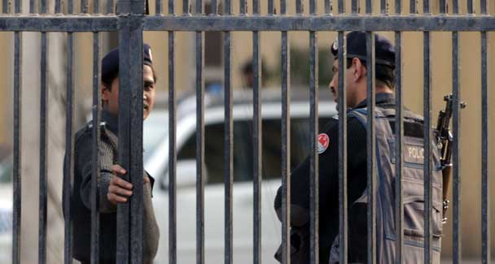
The role played — or not played — by police in fuelling religiously motivated violence needs urgent scrutiny, and should be one of the main drivers of institutional reform.
THANKS to media coverage, there has in the last few weeks been a renewed interest in police brutality and, by extension, police reform. But another aspect of police negligence has not graced our headlines and on-screen tickers.
The role played — or not played — by police in fuelling religiously motivated violence needs urgent scrutiny, and should be one of the main drivers of institutional reform.
Recently, it was revealed that local police had fair warning of a sectarian attack that occurred in Faisalabad last month when an Eid Miladun Nabi procession was fired on, leaving four injured, and leading to protests in which a mosque and police station were vandalised. Sadly, the eruption of violence had come as no surprise to the residents of the city’s Ghulam Muhammadabad neighbourhood.
Before the firing incident, the prayer leader of the Gol Mosque, Zahid Mahmood Qasmi, had announced in his sermons as well as through correspondence that his congregation would halt the religious procession by any means. On Feb 22, Qasmi even had the gall to pre-emptively justify participating in sectarian violence: in a letter to the city police officer, he alleged that participants in the same procession had provoked him a year before (a subsequent police investigation confirmed these allegations to be baseless). Despite being in possession of a written testimony stating that a sectarian attack was imminent, the local police did nothing. One week before the incident, the police were able to identify the perpetrator and location of the attack and yet they could not prevent the assault. In this scenario, the word ‘negligence’ seems like an acute understatement.
Unfortunately, such police inaction has become the rule, rather than the exception, in the context of sectarian violence. In Gojra, too, after seven members of the Christian community had been burned alive in religiously motivated August last year, the local community demanded that the police be held accountable for negligence.
A six-hour-long sit-in by local Christians ended only when the names of the district police officer and district coordination officer were included in the FIR. The Asian Human Rights Commission reported that anti-Christian sentiment had been broadcast over the loudspeakers of mosques — many of which are within hearing range of police stations — for two days before the riot. At the time, the spokesperson of the Pakistan Christian National Party repeatedly asked, “Did the officials at the nearby police station not hear inflammatory speeches of clerics? Why did police not take timely action to stop them?”
The fact is, most religiously motivated attacks are preceded by virulent hate-mongering and incitements to violence. No organ of the state is better situated than the police to identify, report and investigate the hate speech that stirs sectarianism. After all, with a little due diligence the Faisalabad police could have detained Qasmi under Article 7 of the Anti-Terrorism Act for inciting his congregation to violence and threatening procession participants.
For police to proactively and pre-emptively address sectarian threats, stemming from intolerance at the grassroots level has to be prioritised within their mandate. This can only be achieved through mandatory and rigorous police training. It would be naïve to think that police officials in places such as Gojra and Dera Ismail Khan can easily identify hate speech as a criminal activity and cause of sectarian outbreaks; many probably hold the same intolerant and prejudiced views against religious minorities as the perpetrators of violence.
Around the world, police officers receive special training to recognise and handle sensitive social crimes such as domestic violence and hate crimes. Trainings focus on the special nature of these crimes, the legal and constitutional framework within which they can be prosecuted, and ways in which law-enforcement and investigation can be conducted to reassure victims and alleviate community tensions.
Ideally, the Pakistan police should tailor a training course on identifying and preventing sectarianism based on local law, politico-communal dynamics, and available means. In the absence of the expertise and resources to design and implement such a course, our police should turn to the international community for help.
For instance, the US Civilian Police Advisory Training Team, which was tasked with training the Iraqi National Police, devised a course to address the problem of sectarian death squads within the police force itself. Certain Iraqi police units received three-week-long “police transformational trainings” to boost their respect for human rights and the rule of law and counter sectarian sentiment. Such police training resources could be shared with Pakistan under the Coalition Support Fund.
The need for such training cannot be underestimated. Police negligence is further eroding the public’s trust in the state, leaving huge swathes of the country vulnerable to rampant sectarianism and rule by localised armed militias. It is telling, for example, that protesters in Faisalabad stoned and torched the police station and set police vehicles ablaze after the sectarian attack there. In their opinion, the callously unconcerned police — and not the Gol Mosque congregation — were the villains of that attack.
Moreover, sectarian tensions are once again conjoined with law and order: through 2010, from Karachi to Dera Ismail Khan, certain elements have tried to stoke cycles of sectarian violence to undermine state authority. The police therefore should take all measures possible to tackle sectarian threats.
Ultimately, training for police officials to handle sectarianism must be enshrined in institutional reforms. In the meantime, in an effort to make Pakistan’s religious minorities feel secure, the government should empower the public safety commissions created by the Police Order 2002, and enforce stringent mechanisms for police accountability.

