Terrorism and the police
By Ayesha Siddiqa
Friday, 14 Aug, 2009 | 02:58 AM PST
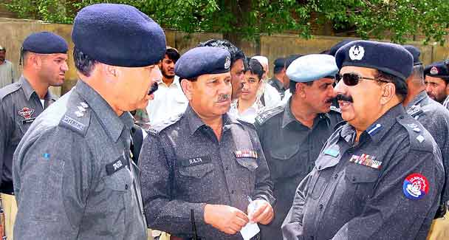
The police’s strength lies in its institutional network which is extremely sound when it comes to gathering information at the local level. –Photo by APP
In a recent letter to the editor in this paper, a reader has expressed surprise at a perception contained in columnist Ahmad Faruqui’s article Talking to India (Aug 3) that no assurance can be given to an ‘apprehensive Indian population that Pakistan’s shadowy intelligence agencies are serious about cracking down on the zealots….’
It has also been pointed out in the letter that ‘it is the law-enforcement agencies, not the intelligence agencies, that are supposed to take corrective action against anyone who breaks the law.’
This shows a lack of understanding of how law-enforcement agencies in Pakistan are less powerful than the military and its intelligence agencies. In a country, which has been ruled by the military for half of its history, it is strange, that some people should still not be able to comprehend the fact that the armed forces or any institution attached to them are more powerful.
However, the more pressing question remains of whether the police can fight the terrorists. Experts believe that the police do not have the capacity to fight terrorism. Surely, the police could never deal with the Taliban in the tribal areas which in any case have never been under state control.
In fact, control over places like Swat in the Frontier province was also lost as weapons flowed into these areas. Once the police found itself out-manoeuvred because of better equipment in the possession of the other side, fighting became difficult and Fazlullah and his group got out of control. Such circumstances also lead to a lack of motivation. How can a numerically inferior and ill-trained and under-motivated force fight the highly motivated jihadis? It is no secret that the police in most provinces are busy protecting the numerous VIPs.
However, its strength, especially in areas where the state has some marginal writ, lies in its institutional network which is extremely sound when it comes to gathering information at the local level. For instance, the police can tackle the Punjab-based jihadis. This is not because these different groups responsible for deadly attacks inside and outside the country are weak. In fact, they are deadlier than a lot of Taliban groups as their force is driven simply by ideology and they are not tied down by ethnic and tribal affinity. In terms of their lethality, the Punjab-based groups are on a par with the Jemaah Islamiya of Indonesia or the Uzbek warriors.
Here, the argument is that the greatest strength of the police is its tremendous intelligence network. Police know what is happening in an area and who the crooks and the good guys are. Many must have heard of the joke about the search for the British queen’s lost dog. While the British, German and American police were unable to find the canine, a Pakistani police official went into a nearby forest and returned with a cow who ‘confessed’ to being the queen’s dog. This reflects the institution’s brutality and its penetration.
So, it is impossible that the local police had no idea about Master Riaz (linked with the Mian Channu blast) and his activities. In fact, police in Punjab, like their colleagues in the Frontier, know exactly where the culprits are.
Problems occur when they are ordered not to touch unsavoury characters or there is intervention from the authorities considered more powerful than the lowly police official. In a socio-political system driven by sheer authority, a police SHO or ASI knows fully well that saying no to someone who claims to be a military intelligence official might have extremely unpleasant consequences. There are many instances when the police are unable to carry out their duties due to outside interference.
There have also been many instances in the past when jihadi groups proved effective in tackling extra efficient police officials and officers. Some might argue that such intervention happened during times when most or some of the jihadis were state assets. Nevertheless the problem is two-fold. First, it is still not clear if all state elements have completely withdrawn their support for certain jihadi outfits. For instance, in numerous cases journalists trying to study south Punjab were warned off not by jihadis but by military intelligence. So, are these militants assets?
Clearly, the Pakistani state seems to be sending mixed signals. There is the political state which wants to solve the problem; thus we have the interior minister submitting a list of 25 banned organisations. But then secondary verification shows that even organisations like Al Qaeda are not banned (this was admitted in the Lahore High Court) which means that covert state elements may well be continuing their support to groups.
Second, with such confusion police officials find it very difficult to tell if the more powerful part of the state continues to support the militants. After all, intelligence agencies never publish an announcement saying that they are withdrawing support. Perhaps police officers should be held responsible for not raising a hue and a cry when they see things going wrong.
The majority constitute those who are afraid for their lives considering that the police are in the direct line of jihadi fire. In the words of a police officer, ‘Why should I put myself in the line of fire when all that I will get for sacrificing my life is Rs100,000 and a state funeral? I go after the shooting is over.’
Incidentally, the officer cited above is truly one of the most professional, committed, honest and well-trained officers. But the bulk of police officers give in to pressure be it from politician, the army or military intelligence. The pressure from above and irresponsible policing then results in poor handling of situations as we saw in the case of Gojra. The bottom-line is that while the government goes around asking for better training and equipment for its police force, it must also attend to internal systemic problems.
While the police needs clarity regarding state policy, it would help if the law-enforcement agencies were empowered to carry out their duties without any interference. It is also high time that we understand that covert states have a high opportunity cost and hamper peace and stability in the country, the region and the world at large.

