What about the police?
By Ayesha Siddiqa
Friday, 19 Jun, 2009 | 03:41 AM PST
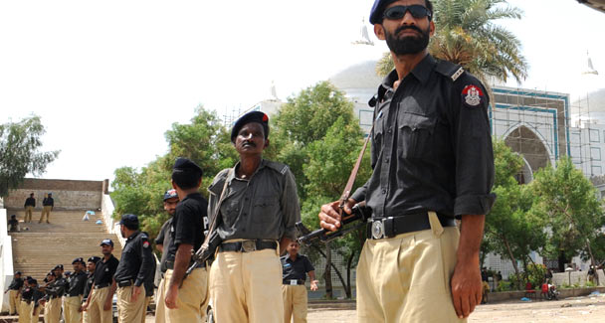
The money invested in the police as compared to the military is much less and thus there are fewer impressive results: Ayesha Siddiqa. –AFP Photo
President Asif Zardari announced his decision to allow a cantonment in Swat with more allowances for military personnel, especially those fighting in the difficult terrain. This is indeed an expression of his appreciation for the military’s ongoing efforts in the fight against the Taliban in Swat and Fata, and his concern for national security.
Surely, the nation must take note of the sacrifice of its soldiers, officers and civilians who died to save the state and society from the Taliban.
While the president is involved in appreciating the services of different people and institutions, one would like to draw his attention towards another force. This refers to the police which have been at the forefront of the war on terror for a long time, in fact, much before the army. One hopes that Mr Zardari will also announce some form of compensation and facilities for the law-enforcement agencies rather than just for the military.
This recommendation does not emanate from a sense of competition with the army, as some generals might imagine, but recognition of the fact that one may not actually be forced to use the army on internal fronts if the necessary investment is made in security. It is a matter of getting one’s priorities right and understanding that the police (including Pakistan’s) have the best intelligence network and the necessary information to act against internal enemies and extremist forces. Since the police operate in all neighbourhoods, its officers are aware of all the good or bad guys in the area. Furthermore, the police may use forceful methods but symbolically they are a less coercive tool than the military. Hence, deploying the police should be the first option.
This naturally leads to the larger question of how one can depend on a force that is deemed corrupt and inefficient. One is reminded of a joke about three police officers — American, British and Pakistani — comparing notes. The American boasts of being able to catch a thief within 72 hours of the crime. The British competes with a claim of 24 hours. Not to be left behind, the Pakistani policeman claims to be smarter than the other two: ‘We know of the crime even before it takes place,’ he says. Jokes apart, one cannot expect a great performance from a poorly paid, and badly trained and equipped force that fails to achieve results or impress its clients. The money invested in the police as compared to the military is much less and thus there are fewer impressive results.
The police in this country lack investment in resources that could help motivate security personnel into performing better. In cases where the force has been provided with resources and leadership and backed by those at the top, the results have been nothing short of amazing. The Islamabad Traffic Police (ITP) are an example of how things can be changed with the right combination of resources, leadership and commitment. A visit to the SSP traffic’s office is mind-boggling. Not only are the officers manning the premises polite, a visitor does not require a reference to enter the office of the SSP who tries to solve the visitor’s problems as quickly as possible.
SSP Sultan Azam Taimuri and SP Ashfaq Ahmed Khan seem to have made their office responsive to the needs of the people. Besides investing in better training and equipment, an improvement in services was made possible due to the commitment of the top political leadership. We may fault former prime minister Shaukat Aziz for a lot of things, but it is necessary to appreciate some of his achievements, one being the ITP. Reportedly, the Islamabad police were not stopped from impounding VIP vehicles if the drivers of the latter were caught violating the rules.
Obviously, the top political leadership set the priorities right as far as the performance of the ITP was concerned and showed a commitment to combat the notorious VIP culture in the capital. Visiting the ITP office one realises that the lives of ordinary Pakistanis can be made easier once the system in place is set right. And we have the capacity to do so.
In any case, policymaking is about setting priorities right and then showing a commitment towards fulfilling the goals. Governments often fall into the trap of making policies that may have a symbolic value but comparatively few dividends. The proposed investment in the Swat cantonment is one such issue. Why build another cantonment which would require more funds for its protection? A possible answer could be that a cantonment would guarantee that the Taliban would not ever enter the area again. This is based on the assumption that the inflow of Taliban forces is driven from outside, by enemies of the Pakistani state.
There are two possible scenarios. First, the war continues for many years in which a cantonment will prove to be a sitting duck, highly fortified and with no confidence even among the soldiers who would only be able to use heavy artillery without stepping out. A second scenario, on the other hand, is that most extremist forces are eliminated and people manage to return to their homes. In such conditions what would be of greater benefit is to invest in the socio-economic and human resource development of the area. A better administrative, judicial and law-implementation mechanism might be expensive but would bring greater benefits.
A happy, satisfied and secure set of people would not require the military security that Islamabad plans to invest in. In any case, such expansion would be tantamount to bringing an infrastructure in the area that would dominate everything else. Many would justify it on the basis of development that a cantonment might bring. However, investing in direct development is likely to prove more beneficial than such indirect development.
The writer is an independent strategic and political analyst.
ayesha.ibd@gmail.com

