The state of prisons
By Anees Jillani
Monday, 07 Dec, 2009
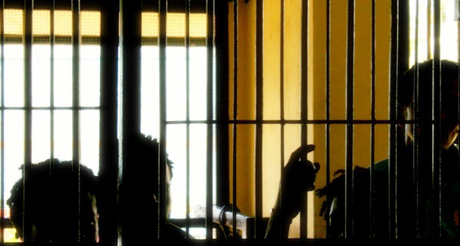
Regardless of personal experiences, one needs to appreciate that a prisoner’s life is as precious as that of any other person. Our collective conscience should lead us into doing something radical to reform our prisons and cure them of their present ills.
One thing that anyone visiting a prison in Pakistan would notice is that almost all the prisoners are invariably from the lower class and thus extremely poor.
One thus begins to wonder whether the rich in this country consist of angels, are above the law, or justice here is one-eyed. Once in a while the rich do end up in jail. But they miraculously immediately fall ill and obviously have to be hospitalised. Mercifully, they don’t request for urgent transportation to a facility in London as this would be an immense burden on the exchequer.
But while in jail the rich enjoy all the facilities available at home, including satellite television, mobile phones and of course three to four prisoners acting as their bonded servants. One prisoner being kept in a jail in the Frontier province was even keeping a cow with him for fresh milk.
As opposed to this, almost all the remaining over 85,000 prisoners (against a capacity of 41,000) live worse than cattle. Each and every prison in Pakistan is overcrowded, and all prisoners sleep on the floors. Many are roughed up by fellow inmates and sexual abuse is common. Toilets are dirty and located within the same cell, thus used by dozens of prisoners, who spend their time day and night in the same place; the stench alone is enough to make one sick.
Infectious diseases are widespread, exacerbated by the lack of water, what to talk of clean drinking water, and every fourth prisoner appears to be suffering from the skin disease scabies. It is undoubtedly a perilous existence. Unfortunately, it is not a new phenomenon as conditions have gone from bad to worse since independence.
We all agree that criminals should be punished, although it is much more advisable to opt for rehabilitation than simply putting them behind bars and forgetting about them. But what makes their plight even more deplorable is the fact that almost 70 per cent of the inmates are undertrials. Many end up spending time inside jails that exceeds the maximum period for which they could be convicted under the law, if found guilty at all.
One should not forget while detesting the prisoners that there are dubious arrests by the police and the even more galling convictions by courts on false cases, sometimes trumped up by the prosecution, which result in innocent persons being sent to jail. The notion that many who should be in jail are outside — thanks to political and economic clout — is not wholly baseless. Many are also incarcerated for committing minor offences.
Corruption seems to have become our national trait and prisons are not immune to this disease. Food is one of the major means available to the prison management to make a quick buck. The low quality of food served to inmates in almost all prisons is attributed to malpractices in the award of contracts to suppliers of groceries. Medical facilities also leave a lot to be desired.
Bribes from prisoners are a major source of money for prison staff, which may be given for purposes ranging from getting better food from the outside to smuggling drugs into prison, to using mobile phones, to being given access to certain juvenile prisoners for purposes of sexual abuse. The list is endless, and the rates vary from prison to prison.
The ones who dare to protest may face violence perpetrated both by prison staff and fellow prisoners.
Prison staffers are hardly appropriately trained and do not appear to enjoy their work and are clearly frustrated at the stultifying work environment. Hardly anybody bothers to improve their work atmosphere.
The laws dealing with the establishment and management of prisons are outdated. The Prisons Act was enacted in 1894; the Prisoners Act in 1900; the Penal Code in 1860 and the Code of Criminal Procedure in 1898. The jail manual, which consists of rules enacted in 1978 under the provisions of the Prisons Act, sadly is badly drafted. It fails to take into account the modern philosophy of rehabilitation with regard to incarceration. Many of the provisions of the manual are self-contradictory and simply cannot be enforced.
Ironically, all this is happening when our president and prime minister spent a number of years in prison, and thus should have taken a little bit of personal interest in the prisoners’ welfare. But perhaps they did not face the problems mentioned above due to their clout and political and economic status.
Regardless of personal experiences, one needs to appreciate that a prisoner’s life is as precious as that of any other person. As long as it is possible for the criminal justice system to make flagrant mistakes and lock up innocent people, we need to look after our prisoners with the utmost benevolence. Nothing else can act as a testimonial to our urbanity and humanity — two qualities that are in danger of becoming extinct.
Our collective conscience should lead us into doing something radical to reform our prisons and cure them of their present ills. As someone said, a nation will be judged by the manner in which it treats its prisoners.

