Coverage of US issues
By Huma Yusuf
Sunday, 25 Jul, 2010
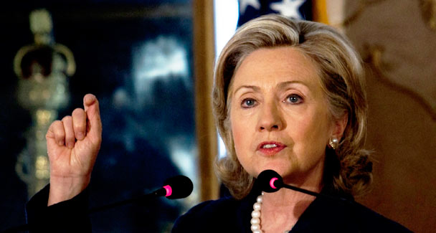
The US seems to realise the limitations of its approach to the local press. In responding to a question at the Islamabad town hall meeting about increasing US engagement with the Pakistani media, Ms. Clinton sought advice rather than laying out a clear strategy: “If you have ideas as to what else we can do, I would appreciate them, because a number of people with whom we’ve been working over the last 14, 15 months have said the same thing. - Photo by AP.
Addressing a town hall meeting in Islamabad nearly a week ago, US Secretary of State Hillary Clinton described Pakistan’s media as “freewheeling…free, [and] quite influential”.
This high praise for the fourth estate should be quite welcome in a country struggling to establish its democratic credentials. Unfortunately, the comment could spark a new crisis of media credibility within an industry that is already wracked by conspiracy-theorising. The image that comes to mind is of a dog chasing its own tail.
The fact is, the Pakistani media seems to have backed itself into a corner with regard to coverage of US foreign and military policy, aid (both military and civilian) and development projects. The sustained high note of anti-Americanism, which reached a crescendo when the Kerry-Lugar bill was passed, has rendered the objective reporting and consumption of US-related issues nearly impossible. If media outlets keep the criticism up, they will be accused of harbouring a blatant and unprofessional bias. But if they offer any praise for the Great Satan and its non-military investments in the country, media outlets are bound to be subject to finger-pointing by the competition.
This finger-pointing will no doubt be based on the allegation, whether implicit or explicit, that an outlet has been bought off by the Americans. Earlier this year, the Obama administration announced that it was allocating $50m for a ‘comprehensive communications strategy’ in Pakistan. Part of the funds was meant to be used to strengthen moderate voices in the Pakistani press, counter extremist views and monitor local media for inaccurate reporting about the US.
Through increased engagement with the Pakistani media, particularly private television channels, the US State Department aims to improve the American ‘brand’ by highlighting US-funded civilian and development projects, thereby stemming the tide of anti-Americanism. Not unexpectedly, this allocation was described as a ‘bribe’ for the Pakistani media and a fillip for the US propaganda machine.
Of course, it is only fair that there be an impartial, accurate and proportionate coverage of US-related issues and events within Pakistan. If anything, the US government’s need to create a media engagement fund is a sad reflection on the professionalism and reliability of our industry. But the existence of such a fund, and the rhetoric that surrounded its announcement, could taint any positive coverage of US initiatives. This may prove problematic as aid under the Kerry-Lugar Bill is disbursed and good news about hydroelectric projects and maternity hospitals starts trickling in.
The US seems to realise the limitations of its approach to the local press. In responding to a question at the Islamabad town hall meeting about increasing US engagement with the Pakistani media, Ms. Clinton sought advice rather than laying out a clear strategy: “If you have ideas as to what else we can do, I would appreciate them, because a number of people with whom we’ve been working over the last 14, 15 months have said the same thing. We see a lot of the changes, a lot of the progress in the [US-Pakistan] relationship, but it isn’t often reflected in the media, and the Pakistani people don’t know…. [Some] of it is we have to be more effective in how we deal with the Pakistani media… and we would welcome the advice that anyone might give us.”
It is clear, then, that the US is still determining how to effectively engage with — and, when required, tackle — the hydra-headed Pakistani media. A recent article in The Washington Post draws attention to an eight-month-old campaign launched by the US embassy to issue corrections in response to any factually incorrect or misrepresentative reports in the Pakistani press.
For his part, Adnan Rehmat, the executive director of Intermedia, an NGO concerned with media freedom and capacity building — and incidentally the person who posed the question about the media to Ms Clinton — believes that more engagement is key. Speaking to the Post, he argued that the US should focus on increasing interactions between Pakistani journalists and Americans from all walks of life — academics, artists, athletes and more.
But the onus to balance out coverage of the US in the local media does not lie with the Americans alone. It is essential that Pakistani media professionals brainstorm ways in which to boost the credibility of US-related reports — nothing less than the industry’s reputation is at stake.
The fact is, the Pakistani public is still feeling out the private media landscape. Public opinion about the media’s role in the current democratic set-up oscillates almost as wildly as US-Pakistan relations. For instance, a Pew poll in August 2009 noted that 77 per cent of Pakistanis believed that the media “is having a good influence on the country”. By November that year, the media had fallen out of favour with the public, and a Gallup poll documented that 31 per cent of Pakistanis blamed the media for political instability in the country. If the US succeeds in exposing the Pakistani media as hyperbolic, the industry could lose its audience for the fine work it does too.
In other words, in these still early years of a liberalised media landscape, coverage of US-related issues could determine how the Pakistani media is perceived both domestically and abroad. And in a worst case scenario, it would be truly unfortunate if anti-media voices in the government joined hands with the perplexed US authorities and succeeded in curbing media freedoms.
The time has come to think responsibly and creatively about how to cover US-related issues, particularly in terms of moving on from the mudslinging that has already passed. Editorial decisions in this regard will continue to be challenged by Pakistan’s security climate — for instance, in February this year, Radio Pakistan suspended broadcasts of Voice of America’s Pushto-language service, Deeva Radio, when the Taliban threatened to bomb its Peshawar premises. But if the fine line between censorship and sensationalism is not charted, the credibility of the Pakistani media will remain vulnerable to attack from various quarters.
huma.yusuf@gmail.com

