Global media’s war
By Manzoor Ali Memon
Tuesday, 28 Jul, 2009 | 12:41 PM PST |

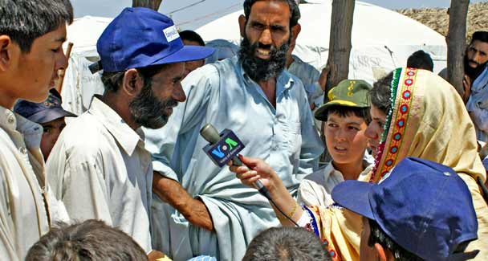
Why are VOA and BBC programmes being aired on private Pakistani TV and radio channels? — File Photo
The global players claiming to be champions of democracy and freedom of the media are using their media outlets as instruments to further their political, economic and foreign policy agendas.
Interestingly the so-called independent and liberal media of various countries supports them so that they can realise their national objectives. Hence they too are the agents of global political and economic powers.
This can be illustrated by the role of the CNN, BBC and others who supported their governments in the Gulf and Iraq wars. It is a classic example of a ‘marriage of convenience’ and ‘symbiotic relationship’ between different forms of power including political, economic, coercive and symbolic media power as identified by John B.

Thompson. By closely monitoring the international media one can easily conclude that they are protecting and promoting their national interests. Gone are the days when wars were only fought on the battlefield. Now the media has become an indispensable component of the war strategy. Manipulation of the media by political powers during wartime has altogether redefined the concept and definition of war.
At present, Pakistan is engaged in a media war which is planned and systematic. The country is not only the victim of physical terror but also of media terrorism launched by the foreign media and their sponsors. Often, questionable and baseless stories are aired by the foreign media which besides tarnishing the image of the country are meant to put pressure on the Pakistani government, leading to an environment of uncertainty, fear and political turmoil. Why are VOA and BBC programmes being aired on private Pakistani TV and radio channels? What is the agenda? Are these being run out of altruistic motives? Or is it simply to improve the image of the US and Britain in Pakistan? The public has a right to know under what terms, conditions and arrangements the private channels allow this. It is shocking that our indigenous media should be offering space to foreign and local forces that can be charged with airing programmes against Pakistan’s national interest.
The international media doesn’t focus on the positive aspects of Pakistan and simply portrays it as an exporter of terrorism. Regrettably, the authenticity and veracity of reports by the foreign media is not checked. A responsible media doesn’t unnecessarily create fear among citizens. Instead of becoming a part of the conflict it should find solutions to crises. Its role is to provide information and analyses based on facts and figures and to guide the leadership through expert opinion and healthy discussions and debate on the country’s numerous challenges.
Undoubtedly Pakistan is passing through a critical phase of its history as it faces both internal and external threats. Therefore, the Pakistani media must act in a way befitting a period of conflict. The elements of dramatisation and sensationalism for improving the ratings of talk shows must take a backseat. It is also about time that the local news media differentiated between national and commercial interest since it has immeasurable power to mould opinion in the country.
The news media should unite the country which is unfortunately divided on ethnic, sectarian and provincial lines. One is confident that the current position is reversible, but not without the help and support of the local news media which should be able to defend the country from the war of words and images imposed from outside. Such confidence is based on precedent. Who can forget the commendable role that the media played in the wake of the devastating October 2005 earthquake in the north? Or how Indian propaganda against Pakistan was countered after last November’s Mumbai attack.
Media owners, journalists, anchors and media managers are information warriors and should work together on a two-point agenda i.e. defending Pakistan from a media onslaught and pulling the country out from the current crises. The news media has got unprecedented liberty and if used in a responsible manner this could keep agendas compromising the national interest from prevailing. Thus it devolves on the media to investigate stories fully before running them especially when national interest is at stake. Even John Stuart Mill, the strongest proponent of free speech, conceded that restrictions on free speech may be justified in the interest of public order.
If VOA and BBC can run their programmes on our media channels then why can’t our state-run and private media channels get air-time on foreign channels in order to counter any propaganda and give an alternative viewpoint on contentious issues? The government should help our media gain access to popular global media channels to run our programmes on a regular basis in order to promote Pakistan’s cause.

manzooralimemon@yahoo.com

