Media and crime
By A.G. Noorani
Saturday, 23 Jan, 2010
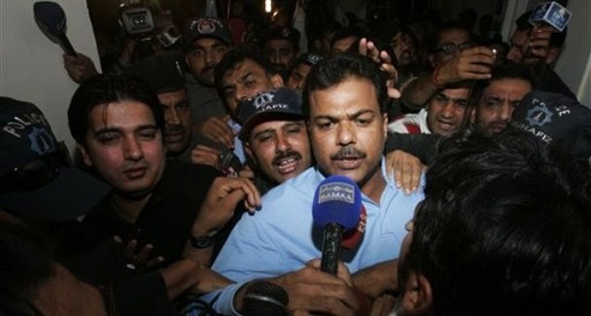
It is important to recognise that the media is doing a public a service. It has rendered services in exposure of fraud, corruption in police and perversion of investigation.

A series of high-profile murders and suicides in India in recent years aroused public interest for two reasons. One was the persona of the suspect or the accused and, in some cases, the victim as well. The other was the media’s keen persistent interest; the electronic media particularly.
Initially, defence lawyers enjoyed appearing before TV cameras to testify to their clients’ innocence, throwing overboard established rules of professional ethics and norms of propriety. Before long, however, they launched an offensive and questioned the media’s locus standi itself.
The most prominent among them, a veteran performer on TV, propounded a doctrine which even judges and policemen would think twice before endorsing in this day and age. He asserted that if the media had acquired any evidence, it ought to provide it to the police or the courts and not publicise it.
This view is untenable on three grounds. First, it is simplistic and sweeping, without any qualifications, and this in a realm in which there are no absolutes but competing public interests involving the probity of the police investigation, the right of the accused to a fair trial and the people’s right to keep a vigil over the entire process and to demand that these values are respected.
The other is a profound ignorance of the role of the media in modern times. There was a time when judges held that the freedom of the press was no more extensive than the right of a citizen to comment on public affairs.
The modern view is that the media enjoys some additional rights as an institution; for instance in regard to access to sources. In 1980 the US Supreme Court upheld in the Richmond Newspapers case “the media claim of functioning as surrogates for the people”. It enjoys a representative capacity on behalf of the people, its readers or watchers.
Thirdly, as distinct from the role, the status of the media is also overlooked. The fourth estate is as much a part of the democratic process governed by the rule of law, as the other three — the executive, the legislature and the judiciary.
None of the four can claim absolute rights. Each exercises its power under constraints laid down in the constitution. The judiciary can bring to heel a journalist who violates the law. The journalist is as entitled to censure a judge for violating the law, the norms of propriety, for incompetence or for manifest bias.
It is well settled that a judgment is open to public scrutiny whether in a learned law quarterly, by a bar association or in the media. So, indeed, is the conduct of a proceeding in a court of law.
This right surely extends also to the conduct of police investigation. The media has no right to pronounce a person guilty of a crime, haul up his past convictions, air evidence inadmissible in a court of law or create against him prejudice in the public mind.
That is trial by media which the courts have rightly ruled vitiates the trial in the court, and not only in jury trials. That also constitutes contempt of court punishable with imprisonment as well as fine.
But this is a far cry from a case in which the police are palpably inefficient, lethargic or indifferent in the investigation of a crime causing public disquiet. In such cases, the media is perfectly within its rights in probing into the matter itself and thus forcing the police to do their duty.
What of the newspaper’s independent investigation? Investigative journalism has an ancient lineage though it has acquired vigour in recent decades. In 1885, W.T. Stead of the Pall Mall Gazette exposed child prostitution by going out and buying a 12-year-old girl. He was imprisoned for a time. The law was changed.
British courts banned the Sunday Times from conducting a campaign against Distillers, manufacturers of the deforming drug Thalidomide, for the niggardly compensation they gave to the victims.
The courts held that this put unfair pressure on the manufacturers to settle pending cases for damages for more than they would have given. The European Court of Human Rights rejected this view. Pending litigation did not affect the responsibility of the media to impart information and comment on a public tragedy. The old test of a ‘possibility’ of prejudice was rejected in favour of the test of a “substantial risk of serious prejudice”.
The media goes wrong when it denounces suspects. But the police are even more brazen in triumphantly parading before TV cameras a captured ‘terrorist’. In 1995, the French minister of the interior, who held a press conference with police officials in which they named a man as one of the instigators of the murder of an MP, was ordered by the European Court of Human Rights to pay him two million French francs for violating a human right — the presumption of innocence.
The solution lies in recognising the public interest as a valid defence. Publication of the photograph of a dangerous suspect on the run is a service, not contempt. The media has rendered services in exposure of fraud, corruption in police and perversion of investigation. But one must recognise the potentiality of conflict to harm the public interest.
If the media collects evidence and a trial is imminent, it publishes the evidence only at the risk of committing contempt of court. However, once judgment is delivered the media is entitled, indeed bound, to comment if there is a miscarriage of justice.
It was a media campaign which led, belatedly to the release of four defendants in 1989, 14 years after their conviction, for causing an explosion in a pub at Guildford. Likewise, in 1995, six persons were freed, 19 years after their conviction on 21 counts of murder in Birmingham. In 1997 three men were freed after a wrongful conviction 18 years earlier for the killing of one Carl Bridgewater.
In each case the police had fabricated the evidence. Judges who tried the cases and sat on the full gamut of appeals shut their eyes. In the final belated stage they exonerated their colleagues by fastening the blame on the police alone. None gave the credit to the media whose campaign alone ensured review of the cases and the belated righting of a monstrous wrong.

