Media’s partisan image
By Syed Irfan Ashraf
Monday, 11 Jan, 2010
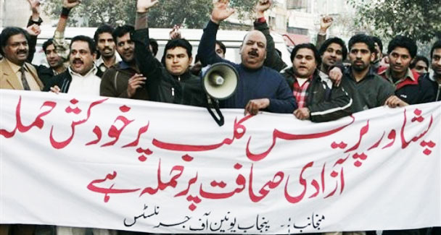
Journalists rally to condemn the suicide attack on the Peshawar Press Club, holding a banner that reads "Suicide attack on Peshawar Press Club is an attack on free journalism" Tuesday, Dec. 22, 2009 in Lahore.
The recent suicide attack on the Peshawar Press Club appears not to have alarmed the mainstream media, although the blast underscored the magnitude of the security problems faced by NWFP journalists.
The relatively low casualty figure in the press club blast should not lessen the gravity of the challenge.
In the Frontier, which is bearing the brunt of militant attacks, it may be easy to rationalise the attack in the wider context of violence in the province. But oversimplifying the issue is of little use, especially when journalists in the NWFP know that the countdown for them began much before the blast.
This observation is underscored by a survey released by Intermedia, Pakistan. According to the media development organisation three journalists were killed in the NWFP in 2009, four were kidnapped and at least 10 were injured in assaults. Media organisations were attacked, journalists issued threats. Besides several gag orders and censorship cases were registered.
Militants represent one kind of threat to media people — and state agencies another. The former does not hesitate to attack press clubs, while the latter make it known in other ways that they consider independent reporting a threat to national security. This has turned journalism upside down. Conscientious reporting has become a risky job. One young journalist described how he, like many of his colleagues, was pressurised by an intelligence agency to share his sources quoted in a recent story. “With all this how can I maintain a balanced line?” he asked.
In a survey conducted in Swat valley, all the 29 journalists interviewed admitted that working conditions demanded that they sacrifice truth for security. Twenty-eight said they had received threats. Eight blamed security forces and 10 the Taliban for direct threats. Ten journalists said they preferred to kill a story when intimidated, while eight said they modified it according to the demands of whichever group was pressuring them.
All too often journalists find themselves in a tight spot. In a talk show a Voice of America host unexpectedly asked a local journalist in Swat as to who was responsible for violating last February’s accord for the implementation of the Sharia in Malakand — the Taliban or the army? The baffled reporter from Express TV reluctantly replied that it was neither the Taliban, nor the army but the people!
In this way the reporter tried to escape the wrath of the real violators by putting the responsibility on the victims. Unfortunately for him, this did not do the trick. He soon received a call from a militant who reprimanded him for spouting utter nonsense and for not telling the ‘truth’ that the security forces were responsible.
Many senior journalists are shrewd and know how to run with the hare and hunt with the hounds. Their close rapport with official power centres has so far kept them safe, but at the cost of their integrity in the journalist community. Meanwhile, younger journalists in the NWFP are increasingly finding balanced reporting a precarious job as they want to excel in selling top terror stories but are disinclined to compromise their objectivity in the process.
One cub reporter was grilled for a couple of days by officials for reporting a story about the military operation. The terrified youngster sent an email to his university professor asking him not to teach the values of fairness and objectivity, the cornerstone of true journalism, because such values, he felt, had become old-fashioned in the post 9/11 world.
Many conflict reporters say that writing up investigative pieces brings them fear and tension. “General Sahab is angry,” and “we will hang you upside down” are two pet sentences they hear the day after their piece is published. Threatening letters and phone calls are in addition — the Peshawar Press Club had been receiving both since long. This culture of intimidation has strengthened the built-in mechanism of self-censorship. A reporter thinks many times before writing about the conflicting parties. It is understandable then why one can detect a partisan tone in reports, many of which have a clear bent towards one or the other ‘power’ centre.
In July 2009, when Swat returnees were on their way home, incidents of custodial killing of alleged militants started in the valley and mass graves were also identified. Instead of making use of primary sources and reporting these incidents, some journalists preferred to inform human rights organisations about the violations, and later, a press release was published in different newspapers as a secondary source. The journalists believe that this is how they escaped danger.
Generally, in a war-like situation, lack of accessibility to primary sources or the scene of action has always blurred the lines — ‘who’, ‘what’, ‘how’ and ‘why’ are not always satisfactorily answered. It is easy to secure and use information released by conflicting parties — this qualifies as propaganda.
In the NWFP this approach has added to the negative image of journalists. An angry militant flung the front page of a local Urdu daily at this scribe at a police picket at Shangla Top. How, he asked, could it be reported that shelling from a helicopter gunship had left 36 militants dead when not one militant was on the ground. It was hard to convince the militant commander that newspapers are bound to carry ISPR claims. “You are all friends of the infidels,” he replied angrily.
To avoid controversy, journalists show a flexible attitude in not reacting as an institution to those forces which are putting pressure on them, and their ethics as well. This approach needs a rethink. Press clubs and representative media bodies must be able to provide the leadership needed to rescue the journalists from troubled waters. Terror has taken hold of their minds and is on its way to strike their institutions. A joint platform must be activated to address these issues which are giving a bad name to the journalist community in the NWFP.

